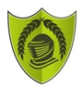
Year 5 – Autumn 1 – Earth and Space
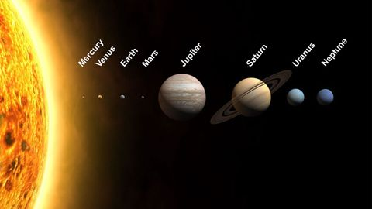
Key Facts
The solar system consists of the Sun and everything that orbits, or travels around, the Sun. This includes the eight planets and their moons, dwarf planets, and countless asteroids, comets, and other small, icy objects. However, even with all these things, most of the solar system is empty space.
Mercury, Venus, Earth and Mars are rocky planets. They are mostly made up of metal and rock. Jupiter, Saturn, Uranus and Neptune are mostly made up of gases (helium and hydrogen) although they do have cores made up of rock and metal.
The planets are held in their orbits by the gravitational pull of the sun.
The moon orbits the Earth every 28 days and is held in its orbit by the gravitational pull of the Earth.
The Earth orbits the sun every 365 ¼ days
The Earth rotates anti-clockwise on its own axis every 24 hours.
Other planets have moons. Jupiter has 79 moons!

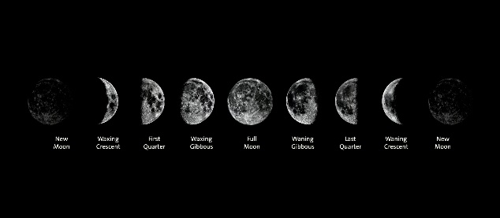

Key Vocabulary
Orbit | To move in a regular, repeating curved path around an object. | Constellation | A group of stars forming a recognisable pattern.
Satellite | Any object or body in space that orbits something else. | Rotation | A spin around something.
Star | A giant ball of gas held together by its own gravity. | Axis | An imaginary line that a body rotates around.
Planet | A large object, round or nearly round, that orbits a star. | Geocentric | A belief that other planets and the sun orbited the Earth.
Moon | A natural satellite that orbits a planet. | Heliocentric | The structure of the solar system in which the planets orbit around the sun.

