Key Facts
Isaac Newton (1643-1726) developed his theory of gravity when he saw an apple fall to the ground from an apple tree.
Unsupported objects fall towards Earth because of the gravitational pull of Earth.
The moon has a smaller mass than the Earth so the gravitational pull is smaller on the moon than it is on Earth.
Pulleys can be used to make a small force lift a heavier load. The more wheels in a pulley, the less force is needed to lift a weight.
Gears can be used to change the speed, force and direction of motion.
Levers can be used to make a small force lift a heavier load. A lever always rests on a pivot.
Year 5 – Autumn 2 – Forces
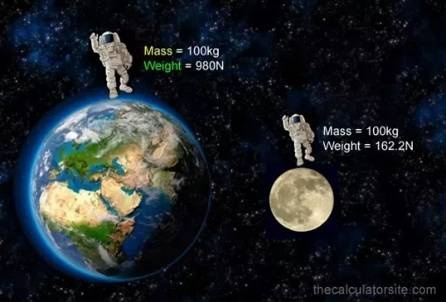
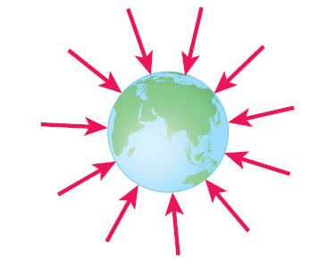

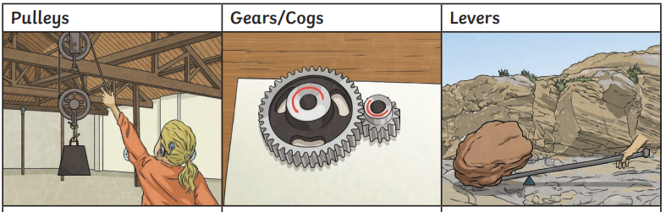
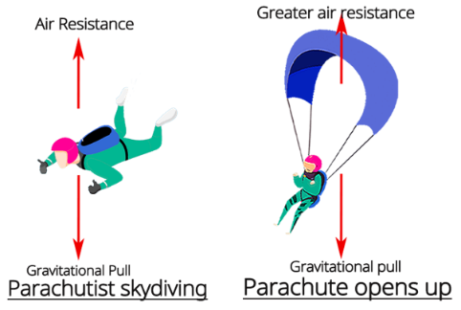
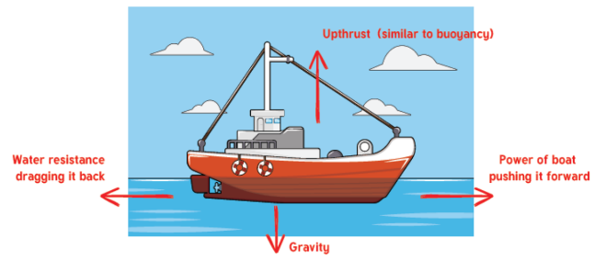

Key Vocabulary
Gravity | A force that pulls objects towards each other. | Water resistance | A type of friction caused by water pushing against a moving object.
Earth’s gravitational pull | The pull that Earth exerts on an object, pulling it towards Earth’s centre. | Streamlined | A shape that reduces resistance when moving through gas or liquid.
Weight | How hard gravity pulls down on an object. It is measured in newtons (N). | Upthrust | A force that pushes an object upwards, usually in water.
Mass | How much matter (‘stuff’) there is in an object. It is measured in grams (g) and kilograms (kg). | Buoyancy | When an object floats. This is because the weight of the object is equal to the upthrust.
Air resistance | A type of friction caused by air pushing against a moving object. | Mechanism | Simple machines with moving parts that change input forces into useful output forces.

