Year 5 – Summer 2 – Living Things & Their Habitats
Plant Sexual Reproduction | Plant Asexual Reproduction
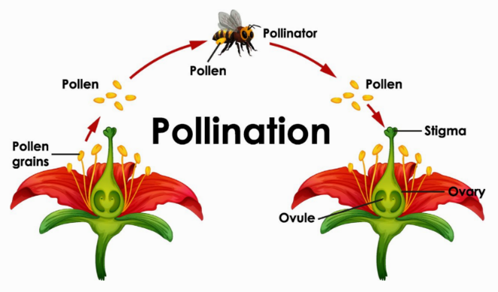 | 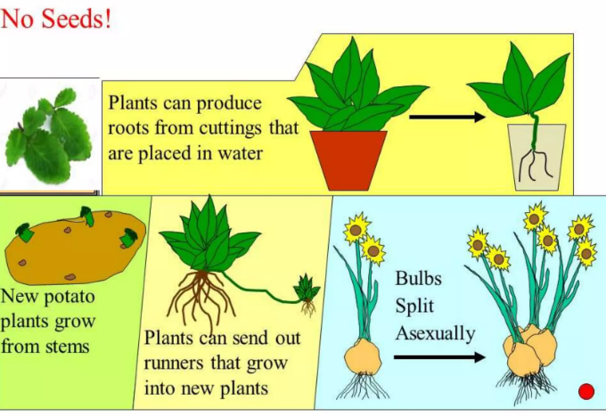
Key Facts
Most plants contain male sex cells (pollen) and female sex cells (ovules) but they don’t fertilise themselves.
Wind and insects transport pollen to different plants.
Pollen from the stamen (male parts of the flower) of one plant are transported to the carpel (female parts of the flower) of the other.
This pollen is collected at the stigma, travels down the style and fuses with an ovule.
For mammals, the male sex cell (sperm) fertilises the female sex cell (egg).
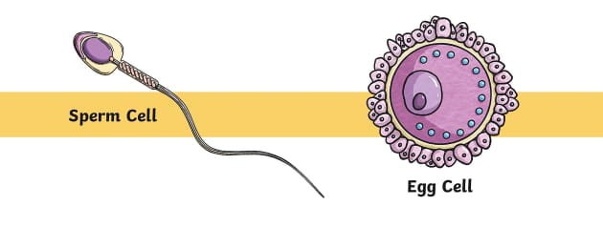
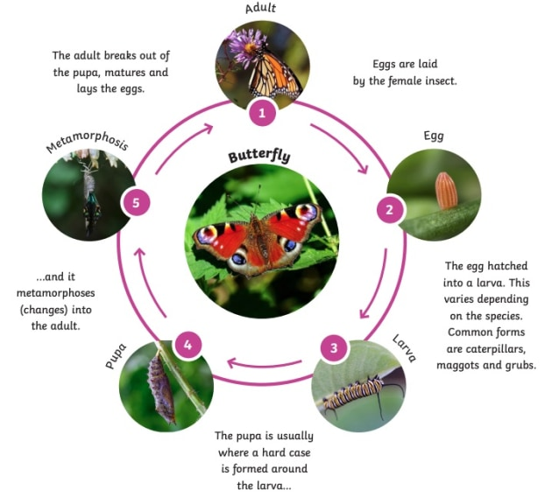
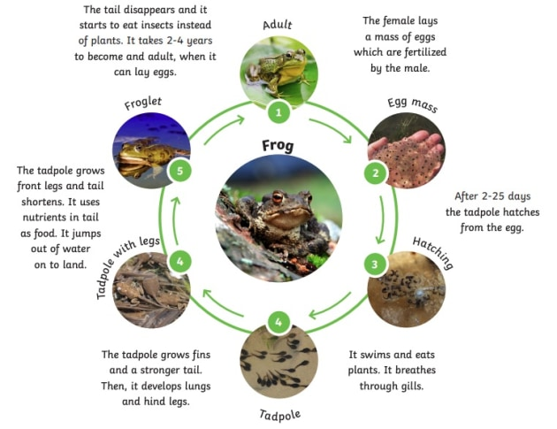
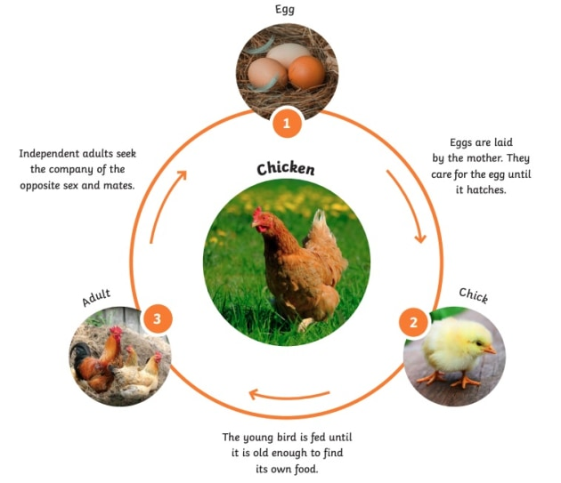

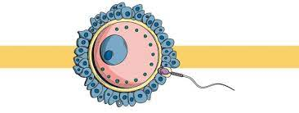

Key Vocabulary
Asexual Reproduction | This is when offspring is created by one parent and is an identical copy of the parent. | Metamorphosis | The process some animals go through to become adults. The change is dramatic and the baby stage looks very different from the adult stage.
Sexual Reproduction | This is when offspring is created by two parents and is similar to the parents but not identical. | Monotremes | Mammals that lay eggs but also feed their babies with milk.
Gestation | The length of a pregnancy. | Marsupials | Mammals that carry their newborn young in a pouch.

