Key Facts
Mammals use sexual reproduction to produce their offspring.
Aristotle was the first scientist to formally classify organisms. He was an Ancient Greek.
Carl Linnaeus was a Swedish Scientist who formalised the modern system for classifying organisms.
David Attenborough is a famous naturalist who studies animals in their habitats and observes their behaviour.
Year 5 – Spring 2 – Living Things & Their Habitats
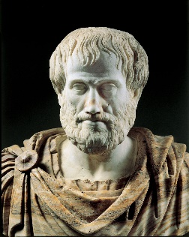
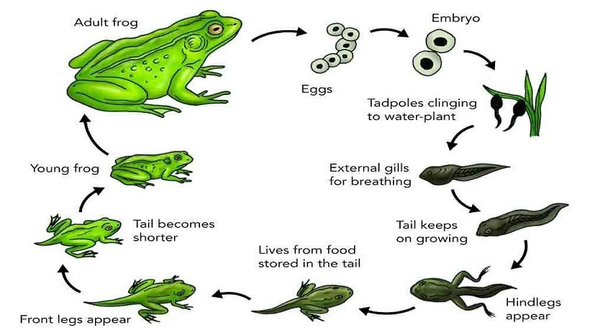

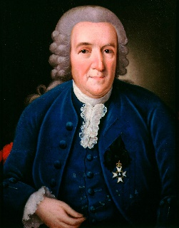

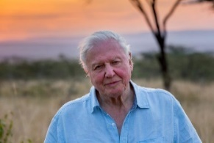

Key Vocabulary
Asexual Reproduction | This is reproduction without mating. In this form of reproduction, a single organism or cell makes a copy of itself. This is not possible in mammals. | Pollination | Pollination is the process that allows plants to reproduce. In some cases, the wind and rain blows pollen between plants, which causes pollen to transfer to the female reproductive part of the plant
Sexual Reproduction | The Biological process by which new individual organisms – “offspring” – are produced from their parents. | Dispersal | The means by which a plant ensures its seeds are spread as far as possible from the parent plant.
Fertilisation | The action of fusing the male and female sex cells in order to develop an egg. | Stamen | The part of a flower that produces pollen and is made up of an anther and a filament.
Germination | Germination is the process by which a plant grows from a seed. | Stigma | A stigma is a part of a flower that gets pollen from pollinators such as bees. The stigma is part of the female reproductive part of a flower.
Gestation | The length of a pregnancy. | Metamorphosis | The process some animals go through to become adults. The change is dramatic and the baby stage looks very different from the adult stage.

