Key Facts
Different materials are used for particular jobs based on their properties: hardness, solubility, transparency, conductivity and response to magnets.
A mixture can be separated by sieving, filtering and evaporating.
Sieving works by smaller particles being able to fall through the holes in the sieve, separating them from larger particles.
Filtering works by liquid being able to pass through the filter paper but solid particles getting caught.
Evaporating works by the liquid turning into a gas, leaving behind the solid particles.
Most metals are thermal conductors (they conduct heat) and electrical conductors (they conduct electricity).
Year 5 – Spring 1 + 2 – Materials
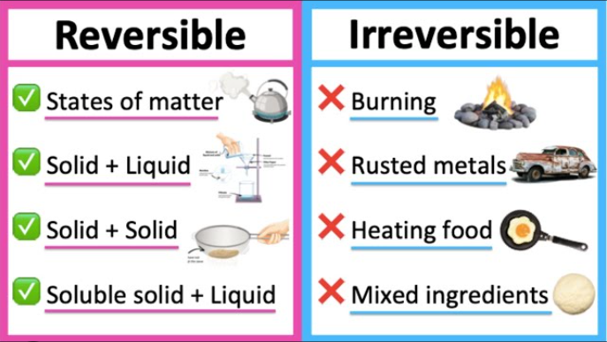
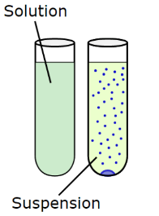
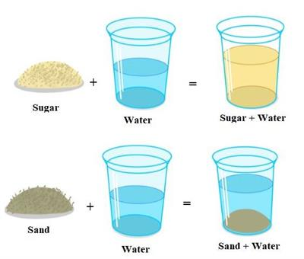

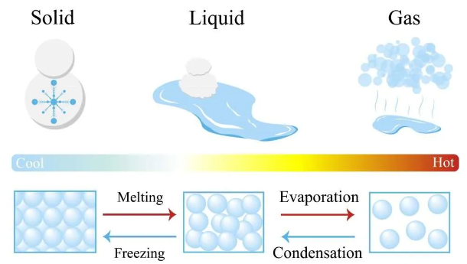

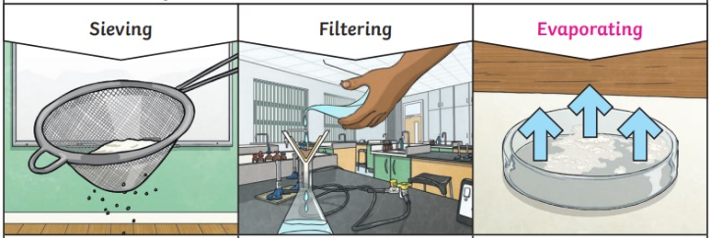

Key Vocabulary
Soluble | Materials that will dissolve. | Conductors | A material that heat and electricity can easily travel through.
Insoluble | Materials that will not dissolve. | Insulators | A material that does not let heat or electricity travel through.
Solution | A mixture of two or more substances that stays evenly mixed. | Reversible | Able to change back to how something was.
Suspension | A mixture that does not stay evenly mixed. | Irreversible | Not able to change back to how something was.
Filter | A device for removing unwanted parts from something e.g. removing solid particles from a liquid. | Transparency | How well light passes through a material.

