Year 6 – Summer 2 – Animals including Humans
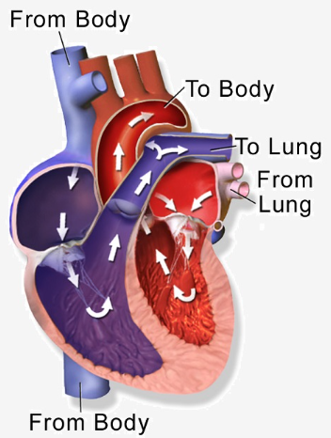
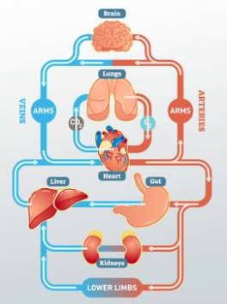
Key Facts
Mammals have hearts with 4 chambers: the right atrium, the right ventricle, the left atrium and the left ventricle.
Deoxygenated blood comes from the body and goes to the lungs. Oxygenated blood comes from the lungs and goes to the body.
Blood transports gases (oxygen and carbon dioxide), nutrients (including water) and waste products around the body.
Red blood cells carry oxygen.
Platelets help stop bleeding when you get hurt.
White blood cells fight infection when you are unwell.
Plasma is made up of protein and water.

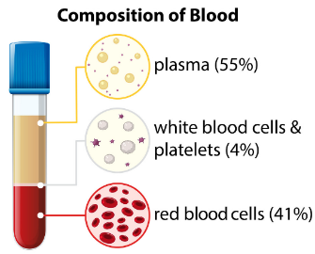
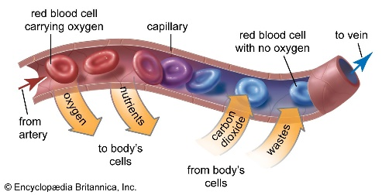
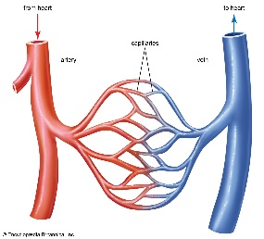

Key Vocabulary
Circulatory system | The system responsible for carrying oxygen and nutrients to cells and removing carbon dioxide and waste products. It is made up of the heart, blood vessels and blood. | Arteries | Tubes that carry oxygenated blood from the heart to the rest of the body.
Heart | An organ that pumps blood around the body. | Veins | Tubes that carry deoxygenated blood from the body to the heart.
Blood vessels | Tubes that carry blood around the body. They include arteries, veins and capillaries. | Capillaries | Tiny tubes in which the exchange of oxygen and nutrients, carbon dioxide and waste products happens.
Oxygenated blood | Blood that has more oxygen in it than carbon dioxide. It is pumped from the heart to the body. | Drugs | Chemicals that change the way the body works.
Deoxygenated blood | Blood that has more carbon dioxide than oxygen. It is returning to the heart from the body. | Alcohol | Chemical substance in beer, wine and spirits that changes the way the body works.

