|  |
| --- |
| **Key Facts** |
| Roman laws were called the ‘Twelve Tables’ and written around 450BC. |
| In Roman times the worst crime was treason and was punished by being thrown to the lions. |
| If an Anglo-Saxon trial could not decide if a person was a guilty, a trial by ordeal was given to let God decide. |
| Trials by ordeal included trial by cold water, trial by iron bar and trial by hot water. |
| The Tudors invented harsh punishments to deter and humiliate people. They included a dunking stool to see if someone was a witch. |
| In the 18th and 19th centuries being transported to the British colonies, such as Australia, was a form of punishment more merciful than execution. |
| The Victorians built many prisons to prevent people committing further crimes. They could be forced to do physically demanding tasks such as a treadwheel and the crank. |

**Year 6 – Autumn 1 – Crime and Punishment**

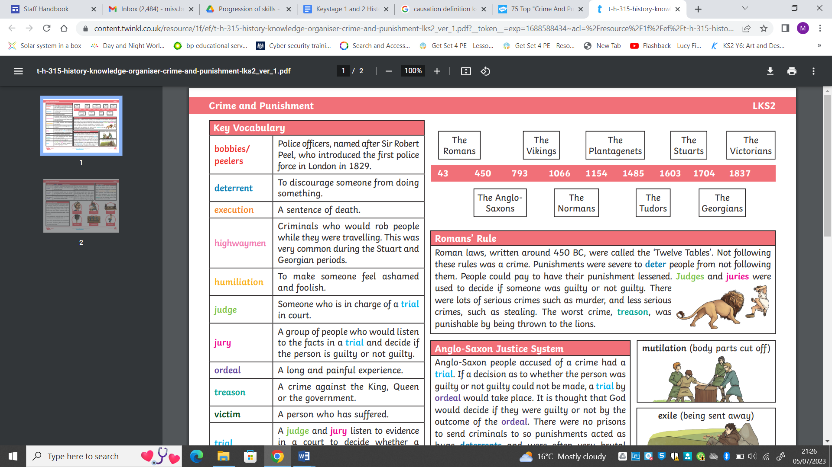

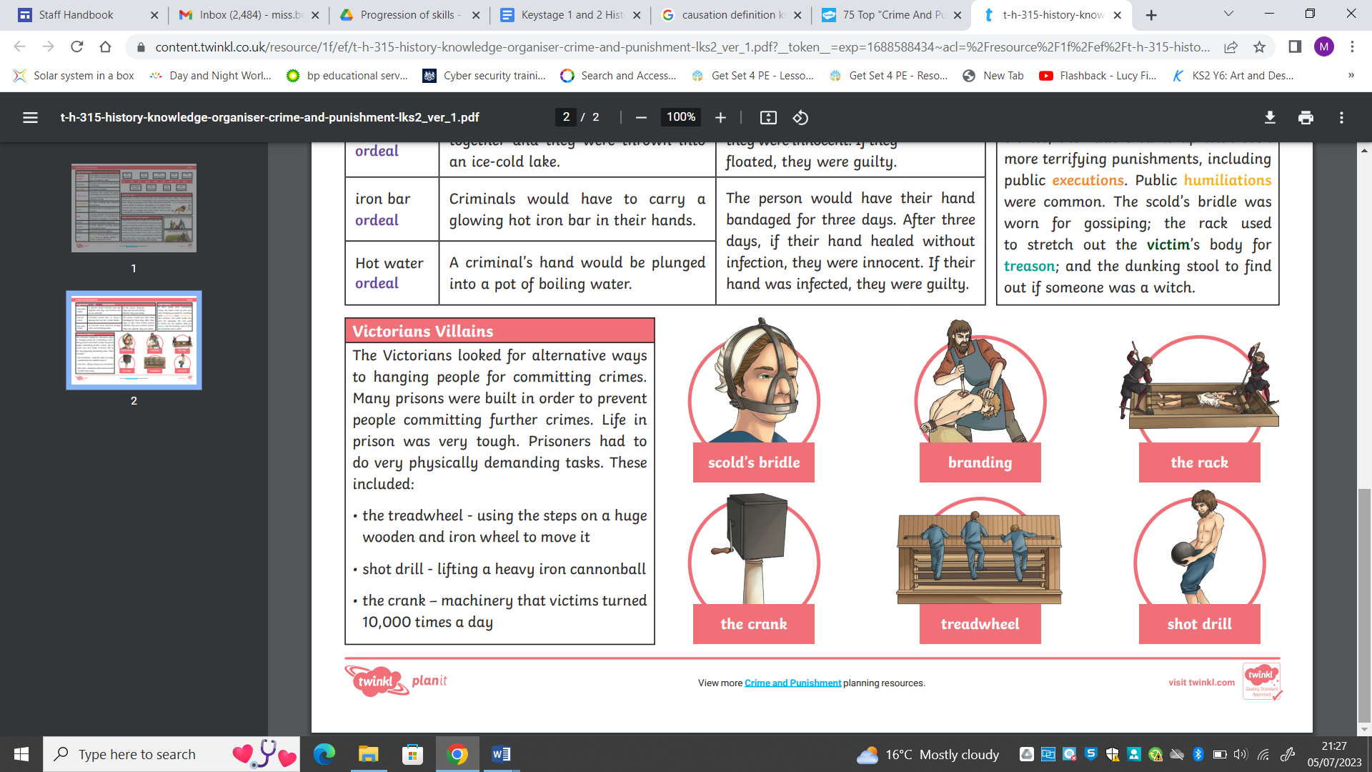

|  |  |  |  |
| --- | --- | --- | --- |
| **Key Vocabulary** | | | |
| Judge | Someone who is in charge of a trial in court. | Treason | A crime against the King or Queen. |
| Jury | A group of people who listen to the facts in a trial and decide if someone is innocent or guilty. | Deterrent | To discourage someone from doing something. |
| Trial | A judge and jury listen to evidence in a court to decide if a person is guilty or not. | Bobbies/peelers | Police officers names after Sir Robert Peel who introduced them in London in 1829. |
| Trial by ordeal | Anglo-Saxon practice of deciding if a person is guilty by making them suffer in a painful experience | Highwaymen | Criminals who robbed people while they were travelling. |
| Execution | A sentence of death. | Victim | A person who has suffered. |