Key Facts
Electrical components are represented as symbols. These are used to draw diagrams of circuits.
If more components are added, the electricity is shared between the components making the bulbs dimmer, the buzzes quieter and the motors slower.
To make the bulbs brighter, more batteries are required or a higher voltage. Shortening the wires would also brighten the bulb as it reduces resistance.
To make the bulbs dimmer, add multiple bulbs to a circuit, use less batteries and lengthen the wires in the circuit.
Bulbs in parallel circuits have the same brightness
Year 6 – Summer 2 – Electricity
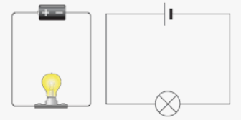
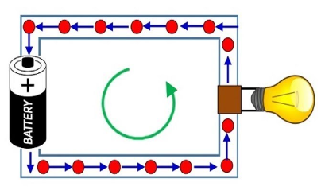

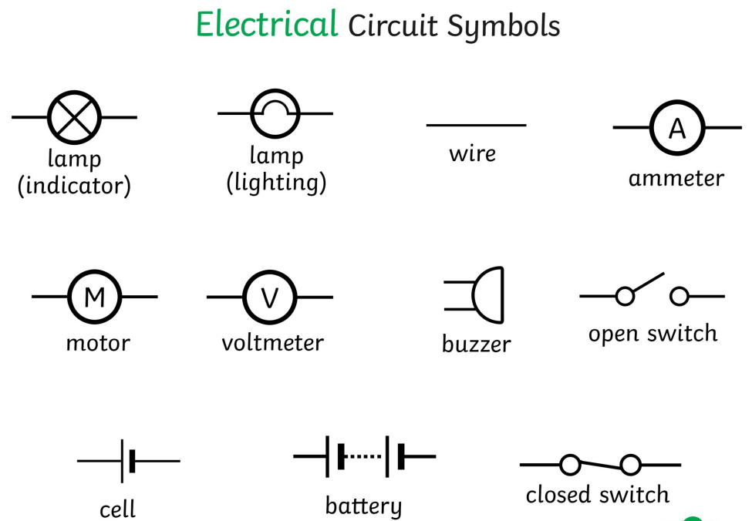
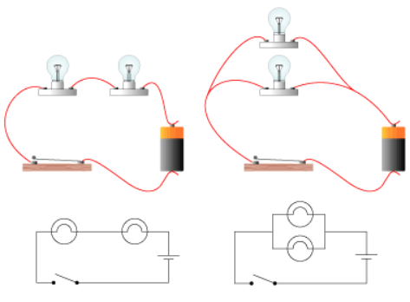
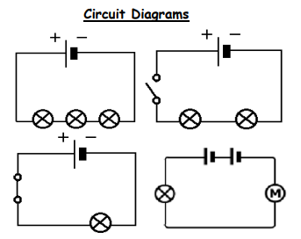

Key Vocabulary
Cell/battery | A device that stores electricity as a chemical. A cell is a single unit, a battery is a collection of cells. | Resistance | The difficulty the electric current has when flowing around a circuit.
Current | The flow of electricity. | Electrons | Small particles that travel around an electrical circuit.
Amps | What the flow of electricity is measured in. | Series circuit | A simple loop with all components connected in a line.
Voltage | How strong a current is in a circuit. The greater the voltage, the more current will flow. | Parallel circuit | Two loops, both connected to the same battery, each with its own components.

