Key Facts
Animals and plants produce offspring that are similar but not identical to them. Offspring often look like their parents due to inherited traits.
Fossils of giraffes from millions of years ago show that they used to have shorter necks. They have gradually evolved through natural selection to have longer necks so that they can reach the top of taller trees.
Charles Darwin (1809-1882) explained how things evolve over time through natural selection. This shocked everyone because, until then, it was widely believed that all the animals on the planet had been made at the same time by one creator.
Year 6 – Autumn 2 – Evolution and Inheritance
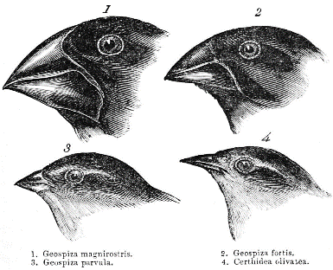

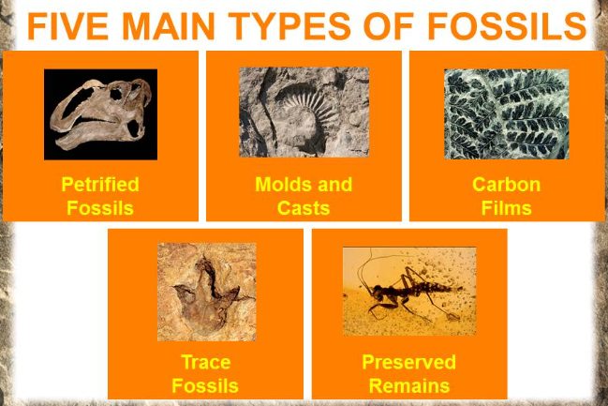
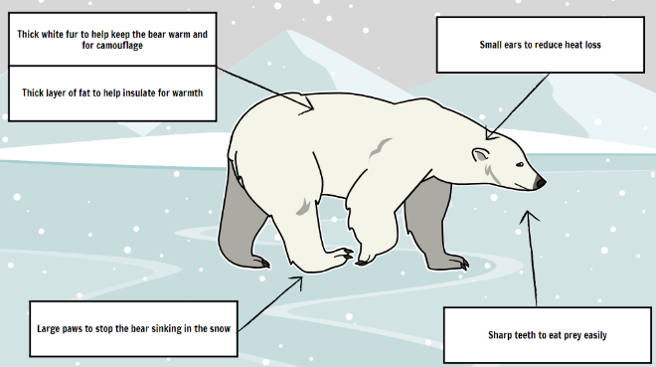
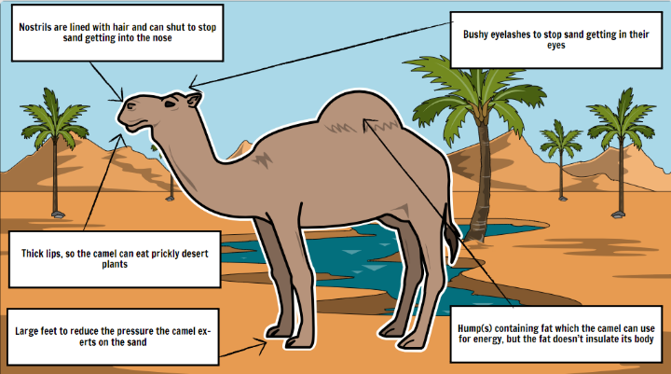

Key Vocabulary
Adaptation | When a trait or characteristic changes to increase the living thing’s chance of survival. | Variation | The differences between individuals within a species.
Inheritance | When a trait or characteristic is passed onto the offspring from their parents. | Mutation | A mistake or a change to genetic code.
Adaptive traits | Characteristics that are influenced by the environment the living things live in. | Natural selection | The process by which species that are best adapted to their environment survive, while those that are less well adapted die out.
Inherited traits | Characteristics that are passed onto offspring e.g. eye/hair colour. | Evolution | The change in a species’ characteristics over several generations.
Maladaptation | Failure to adapt to a new situation or environment. | Fossils | The remains or impression of a prehistoric plant or animal embedded in rock and preserved.

