Key Facts
Light rays travel in straight lines.
Light rays travel directly from luminous objects into our eyes. Light rays are reflected off non-luminous objects so that we can see them.
Light travels as a wave, like sound. However, unlike sound, light does not need a medium to travel through so can travel through a vacuum.
Isaac Newton shone a light through a transparent prism, separating out light into the colours of the rainbow – the colours of the visible spectrum.
All the colours in the visible spectrum merge together to make light.
Year 6 – Spring 1 – Light
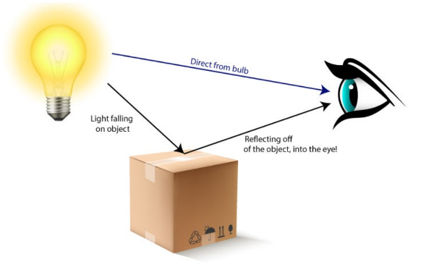
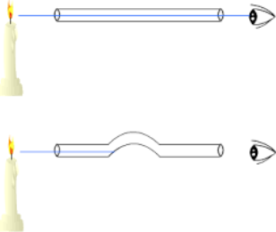

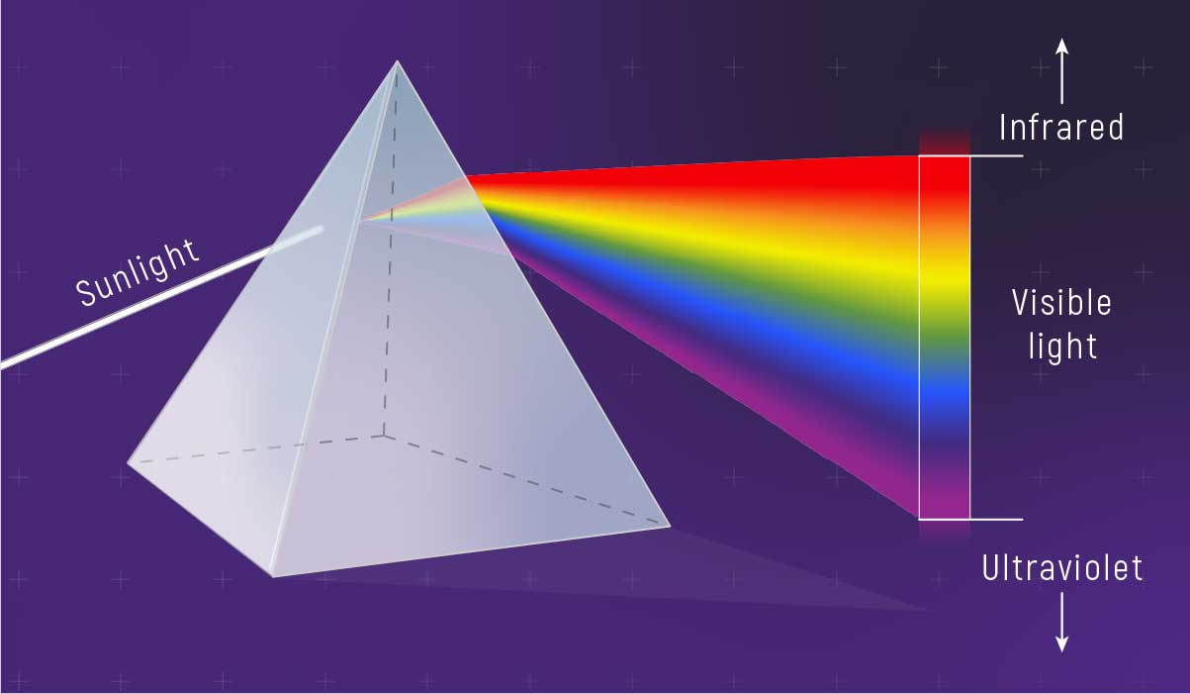
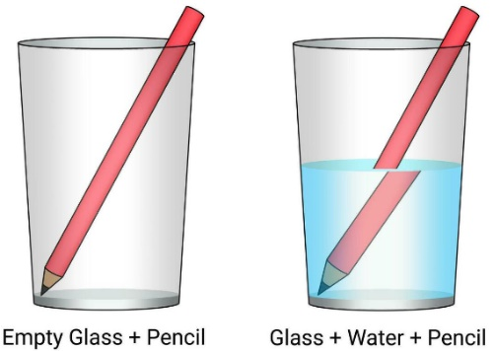
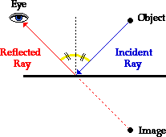
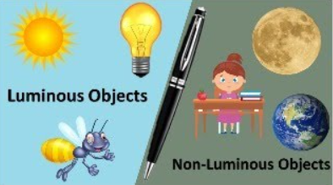

Key Vocabulary
Emit | To give off e.g. to give off light. | Refraction | When light bends when it travels through one transparent medium to another e.g. through air to water.
Incident ray | A ray of light that hits a surface. | Visible spectrum | Light that is visible to the human eye. It is made up of a colour spectrum.
Reflected ray | A ray of light that bounces off a surface. | Luminous objects | Something that emits visible light.
The Law of Reflection | The angle at which the ray hits the surface is equal to the angle at which the ray bounces off the surface. | Non-luminous objects | Something that does not emit visible light.

