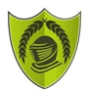
Year 6 – Autumn 1 – Living Things & Their Habitats
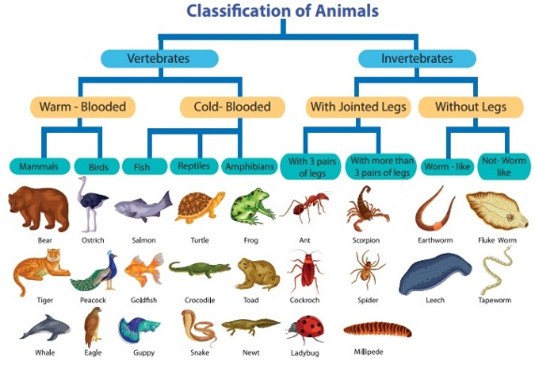
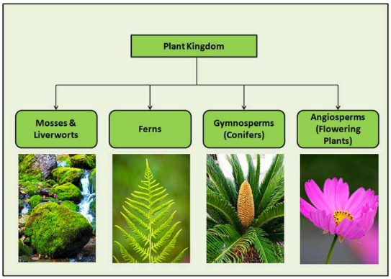
Key Facts
In 1735 Swedish scientist Carl Linnaeus first published a system for classifying all living things. An adapted version of this system is still used today: The Linnaeus System.
The 6 living kingdoms are: animals, plants, fungi, bacteria, protists and archaea.
Fungi are their own kingdom as they gain energy from dead plants and animals, not the sun.

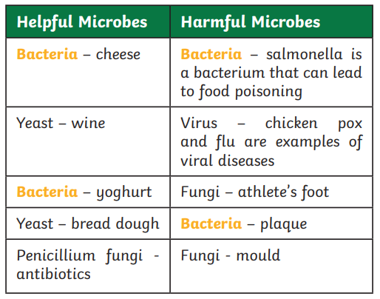
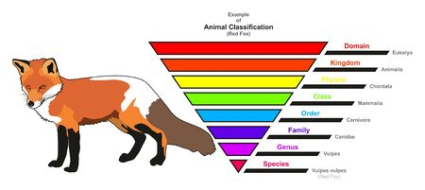

Key Vocabulary
Kingdom | A category grouping together all forms of life which have certain characteristics in common. | Microorganism | An organism that can only be seen using a microscope.
Species | A group of animals that can reproduce to produce fertile offspring. | Bacteria | A single cell microorganism.
Organism | Any living thing. | Prokaryote | A single cell microorganism with no nuclear membrane.

