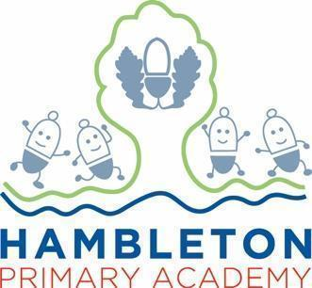

Subject Leader Art Policy / Report

Whole School Curriculum Intent
At Hambleton Primary Academy we work together to ensure all our children achieve academic success whilst remaining healthy, happy and emotionally aware young people ready to move to the next stage of their education.

Subject Intent
Through Art and Design at Hambleton Primary Academy children will be equipped with the knowledge and skills to experiment, invent and create their own works of art, craft and design.

Subject Specific Aims
Art and Design at Hambleton Primary Academy aims to ensure that all children;
- Know about great artists, craft makers and designers, and understand the historical and cultural development of their art forms.
- Produce creative work, exploring their ideas and recording their experiences.
- Become proficient in drawing, painting, sculpture and other art, craft and design techniques.
- Evaluate and analyse creative works using the language of art, craft and design

Progression of knowledge and skills

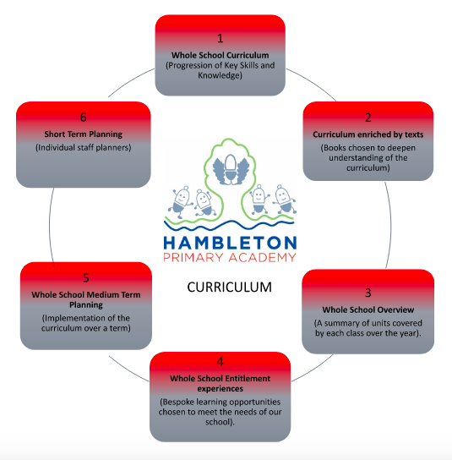

Art Long Term Plan (2).docx

Subject Implementation
Hambleton Primary Academy seeks to provide an all-round education for children in a bright, stimulating and fun atmosphere. At Hambleton, we follow a sketchbook approach in Art allowing pupils to explore their creative imagination, inspired by the work of recognised artists and architects, including visiting artists. They will focus on developing and progressing the skills to enable them to explore different ways of working and to develop core knowledge centred on the language associated with tools, media, techniques and evaluation. Teaching art gives children the opportunity to be immersed within the subject and providing choices later in life. To enhance this, we use the Access Art ‘Split Primary Curriculum’ sequence of lessons, so ensure children are learning, developing and applying their knowledge and skills about Art from lesson to lesson. This scheme of work allows teachers to deliver lessons which not only focus on the technical skills needed for Art, but also helps children to develop the creative thinking skills needed to learn through Art, not just about Art.

Fundamental Great British Values
At Hambleton, we understand our responsibility in preparing children for their next stage of education and for the opportunities, responsibilities and experiences of later life, laying the foundations so that they can take their place successfully in modern British society. We understand how this subject has an underpinning link to British values. The spiritual, moral, social and cultural development of each child is central to everything that we do as a school. Our Art work reflects our inclusive environment and through the many opportunities provided for our children, they develop understanding of democracy, law, liberty, mutual respect and tolerance. Opportunities to make links with other cultures and religions are actively sought through our curriculum. For example, children in Year 1 learn about the Danish Artist, Molly Haslund through specific talking points embedded into the scheme of learning. Year 4 learn about Paul Cezanne, a French Post-Impressionist painter, which enables them to compare and contrast Art from different cultures, by different Artists. As part of the Access Art scheme, Year 6 complete a unit on ‘Activism’, which encourages children to use a range of artistic skills to speak on behalf of different communities, which also expands children’s thinking to how they can change the world for the better.
Planning
Our curriculum is thoughtfully planned to engage and inspire all our learners. Our whole school curriculum (a progression of knowledge and skills) and long term plans, map out the Art techniques covered each half term for each class. These plans define the skills and knowledge we teach to ensure an appropriate balance and distribution of work across each term and each year. Additionally, planning and teaching in Art is fully inclusive ensuring that all children can access the curriculum at their level. Knowledge and skills are progressively built upon as children journey through our school. Cross-curricular links are emphasised, enabling the children to apply their skills and knowledge in other areas of the curriculum. Enrichment activities are carefully planned to ensure that children have experiences beyond the classroom that may inspire them to become lifelong learners of Art.

Based on the changes made to the Early Years Foundation Stage Framework in 2022, children begin to develop their understanding of imagination and creativity, self-expression and communicating through arts. They also create collaboratively, share ideas, resources and artistic skills.

The range of skills shown through different continuous provision activities are;
- Colour mixing.
- Intentional mark making.
- Observing colours, shapes and textures.
- Respond with a range of materials and media for them create and construct.
- Printing.
- Enjoy using different tools (sponges, brushes, fingers or twigs).

Collecting Evidence
Evidence is collected throughout the year and in a variety of different ways. These include, planning in Staff Planners, subject monitoring (book scrutinies, walk throughs and pupil voice), staff discussions (meeting notes) and data captures. Children have a sketchbook for Art which moves through the school with them. Examples of work from lessons are included on learning journeys displayed in classrooms. In addition to this, Hambleton’s Facebook Page is used to collect and record examples of artwork.

COVID-19 Impact
During the first lockdown from March 2020 and the subsequent lockdowns in January 2021 all children received comprehensive support for home learning by all members of staff across the curriculum. Art was included as part of the topic work set on Google Classroom throughout the period. Whilst children did not always have access to the variety of materials and tools we have in school, drawing and painting were often activities children completed for pleasure whilst in lockdown. As a result of the time in school missed, teachers need to ensure time is spent supporting children with obvious gaps, for example, those who struggle with fine motor skills. Due to time missed in school due to the pandemic, exploration and confidence are key areas which we need to support children with. Through regular Art lesson time and the implementation of the new Access Art scheme, we can help our children to become confident Artists.

Able, Gifted and Talented Pupils
Key skills and knowledge needed for each year group are used to assess pupils and are assessed against and added to our subject data collections. Teachers can clearly see children working at greater depth for Art and can effectively plan opportunities for these children. The subject leader supports teachers in supporting greater depth pupils and ensuring breadth and balance. The subject leader will work with staff to ensure the development of techniques and opportunities which deliver appropriate stretch for AGT pupils within lessons.

SEND and PP Pupils
At our school we teach Art to all children, whatever their ability. It is part of the school curriculum policy to provide a broad and balanced education to all children. We provide learning opportunities that are matched to the needs of children with learning difficulties. Planning of Art lessons considers the targets set for individual children in their Personal Plans (PPs). Through our sketchbook approach all children explore visual, tactile and other sensory experiences to communicate ideas and meanings. The children’s sketchbooks are not marked to give the children ownership of their work and an understanding that their art work is never wrong. We provide verbal assessment including small, achievable next steps to individual children on how to improve their work. We also have experienced TA’s who are trained to support all children and are trained to take out intervention groups which may include SEND children. Vocabulary is constantly modelled by the teacher and repeated back to target children both during group and independent discussions. Additional support is provided in all lessons due to our new ‘adaptive learning’ format for planning and learning objectives. This means that appropriate adaptations are made to help children meet the learning objective, for example, creating a word mat using Widgit to help children annotate their work.

Enrichment opportunities
The Art curriculum is widely enriched through visual and high-quality practical resources, after school clubs, trips and visits including:
Enrichment Activity Examples | Further Information
Craft Club | KS1 attended an after-school club over 5 weeks in Autumn 2 which allowed children lots of exploration time to make things like Christmas cards and decorations to take home.
Creating an art display for the community | Whole school collaboration with Over Wyre Medical Centre creating a display thanking the NHS for their ‘front room’ (wellbeing room).
Celebrating Black History Month | Whole school researched and created a piece of artwork to commemorate their favourite black artist. The best pieces were selected and displayed in school.
Visits from Local Artists | Inviting local artists into school to give the children the opportunities to see the different careers in art and be taught skills from experts.
Young Seasiders Competition | The opportunity for children to enter their artwork into a local competition and have their artwork exhibited in the community.  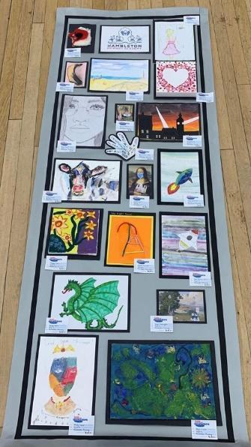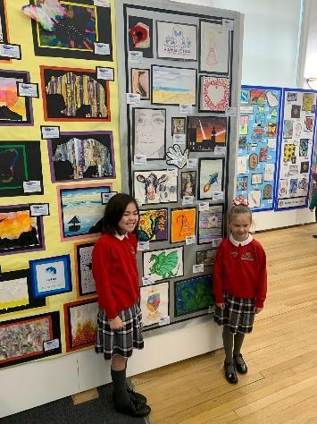

Targets

To upskill staff in the understanding of how to teach skills to children in their class using well known artists. | -Enable staff to feel confident and passionate about teaching art.  Improve standards of learning across the whole school.  -Provide a consistent approach to the teaching of art across the school.  -Ensure full curriculum coverage over the academic year.  -The skills needed to teach art will be taught effectively across school there will no gaps in learning.
To ensure that there is a consistent approach when using and evidencing in the sketch books. | - It will give children the opportunity to look back at previous work and skills and use these in new pieces of work.  -Ensure children are being challenged appropriately to improve annotations of their work.  -Provides opportunities for children to improve vocabulary choices.  -it provides an opportunity for children to celebrate their work with others.

Impact of Staff Training

Subject Leader provided training for all staff. | - Availability of resources during lessons (art cupboard is stocked up as and when required).  - Providing access to the new scheme of work.  - Children to stick in an LO at the start of each lesson so they can be really clear about their learning.  - Ensuring all teachers are using our new sketchbook approach.  - Ensuring teachers feel confident in teaching Art and modelling expectations (without encouraging children to copy).

Assessment / Measuring Impact
Ongoing assessment and review is fundamental to everyday teaching at Hambleton Academy. Teachers are constantly making judgements with regards to attainment in lessons to inform planning and to ensure differentiation. Children are given ownership of their sketchbooks ensuring the children understand that their interpretation of art cannot be wrong. As such, verbal feedback within the lesson is crucial in ensuring key skills are taught and assessed for individual children. Teachers then record any formative assessment within their planners. Attainment is reported termly via data captures stating whether children are working towards the expected standard, working at age related expectations or working at greater depth. From this data, we can adapt teaching focuses to ensure key skills are being addressed and promoted adequately. Parents are informed of their child’s attainment and effort on a termly basis through Parents’ Evenings and end of Year Reports. Teachers to ask children to complete a ‘cold’ task at the start of a new unit of work as a baseline, and then a ‘hot’ task at the end of a unit of work. These tasks should be placed next to each other and evaluated to see progression in children’s work and identify any gaps.
Future Targets
-Diary date some official art observations in to look for how the LO is being used and the enquiry question.
-Set up an Art moderation file which can be shared with both staff and children.
-Ask teachers to do a baseline cold task based on the unit they are working on. Repeat this again for the final piece. Children to then lay out their work in a gallery and post it note/evaluate what they think of others work and their own. Cold task and final piece to be displayed in the first page of the sketch book together with the post it note comments.
-In staff meeting explain expectation of ‘letting go’. Encourage staff to visit the workshop in Nursery, Reception and Y1 to demonstrate what this actually looks like.
Abi Squire – September 2022

