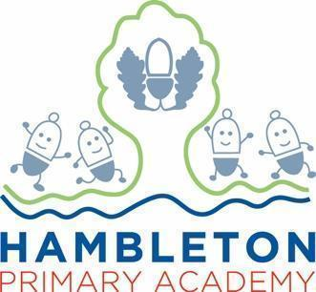

Subject Leader PE Policy / Report

Whole School Curriculum Intent

At Hambleton Primary Academy we work together to ensure all our children achieve academic success whilst remaining healthy, happy and emotionally aware young people ready to move to the next stage of their education.

Subject Intent
In PE at Hambleton, we have designed a curriculum that inspires all children to succeed and excel in competitive sport and other physical-demanding activities. Pupil’s will become physically confident which supports their health and fitness as well as their mental health and wellbeing; whilst building character to embed our school and British values.

Subject Specific Aims
PE at Hambleton Primary Academy aims to ensure that all children;

1. Develop competence to excel in a broad range of physical activities
2. Are physically active for sustained periods of time
3. Engage in competitive sports and activities
4. Lead healthy, active lives.

Progression of knowledge and skills
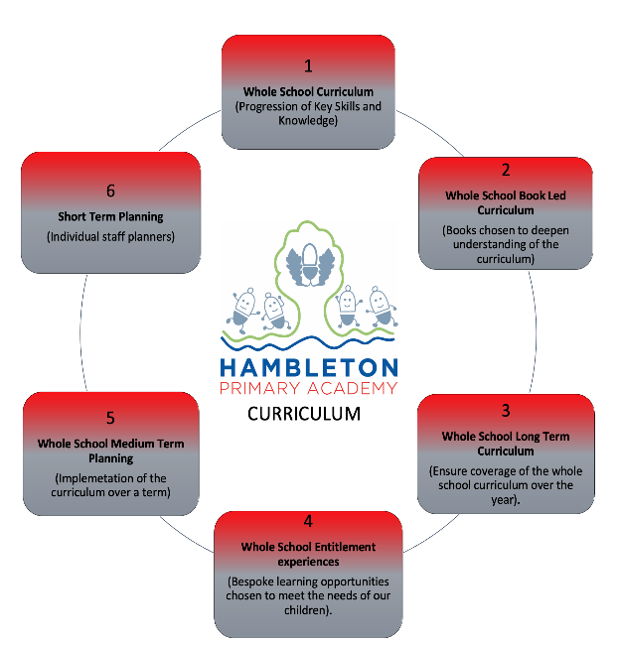

https://hambletonprimaryacademy.co.uk/curriculum/subjects/pe
Subject Implementation

Hambleton Academy seeks to provide an all-round education for children in a bright, stimulating and fun atmosphere. In PE, our intent is to give every pupil an equal opportunity to access the components of our PE curriculum through high-quality teaching. This will equip the children with knowledge, skills and understanding of Physical Education they will need for the rest of their lives.

Fundamental Great British Values

At Hambleton Primary Academy, we understand our responsibility in preparing children for their next stage of education and for the opportunities, responsibilities and experiences of later life, laying the foundations so that they can take their place successfully in modern British society. A high-quality physical education curriculum inspires all pupils to succeed and excel in competitive sport and other physically-demanding activities. It should provide opportunities for pupils to become physically confident in a way which supports their health and fitness. Opportunities to compete in sport and other activities build character and help to embed values such as fairness and respect. At Hambleton Academy, British Values are emphasised throughout our PE curriculum in a variety of ways:

Democracy:

Children are taught about the need for different roles and different responsibilities such as team work and decision making. We have pupil voice for PE & School Sports to allows the subject leader to hear feedback regarding the curriculum, what type of extra-curricular activities we offer, having a new kit).

The Rule of Law:

Children are taught about age appropriate rules, fairness and respect, through a variety of PE activities. We have a zero-tolerance policy on an inappropriate behavior during lessons and if any, it is addressed through the school’s behaviour policy and appropriate actions will take place. Pupils learn to work individually and in groups which also promotes our schools drivers of teamwork and resilience.

Mutual Respect and Tolerance:
We promote a respect for and understanding of different faiths, cultures and lifestyles when taking part in our PE curriculum. This could be through PE lessons, sports week, Healthy Heads, and assemblies on famous sports men and women. The school engages in competition and encourages competition within and across the community. Pupils are taught about the environment and different activity contexts, e.g. OAA units.
Individual Liberty:
At Hambleton we recognise individual differences and celebrate individual sporting achievements. These achievements can be seen during whole school assemblies and show and tell in class. There is an ethos where the views of individual pupils are listened to and respected within an acceptable framework.
Overall, a broad and balanced PE curriculum can develop a range of life skills and values. A whole school approach to PE and School Sport can successfully promote fundamental British values and SMSC development provided that this is supported by Governors, Parents, Head teachers and senior leadership teams, PE subject leaders and pupils.
PE and Sport also teaches skills that form the basis of a healthy life and a positive mindset, which is beneficial throughout their lives. It strives to offer opportunities for pupils to find a sport or activity that they enjoy and can take through to adult life.
PE lessons at Hambleton are fully inclusive and each lesson can be differentiated to meet the needs of the pupils in the class as lessons have STEP – differentiation (Space, Task, Equipment, People) built into them.
We strongly believe that all children, irrespective of physical ability, race, gender, creed or stage of achievement have the right to reach their full potential in PE and achieve enjoyment, satisfaction and success at their own level of ability. Groupings will be based upon skill, agility, experience, strength, size, interest, objective of the task to have the greatest impact for all children to reach our school aims to get them ready for High School.
Planning
At Hambleton Academy we follow the Lancashire scheme of work for PE from EYFS to Year 6. Each unit of work is set out in clear progressions including warm ups, main teaching skills and cool downs. Progressions from one unit of work in a year group are built upon in the next unit in the following year. Skills required are identified, so that teachers know what is expected and are able to identify these skills during lessons. The PE IPad is used to photograph/video children’s moves and techniques. The use of IWB can be used to help assess and evaluate their own and each other’s moves, skills, routines, techniques, in order to improve and progress. These units/videos and assessments can now be accessed via the PE passport on the PE IPad.

At Hambleton Academy, there are 2 hours of timetabled lessons each week for every pupil, allowing pupils to develop themselves as a whole person, build a sound knowledge of basic skills, develop the values of the school’s vision and to build a positive relationship with physical health. We also offer a variety of extra-curricular after school clubs for KS1 and KS2. We also incorporate being active into Maths, English and other foundation subjects wherever possible, bringing active learning into the curriculum. Hall space and outside space are timetabled in order to give each class an opportunity to access PE lessons. Each lesson has a social, personal and technical objective, ensuring that the whole person is developed throughout. Teachers will make links to the school values where appropriate in order to enhance children’s understanding of the values associated to physical health and sport. We have also developed a curriculum map to guide teachers throughout the year. Lessons are planned to cover the National Curriculum themes of athletics, dance, gymnastics, OAA and games (net and wall, invasion and striking and fielding). The curriculum considers the importance of both the breadth and depth of learning. Class teachers are supported with nationally recognised PE resources that provide extensive teaching and learning materials including video clips to build teaching confidence. Lessons usually begin with a quick starter to engage and focus pupils. Pupils then work through a range of progressive activities around a theme or intended learning outcome. There are opportunities to extend and challenge individual pupils and provide support for others. Lessons may be taught in isolation or linked over a number of weeks. A game, performance or task may be the focal point and can be revisited to allow skills to be refined and developed.

Collecting Evidence

Evidence is collected throughout the year and in a variety of different ways. These include, planning in Staff Planners, subject monitoring (observations, walk throughs and pupil voice), staff discussions (meeting notes) and data captures. Also, through the PE Passport scheme, we collect video and photographic evidence. Examples of PE lessons are included on learning journeys displayed in classrooms. In addition to this, Hambleton’s Facebook Page is used to collect and record examples of PE lessons as well as competitions we have entered. Pupils are interviewed about their thoughts about PE during the monitoring cycle. Staff regularly discuss PE with the Subject Leader during the working week for any advice.

COVID-19 Impact

During the period of the school closure due to Covid-19, teachers set physical skill challenges for children to complete that were age and Key Stage appropriate. Children sent results or videos/ photos of themselves completing the tasks via Google classroom. Wyre School Sports Partnership and Spar Lancashire Schools Games also produced a vast range of virtual competitions/ activities that children could participate in, again sending results and pictures in via Google Classroom. At Hambleton Academy we follow ‘Safe Practice: in Physical Education, School Sport and Physical Activity’ as a basis of our legislation requirements which informs our PE Policy and risk assessments for PE and Sporting activities.

Able, Gifted and Talented Pupils

Key skills and knowledge needed for each year group are used to assess pupils and are assessed against and added to our subject data collections. Teachers can clearly see children working at greater depth for PE and can effectively plan opportunities for these children. The subject leader supports teachers in supporting greater depth pupils and ensuring breadth and balance. The subject leader will work with staff to ensure the development of techniques and opportunities which deliver appropriate stretch for AGT pupils within lessons. These children can also be stretched by taking part in competitions against other schools.

SEND and PP Pupils

At our school we teach PE to all children, whatever their ability. It is apart of the school curriculum policy to provide a broad and balanced education to all children. We provide leaning opportunities that are matched to the needs of children with learning difficulties. Task cards, posters, videos, digital cameras and iPads are also used to assist pupils in teaching and learning. The SENCo and PE Subject Leader jointly advise teachers on the support which can be provided for individual children with particular educational needs. Also, we offer SEN, PP Pupils and working towards children an intervention session with Fleetwood Town specialists to enhance their development in PE.

Enrichment opportunities

At Hambleton Academy we seek to offer a diverse and exciting range of enrichment opportunities. These are delivered by staff in some cases and also by external agencies and also specialist coaches. Some activities are competitive and some are inclusive allowing for all the various needs of our children to engage in active pursuits.

Enrichment Activity Examples | Further information
Football league and competition  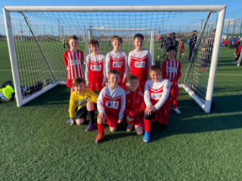  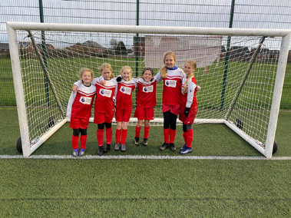 | The year 5/6 Football team this year has taken part in the school football league where we have won every game. They have also managed to reach two semifinals in different competitions.  The key stage 2 Girls and Year 3/4 Football team managed to get to the semifinal in their first competitions as a team together.
Healthy Heads and Healthy Hearts  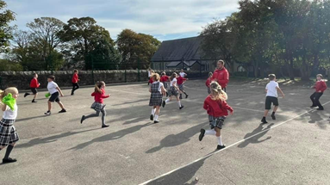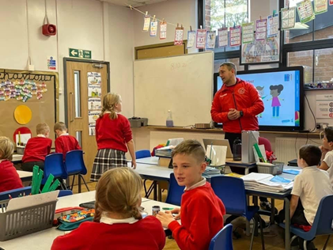 | Healthy Head will spend a half term in every class this year to help promote our school aims.  1.Have a positive relationship to physical health, activity and personal wellbeing.  2.to use physical education to develop their understanding of competition, including: fair play, sportsmanship, team work, passion and playing within the rules.  3.children to have thorough knowledge of the basic skills needed to access specific sports.  4.to use physical education to develop themselves as a whole person - mentally, personally, physically and socially.
Year 4 Dance Festival  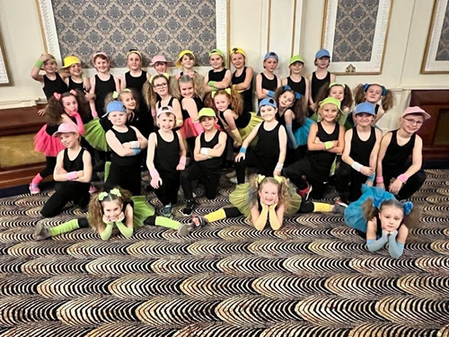 | Year 4 took part in the Dance Festival at the Winter Gardens against schools across Wyre, Fylde and Blackpool. This was a fantastic opportunity to take part in.
Extra-curricular Clubs  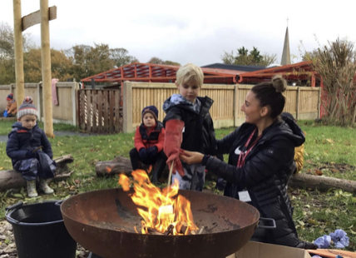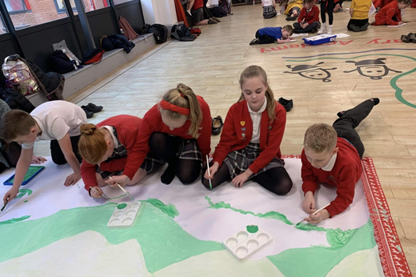 | EYFS, KS1 and KS2 have taken part in a variety of after schools clubs this year to increase physical activity participations and reinforce our school aims.
Fleetwood Town EYFS | Fleetwood Town lead sessions for Nursery and Reception every week throughout the year to reinforce fundamental skills movements.
Bike Ability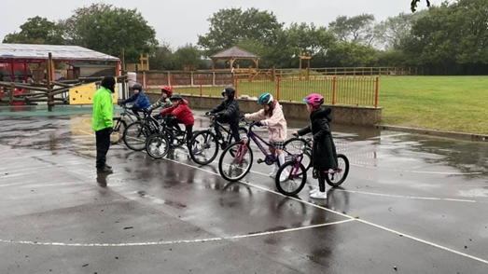 | Year 5 took part in the Bike Ability programme to make sure our children are aware of road safety when riding a bike.
Year 5 Trip (Kayaking and orienteering)  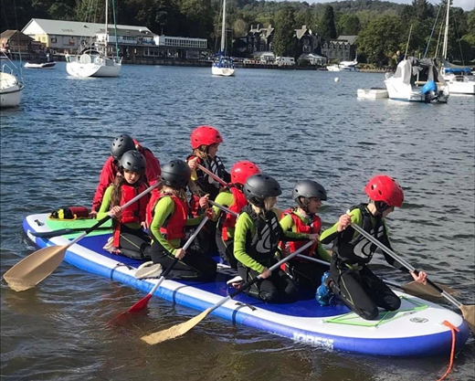 | This allows the children to experience new and different types of activities and is also a build up to Year 6 residential trip.
Sports week and Sports day (Summer 2) | Whole school opportunity for children to showcase their love, enthusiasm and enjoyment through sport taking part in a variety of activities.
Dance Sessions (Summer 1) | Inviting a local dance specialist to work with a number of classes to give children the opportunity to try new dances.

Targets

Impact of Staff Training

PE Passport App Training | To understand how to use the APP effectively using all the tools. To understand how to resolve any issues with the app. This will have a positive impact on the delivery of PE across the school as the app allows support for planning, assessment, progression and club attendance.
PE Conference at Ribby Hall | Liaise with colleagues to discuss School Games, planning, assessment and changes since Covid. From this, as a school it has changed how we are going to deliver PE across the school. This will allow all class teachers to upskill their PE knowledge and skills. Workshop on outside providers and new sporting ideas has provided inspiration for interventions and new extra curricular clubs.
Subject monitoring completed | This highlights where we are as a school regarding PE and what the strengths and areas for improvements are. This gives the opportunity to work on our specific areas for improvements and how we are going to implement positive changes to have the greatest impact.
District Sports Meeting | The meeting gave the opportunity for PE leads in our district to meet up and see where each school is at as last year's meeting was cancelled due to covid. Also, we orgainsed what sporting events are likely to happen next year. We organised competitive and friendly inclusive games to allow all children to take part in.
Monitoring Feedback with AR | This feedback meeting allowed HH to share the strengths and areas for improvements of PE for our school. It highlighted what as a school we are doing well and need to maintain. Also, this clearly showed what needs to be improved and how we are now going to improve these specific areas for the greatest impact for our children. Feedback to be given to all staff the week commencing the 29th November.
PE Clinic | During our Monday meeting in Spring 1, subject lead will deliver a CPD session on the PE Passport app and how to use it correctly and implement the features effectively. This will also be the opportunity to ask any questions or queries.
CPD Twilight | At the end of Spring 1, the Lancashire Physical Education lead will come in and deliver a twilight session to upskill teachers knowledge and skills.

Assessment / Measuring Impact

Ongoing assessment and review is fundamental to everyday teaching at Hambleton Academy. Teachers are constantly making judgements with regards to attainment in lessons to inform planning and to ensure differentiation. As such, verbal feedback within the lesson is crucial in ensuring key skills are taught and assessed for individual children. Attainment is reported termly via data captures stating whether children are working towards the expected standard, working at age related expectations or working at greater depth. From this data, we can adapt teaching focuses to ensure key skills are being addressed and promoted adequately. Parents are informed of their child’s attainment and effort on a termly basis through Parents’ Evenings and end of Year Reports. Learning is assessed against core tasks at the end of each unit these can be accessed by staff using the PE Passport App) and are recorded on the PE Passport tracker. EYFS has its own assessment as part of the Early Years Profile.
Teachers make assessments during each lesson of the skills of the class. These are then used to inform the next lesson and teachers use STEP to differentiate the lessons to meet the needs of the class. Teachers can look on the PE Passport APP to see how children performed in the previous class and be prepared to pitch the lessons at the right level and have some knowledge about which children to support and which to stretch. The PE Passport APP supports staff seeking ways to engage both exceeding children and children needing support during lessons, allowing children to be suitably challenged and achieve goals set in lessons

Future Targets

● To monitor participation
● To promote and to encourage a daily mile.
● Increase spend on playground equipment to then train team leaders for activities.
● To continue to encourage children to try new sporting experiences
● To continue to promote active bodies, lifestyles and minds.

Harry Hesketh - March 2022

