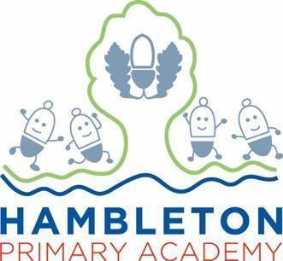

Subject Leader RE Policy / Report

Whole School Curriculum Intent

At Hambleton Primary Academy we work together to ensure all our children achieve academic success whilst remaining healthy, happy and emotionally aware young people ready to move to the next stage of their education.

Subject Intent
At Hambleton Primary Academy, our intent is that the teaching of RE provides opportunities to develop children’s knowledge not only of Christianity but also of other world religions and we reflect on the challenging questions that it provokes. We aim to help the children learn from religions as well as about religions.

Subject Specific Aims

RE at Hambleton Primary Academy aims to ensure that all children;
- Engagement: Reflect on their own experiences, whether that includes religion or not
- Investigation: Children to gain knowledge and factual information of the 6 religions
- Evaluation: Children to evaluate what they have learnt
- Expression: To express their own beliefs and feelings towards the religion

Progression of knowledge and skills

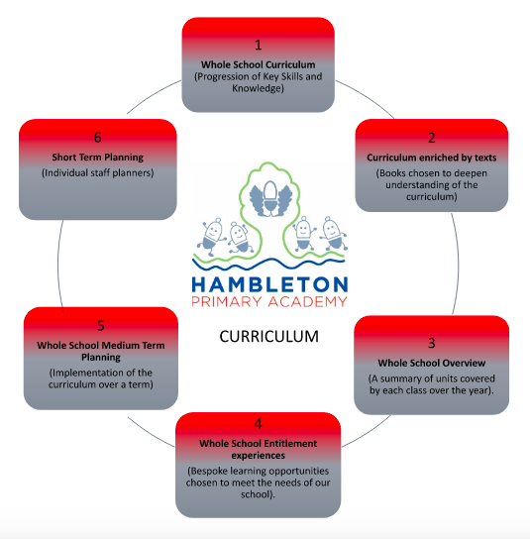

RE curriculum

Subject Implementation
Hambleton Primary Academy seeks to provide an all-round education for children in a bright, stimulating and fun atmosphere. At Hambleton, we aim to deliver an RE curriculum, which enables children to become confident, creative and independent learners through a wealth of hands on, real-life experiences both inside and outside of school. RE at Hambleton is taught through an enquiry based model with the belief that children’s critical thinking skills can be developed, their motivation to learn increased, and their knowledge and understanding of, and empathy with people and their beliefs, religious or otherwise, will be enhanced. This approach takes very seriously the philosophy that children are free to make their own choices and decisions concerning religion and belief. In this approach, all children are exposed to some higher-level thinking questions and problem-solving as well as having the opportunity to collaborate and develop a growth mind-set through working with their peers.

Fundamental Great British Values
At Hambleton, we understand our responsibility in preparing children for their next stage of education and for the opportunities, responsibilities and experiences of later life, laying the foundations so that they can take their place successfully in modern British society. We understand how this subject has an underpinning link to British values. The spiritual, moral, social and cultural development of each child is central to everything that we do as a school.
The teaching of British Values applies directly to topics covered in the RE curriculum and works alongside our PSHE curriculum. We promote a respect for and understanding of different faiths, cultures and lifestyles. The spiritual, moral, social and cultural development of each child is central to everything that we do as a school and central to our school curriculum “drivers” of diversity, teamwork and resilience, community and environment. This is evidenced through our inclusive teaching and learning, our inclusive environment and through the many opportunities provided for our children to understand democracy, law, liberty, mutual respect and tolerance.
Planning
RE is taught using our Discovery RE syllabus which is adapted and is personalised to meet the needs of our children. The syllabus comprises of detailed medium-term planning covering Buddhism, Christianity, Hinduism, Islam, Judaism and Sikhism with reference to Humanism. As well as expectations for each enquiry, Discovery RE includes end of key stage age-related expectations for KS1, lower KS2 and upper KS2. In addition, EYFS has differentiated foundation stage 1 for Nursery and Foundation stage 2 for Reception linking to the EYFS curriculum. The new scheme also offers a better format to assess and evaluate the impact of teaching RE.

Collecting Evidence
Standards in RE are monitored by the subject leader. Data about children’s attainment and progress in collected throughout the academic year. We have decided to move away from individual RE books, and have introduced a class floorbook and class RE learning journey to evidence the children’s learning in RE. We hope this approach promotes a more hands on and practical approach to RE. The RE floorbook evidences children experiences of the enquiry through pupil voice, role play, Art/DT, discovering real artifacts, visits to local places of worship. The impact of this is that the children are getting hands-on lessons with less emphasis on an end product or formal piece of writing. We believe that in RE the pupil’s voice is our main source of evidence. This has had a huge impact on the children who may be less confident in writing, and gives them a chance to verbalise their ideas, beliefs and understanding. We have highlighted the need for our lessons to meet the needs of all children and have taken into account the COEL and thinking about how every child learns. We continue to provide opportunities for writing, however have opened up lessons to be as practical and hands-on as we can. Governors continue to be well informed of standards through regular Governor Meetings. The school governors work in teams to support all subject leaders in their role. The RE subject leader is supported as part of the Humanities team, along with Geography and History.

COVID-19 Impact
During the lockdowns of 2020 and 2021 all children received comprehensive support for home learning by all members of staff across the curriculum. RE was included as part of the topic work throughout the period. Evidence of activities sent home can be accessed via Google Classroom. We know that children may have missed some areas of their topics during the periods of home learning. By beginning each new unit by finding out what the children already know, teachers will be able to fill gaps in learning and plan accordingly.

Able, Gifted and Talented Pupils
The key skills and knowledge needed for each year group are stated in the end of year group expectations and pupils are assessed against these. Pupils working at a greater depth in RE will be able to discuss and show understanding of different beliefs and link them to shared human values in today’s society. As the RE curriculum can be taught in a variety of ways, including dance, art and investigation as well as writing, it is also possible to challenge pupils who show aptitude in different areas of the curriculum. Pupils working at greater depth in other relevant curriculum areas such as art or PE are given opportunities to use their skills in RE

SEND and PP Pupils:
At our school we teach RE to all children, whatever their ability. It is part of the school curriculum policy to provide a broad and balanced education to all children. We provide learning opportunities that are matched to the needs of children with learning difficulties. Work in RE takes into account the targets set for individual children in their Personal Plans (PPs).
During RE discussions, questions are tailored to match the needs of target children. TA’s are trained to work specifically with these target children to give them opportunities to take part in group and independent work as well as respond to discussions during carpet time.

Enrichment opportunities
The RE curriculum is widely enriched through visual and high-quality practical resources, trips and visits including:
Enrichment Activity Examples | Further Information
Visits to the local Church
Nativity Performances to parents/guardians
Celebrating Harvest and giving to Street Life
Visits to places of worship
Diwali Day (Early Years)

Targets

To ensure floorbooks are being used effectively and consistently to collect evidence
To introduce discussions points to support evidence of children’s understanding and highlight differentiation

Assessment / Measuring Impact
Ongoing assessment and review is fundamental to everyday teaching at Hambleton Academy. Teachers are constantly making judgements with regards to attainment in lessons to inform planning and to ensure differentiation. Same day intervention and pre-learning are crucial in ensuring children are prepared to learn; misconceptions quickly identified and rectified. We start topic with a key question which is linked to a religion. These change every half term. The enquiry is based on the children’s initial understanding of the key question – this is often evidenced with pupil voice. At the end of each unit of work children are assessed on their understanding of the same key questions and opportunities are provided to support the children on their reflection of the key question. It’s through this time of reflection, we instil skills such as empathy and support children with their own beliefs. Teachers assess children using the Discovery assessment sheet using the evidence they have collected over the weeks.

Future Targets
- To arrange for visits from people of different faiths
- To build up a collection of real life artefacts which can be used to support teaching and lessons
- To work with other FCAT schools who also follow Discovery RE to look at how this has impacted their school

Georgina Luke - September 2022

