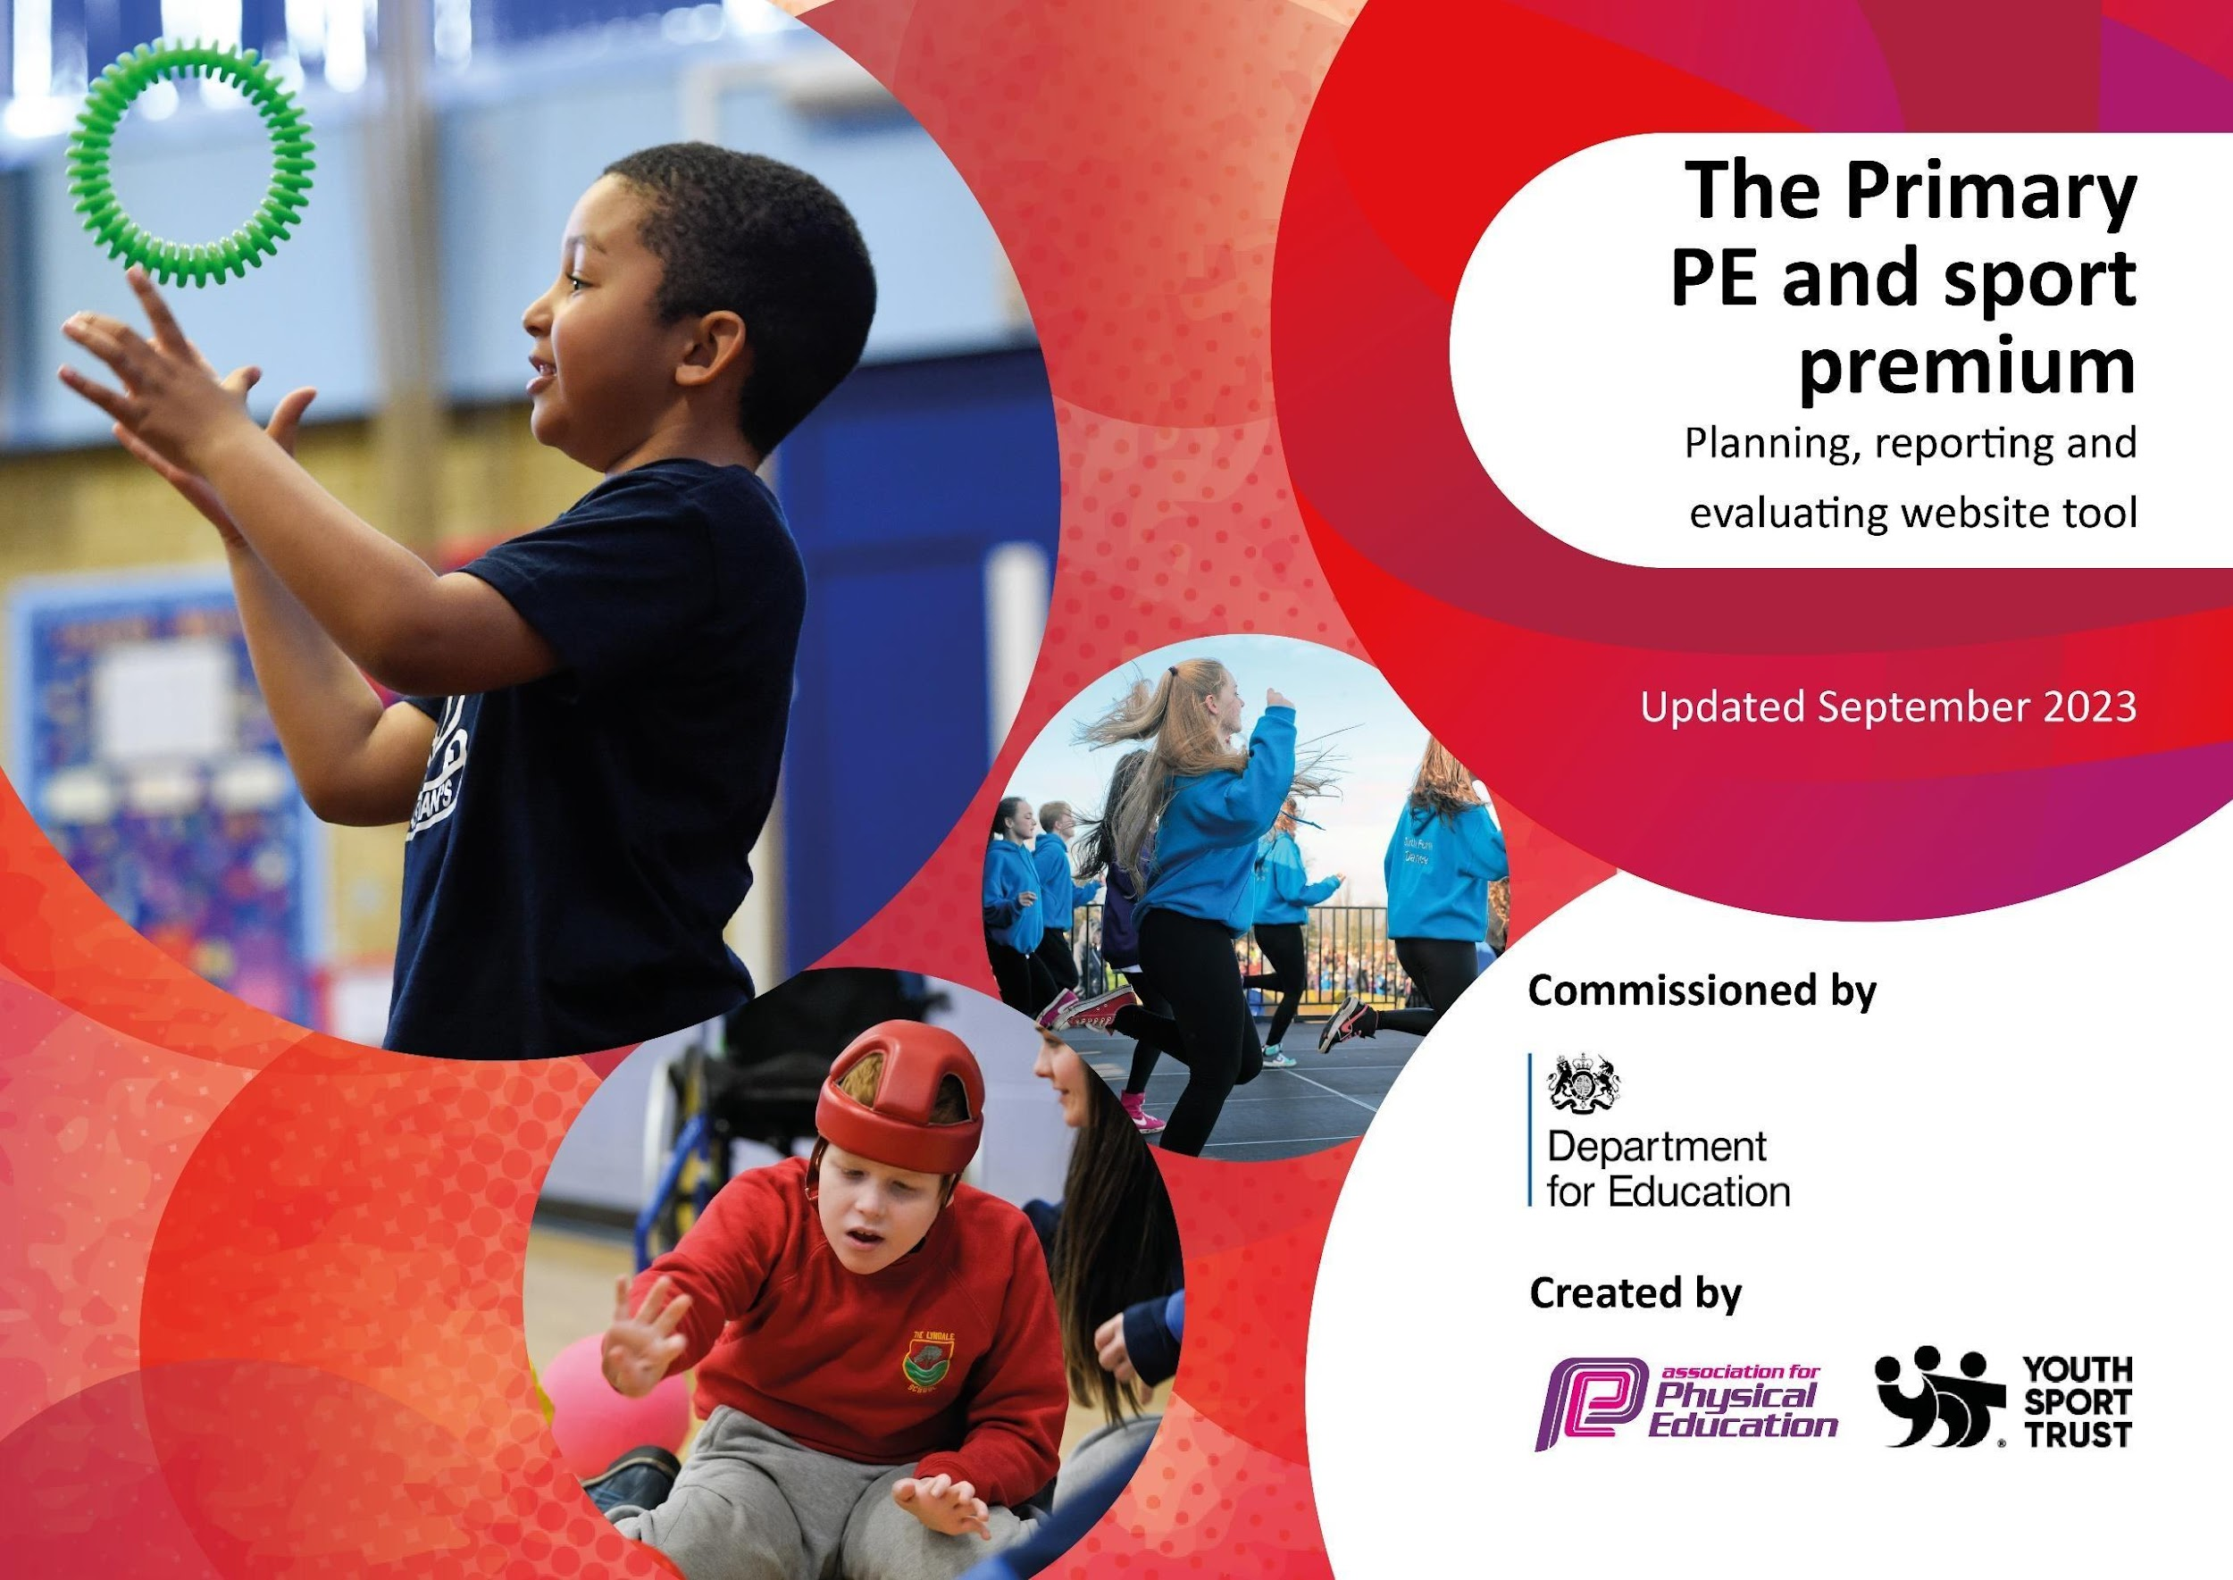
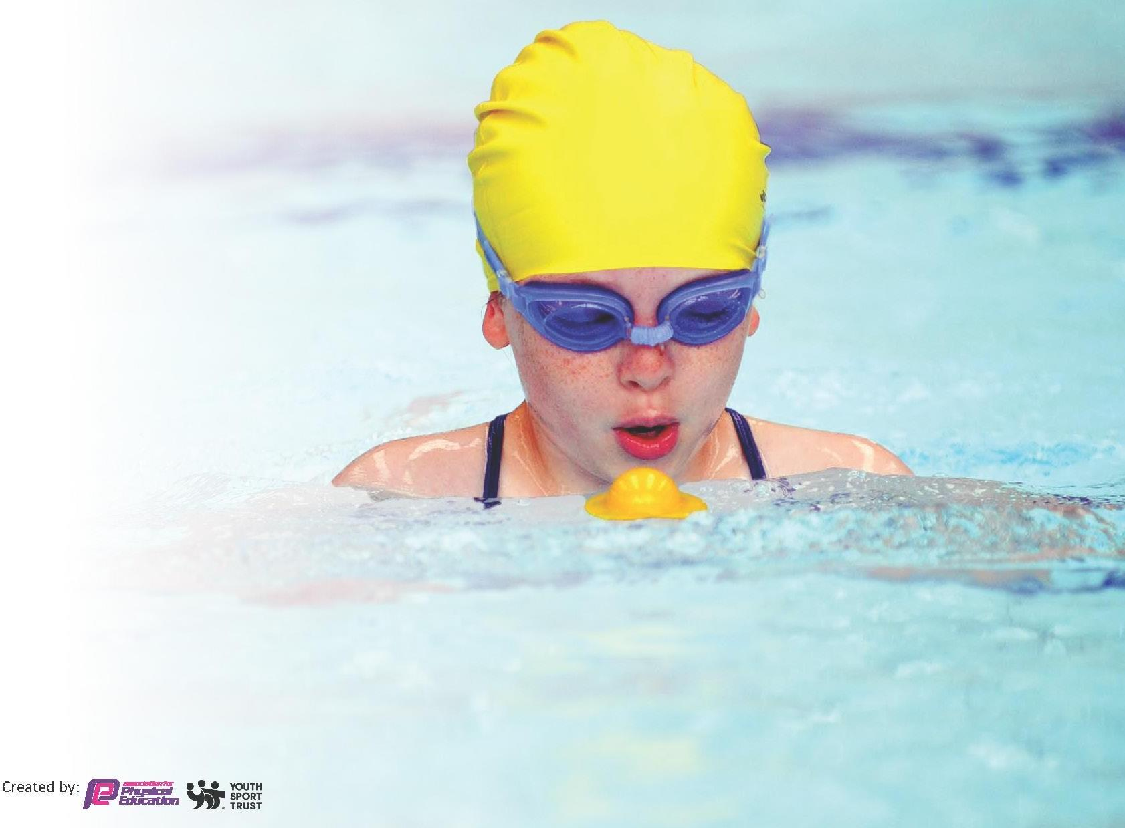
This template can be used for multiple purposes:
- It enables schools to effectively plan their use of the Primary PE and sport premium
- It helps schools to meet the requirements (as set out in guidance) to publish information on their Primary PE and sport premium
- It will be an effective document to support Ofsted inspections enabling schools to evidence progress in Physical Education (PE) and evidence swimming attainment, which forms part of the PE National Curriculum. We would recommend schools consider
the Intent, Implementation and Impact of any spend, as examined within the Education Inspection Framework.

It is important that your grant is used effectively and based on school need.

Schools must use the funding to make additional and sustainable
improvements to the quality of the PE, School Sport and Physical Activity (PESSPA)
they offer. This means that you should use the Primary PE and sport premium to:

- Build capacity and capability within the school to ensure that improvements made now will benefit pupils joining the school in future years
- Develop or add to the PESSPA activities that your school already offers.

The Primary PE and sport premium should not be used to fund capital spend projects; the school’s core budget should fund these. Further detail on capital expenditure can be found in the updated Primary PE and sport premium guidance.

The Primary PE and sport premium guidance, outlines 5 key priorities that funding should be used towards. It is not
Created by:
necessary that spending has to meet all the key priorities, you should select the priorities that you aim to use any funding towards.

Although completing this template is not a requirement for schools, schools are required to publish details of how they spend this funding. Schools must also outline what the impact this funding has had on pupils’ PE and sport participation and attainment and how any spending will be sustainable in the future. All funding must be spent by 31st July 2024.

The Department for Education has worked closely with the Association for Physical Education (afPE) and the Youth Sport Trust (YST) to develop this template and encourages schools to use it. This template is an effective way of meeting the reporting requirements of the Primary PE and sport premium.

Review of last year’s spend and key achievements (2023/2024)
We recommend you start by reflecting on the impact of current provision and reviewing your previous spend.

Activity/Action | Impact | Comments
Review of whole school curriculum mapping  Dance specialist teaching Year 4 for 10 weeks prior to the dance festival at the Winter gardens and providing CPD for teacher and support teacher.  Dance teacher teaching year 5 for 10 weeks prior to the dance competition at Blackpool ballroom and providing CPD for class teacher and teaching assistant.  \  Success in sporting competitions including football and athletics.  The PE Passport app is now used to plan, deliver and assess curricular PE and is being used to monitor physical activity and extra-curricular activity too.  Development of opal play has ensured that there is effective storage and equipment in place. Playground leaders have been trained in how to use this and how to promote physical activity during break times.  School Sports Days- to ensure that all children play competitively in sports and school games we organised our own sports day for the whole school.  Equipment and Resources- Having access to new equipment has increased the opportunities for our children to develop their fundamental skills.  Extra curricular opportunities  Staff CPD and training- targeted support for our ECT and RQT teachers. | A broad, balanced and challenging curriculum is delivered through high quality physical education.  Technical expertise developing an understanding on how to teach coordination and performance at a competitive level.  Motivation, self discipline and teamwork developed over the 10 weeks- specifically in the target class (year 4) who were reluctant performers coming into the dance training.  CPD- dance specialist provided opportunities for teachers to both plan dance lessons and feedback from each session. In turn this impacted on the confidence of the teacher who now has the tools and confidence needed to plan and teach their own lessons.  Increased participation in dance with an interest from pupils to perform more dance routines during break and lunch time increasing physical activity across school.  Positive impact on the community- dance festival was received well by the school community and was a great way of showcasing both our children and the commitment that they have to the arts.  By entering competitions and through celebrating success there continues to be high popularity in the extra curricular activities that we hold in school. Children are keen to be part of a team and to work hard at physical activity in order to represent their school.  Regular participation in training continues to promote physical fitness and well being across school.  There is a sense of community spirit across school when celebrating our successes at competitions.  A broad, balanced and challenging curriculum is delivered through high quality physical education. Colleagues share good practice and have access to high quality CPD.  All pupils take part in competitive sport through intra-school competitions and where and when possible through a broad range of inter-school opportunities.  Physical activity across all year groups meets the 30 mins each day requirement through the introductions of playground leaders.  Continued to raise the profile of school within the community. There were a large number of spectators on the day.  More parents have supported events as a result and offered to attend future events.  All children have competed in school games from Nursery to Year 6.  82% of our Year 2 children have left KS1 one mastering their fundamental movement skills  Increased participation in extra curricular activities including SEND and PP.  Increased confidence in the teaching of PE where skills have been transferred across key stages and shared and modelled with other staff. | £255 – Cardinal Allen High School including annual PE conference (Wyre Sports Partnership collaboration)  £518 - Continue with the next sports premium funding as a new teacher will be teaching the year four class- new to KS2.    £323.75 - Using lunchtimes to further practise for these competitions helped to develop children’s confidence and resilience in the game. Children spectating have also been inspired to join and support the team- attending extra curricular activities through the week.  £490 - Costing for entrance into competitions.  £699 - Access onto PE passport assessment and planning as well as further staff CPD.  £4482 - Staff training programme on how to use a continuous provision style approach during break times. Training can now be integrated into ‘the Hambleton Way’.  £532.20 - Awards including trophies and medals. Food stands for spectators.  £2981.43 - Specific focus on the development of equipment for fundamental movement skills.  £6431 - Fleetwood town SSP  £1168.37 - Wyre SSP support  Total £17880

Key priorities and Planning 2024/2025
This planning template will allow schools to accurately plan their spending.

Action – what are you planning to do | Who does this action impact? | Key indicator to meet | Impacts and how sustainability will be achieved? | Cost linked to the action
Continue with PE passport to support new teachers in developing small step planning including the implementation of the fundamental movement skills in KS1 and EY.  Reorganise the PE equipment and storage to ensure easier access.  To encourage girls to participate in physical activity in KS2. Develop extra curricular activities based around children’s interests including dance, cheerleading and football.  To use physical activity as a means of self regulation targeting Year 5 boys. Include the introduction of the active mile and boxing.  To use physical activity to develop team work and resilience (school driver) across school.  Specialised boxing training sessions to target reluctant learners- Year 5.  Teachers have changed key stages this year and will benefit from some CPD with an SSP.  Monitor the impact of the SSP visits as part of the monitoring cycle across school.  Increase inter school activities.  Find out the inter school competition calendar for the academic year (sports cluster). Align curricular and extra curricular planning to sync with these opportunities where possible and so provide an end point for learning.  Take part in a broad a range of competitions as possible.  Increase teacher CPD in orienteering and how OAA can be implemented across the physical education curriculum. In turn this will continue to build on the work that we are doing on building up teamwork and resilience across the school.  To increase the amount of extra curricular activities that we have available opening physical activity up to children who do not usually access sport outside of school.  Targeted staff to work alongside specialist coaches in delivering the extra curricular. Ideas can be used to develop children’s play at break times particularly lunch time.  Increase physical activity, teamwork and resilience skills at playtime in order to decrease the amount of behavioral reports at break times.  To develop the role of house captains who will work as playground leaders during playtimes.  Introduce podcasters, news reporters and influencers to the year six job roles. All of whom will be responsible for promoting the roles of the house captains and celebrating best practice at lunchtimes.  Attend training PE conference | All teaching and support staff with planning and delivering activities. The plans give teachers some guidelines and relevant CPD notes which will support them in their small step planning as well as how to adapt their lessons in line with the STEP approach.  Teachers, children and sports leaders will have easier access to the equipment making it easier to set up and put away during lessons. There will also be a wider range of throwing and catching equipment which will support children in developing their fundamental movement skills. Various size balls of different shapes are required to be able to do this. Gymnastics equipment is also outdated and needs replacing- currently unsafe to use.  Girls (in particular Y5/6) are becoming reluctant to take part in physical activity in and around school. By sticking with the children’s interest in dance we can encourage more children to take part in physical activity during lunch and break times.  Teacher and support teacher in year five- providing them with tools to help to regulate the class especially those with targeted needs.  Year 5 class- providing them with an outlet for controlling negative behaviour whilst engaging in physical activity  Whole school- Another tool in the toolkit for teachers to use to help to regulate classes and to provide opportunities for brain breaks.  Teachers teaching PE- Staff will have a better understanding of how to embed the PE passport within their lessons. Teachers will have more opportunity to be creative with their planning and to use the STEP approach to challenge and support target children.  All stake holders (children staff) by observing and participating in competitive sport.  Increase in school profile within the local community.  Teachers to be upskilled and to feel more confident in the implementation of OAA and what that should look like in PE lessons. Teachers to use these skills in other subject areas e.g. Geography to ensure that physical activity is taking place at other points of the day.  Children to use their teamwork and resilience skills when working in small groups during play time.  Targeted children who do not have the same opportunities to partake in sporting clubs outside of school. Extra curricular activities will provide children with the chance to discover new interests and take part in team game activities.  Targeted support staff working alongside coaches to develop CPD on the delivery of fundamental movement skills of which can be implemented at break times.  Children to respond better when working in a team. Listening and directing each other through the development of playground leaders.  Young leaders to be promoted and celebrated across school and to become responsible for the running of physical activity at break times.  All teaching and support staff by receiving cascaded information from PE Coordinator  PE coordinator – through collaborating and sharing findings  Begin planning for the best value from September 2025 | Key indicator 1 – Increased support staff confidence, knowledge and skills in teaching PE and sport  Key indicator 2 -The engagement of all pupils in regular physical activity – the Chief Medical Officer guidelines recommend that all children and young people aged 5 to 18 engage in at least 60 minutes of physical activity per day, of which 30 minutes should be in school.  Key indicator 4: Broader experience of a range of sports and activities offered to all pupils.  Key indicator 1 – Increased support staff confidence, knowledge and skills in teaching PE and sport  Key indicator 2- The engagement of all pupils in regular physical activity.  Key indicator 2- The engagement of all pupils in regular physical activity.  Key indicator 3- Raising the profile of sport across the school to support school improvement.  Key indicator 1 – Increased support staff confidence, knowledge and skills in teaching PE and sport  Key indicator 4- Broader experience of a range of sports and activities offered to all pupils.  Key indicator 2- The engagement of all pupils in regular physical activity.  Key indicator 3- Raising the profile of sport across the school to support school improvement.  Key indicator 5- Increased participation in competitive sport.  Key indicator 4- Broader experience of a range of sports and activities offered to all pupils.  Key indicator 1 – Increased support staff confidence, knowledge and skills in teaching PE and sport  Key indicator 4- Broader experience of a range of sports and activities offered to all pupils.  Key indicator 3- Raising the profile of sport across the school to support school improvement.  Key indicator 1- Increased support staff confidence knowledge and skills in developing physical activity.  Key indicator 4- Broader experience of a range of sports and activities offered to all pupils  Key indicator 2- Increased engagement of all pupils in regular activity.  Key Indicator 1: Increased confidence, knowledge, and skills of all staff in teaching PE and sport. | Teachers and support staff teaching PE have more confidence planning the relevant next steps for their class.  The assessment of PE will continue to develop and evolve where physical evidence of children completing activities will be seen on the passport. Evidence can then be used to monitor the effectiveness of PE.  Observe equipment being used effectively when monitoring PE lessons. Share best practice during monitoring meetings so that good examples are not lost.  Cheerleading club to be held at lunchtime which will eventually be run and lead by the girls. Children to be provided with opportunities to perform their cheerleading in front of an audience.  Calmer classrooms with smoother transitions between subjects.  Completion of the active mile documentation.  Increased staff confidence on the discussion of self regulation and how to support pupils in undertaking extra activities inside of school.  PE lead to notice an increase in staff knowledge and confidence when teaching PE. Lessons will no longer follow a set structure from the PE passport and instead will be taught using an assessment informed approach.  New fundamental movement assessment sheet to be completed in EY and KS1.  Increase in the amount of children attending extra curricular activities.  An increased interest in physical activity outside of school.  Facilities have improved as more competition is taking place.  Physical activity forming part of other lessons including Geography and Science- observe through monitoring cycle.  Greater emphasis on resilience and teamwork across school.  Increased percentage of children attending extra curricular particularly targeted at children who do not access physical activity outside of school.  An increase in the amount of children taking part in physical activity at break times.  A democracy day has already taken place which provided time for the whole school to choose the allocated roles. Roles have been delegated and coaches are in the process of training the children on how to become successful playground leaders. More physical activity can now be seen at break times however leadership continues to be developed.  Evaluation of current sports premium expenditure and actions moving forward. Lease with the rest of the school team using a tweak, ditch, keep approach. | PE Passport including Gymnastics add on £900  £2285.05- New equipment and storage  Specialist dance coach- £647.50  Active mile staff and child CPD- £250  Cost of boxing equipment TBC  School Sports Partner to work alongside target members of staff. Peer teaching together and feeding back from lessons. £1800  £450- Local WYRE SSP  £100- Poulton and District sports association including hire of Poolfoot farm for football rallies.  £430- trained SSP to provide sessions with the children as well as staff CPD.  £3750- Wyre SSP and Fleetwood town providing assistance with the delivery of further extra curricular activities for the duration of the year.  £1080- Running extra curricular activities at lunch time for target children (children who do not access physical activity outside of school).  £2160- SSP to coach children on how to lead and develop playground games.  £1080- Playground leader specific work  £1080- Running extra curricular activities at lunch time for target children (children who do not access physical activity outside of school).  £220-Attendance cost for annual conference

Key achievements 2024-2025
This template will be completed at the end of each term and finalised by the end of the academic year and will showcase the key achievements schools have made with their Primary PE and sport premium spending.

Activity/Action | Impact | Comments
Summer Term- 2025  Variety of clubs- Supported by FT coaches  Lunchtime provision continued  Nursery and Reception PE continued  FT Darts activity for Maths day  Line painting for sports day  Competitions  Rowing event- Sports week  Joanna teaching the houses dances for sports day  Cheerleading club- Impact  Playground equipment  Spring Term- 2025  House T-shirts  New Football and Netball kits  Joanna- Dancing with Year 1  Lee Callwallader- Staff development  Fleetwood Town- Nursery and Reception PE sessions Wednesday 9-10:30  Fleetwood Town- Lunchtime support for Year 6 activities with Sports Captains  Support with after school clubs- Netball, Multi-skills  Autumn term- 2024  PE passport- As a school we have renewed our PE passport tool therefore, staff can use this to support their planning, assessment and teaching within PE.  Gymnastics Bolt on  New PE Equipment to support PE lessons, playtimes, after school clubs  Dance teacher- Joanna came in and taught the year 4 class weekly a dance routine in preparation for the dance festival at the Winter Gardens.  Cheerleading- In correspondence with the Dance Festival Joanna also worked with a group of girls at lunchtime putting together a cheerleading routine.  Girls football- After school club to boost girls attendance at clubs. Working towards girls football tournaments and festivals.  Active mile- Encouraging the children to take part in the active mile to allow brain breaks for them and their teachers.  Yoga- Wellbeing  Playtime provision with FT  Variety of clubs/ Clubs supported by FT- football, netball  Broad range of competitions for children to work towards. | Having a variety of clubs has enabled us to have more children attending, creating more interest across the board. We have been able to open clubs up from Reception to year 6 and have a variety of clubs not always sport related.  Lunchtime provision has meant that the children in year 6 have been supported in creating activities and games for the children to take part in at lunchtimes. This has also prevented some behavioural issues at lunch as the children have been entertained and kept busy with activities.  The children in Nursery and Reception have thoroughly enjoyed taking part in PE sessions with the coaches from FT. They have provided them with a variety of PE sessions covering fundamental movements which is a key focus in EYFS.  FT came in for our Maths day where they provided us with a dart board and worked with children from all year groups Reception-Year 6 completing maths activities as part of our Maths themed day. It supported the children and meant that Maths was able to be taught and done in a different/fun way.  Having the field rolled meant it was safer and easier to run on for our events such as sports day. We also had lines painted to help the children and guide them whilst running/competing in their races, giving them better opportunities.  Continued to enter into lots of competitions- Cricket, Tennis, Football, Rounders, Tag Rugby, Inclusion. Build on teamwork and resilience.  We invited Lee Callwallader into school and he provided us with 5 rowing machines. We then planned an entire day in sports week where all the children from Year 3-Year 6 competed in rowing. They each had a set amount of time to row as far as they possibly could. The children thoroughly enjoyed this event and it really encouraged them to work as a team and support one another.  We asked Joanna if she could teach each of the houses a different dance routine in which they would perform on sports day on the field in front of their families. We saw some of the older KS2 children helping and supporting some of the younger ones which was wonderful to see. The parents also enjoyed the day and said it was one of the best sports day that they had attended,  The children that took part in the cheerleading club in Autumn term have continued to perform and organise dances between themselves throughout the year. They even made a performance which they performed on the field at sports day.  We used the rest of our Sports premium money to buy lots of new playground equipment for the children to be kept busy and happy at playtimes and lunchtimes.  All the staff now have coloured t-shirts to wear during PE, sports day and any other sport related events to represent which house they are in.  We found the children were struggling with the kits that we had already, some were finding them extremely tight and uncomfortable. We knew this would affect their confidence and that we needed our children to look presentable and represent our school by looking smart.  Having Joanna come in to teach the year ones a dance routine in preparation for the dance festival at the Marine hall meant the children were offered professional delivery and more opportunities in their experience.  Lee came in to support a variety of members of staff within their teaching of PE. This has allowed them to grow in confidence and upskill themselves in regards to teaching the various lessons found on PE passport.  We decided to continue with the support from Fleetwood town each week in our Nursery and Reception PE lessons. This has been extremely beneficial for our children as they enjoy the variety of activities and games that the coaches play with them. It also is helpful at times to have that change of face and not be continuously taught by the same person all day everyday. The children listen and respond well during these lessons.  We have a coach come to our school three lunchtimes a week- Monday, Wednesday and Friday. They work alongside our House captains and guide/support them into planning fun and inviting activities for all the children to take part in during lunchtime. This has enabled the house captains to have support in their roles especially if they are struggling to come up with ideas on their own or are unsure on how to set something up. This has in ways prevented children from being silly, arguing, fall outs and injuries.  Fleetwood Town have also sent a number of coaches each week to work alongside our staff to run a variety of after school clubs for children all the way from Reception to Year 6. This has been extremely helpful for our staff as not everyone knows how to play specific sports or feels confident enough to prepare the children and get them ready for competitions such as Football and Netball.  The use of PE Passport is an important tool for our school to use. It is designed to support teachers throughout their PE lessons and provide a wide range of resources, lesson plans, assessment tools and videos. In aid of helping teachers deliver engaging PE lessons. This resource follows the curriculum and is in alignment with national curriculum standards. Key features of the tool is video evidence, allowing staff to upload video evidence into each of the childrens’ specific files which will stay with them throughout school. The videos can track progress individually or in groups and helps inform future planning.  Bolting on Gymnastics through our school PE passport has enabled staff to access a variety of resources, videos, and plans that will support them in their teaching of it. Gymnastics is often a weaker area for teaching as people struggle with knowing how to teach it effectively and safely, especially with classes of 30+ children. Therefore, with some extra support and guidance this will have a positive impact on the ways in which Gymnastics is taught.  During the Summer holidays AR and LH sorted the PE cupboards in which we binned broken equipment, tidied and labelled the cupboards and then ordered lots of new resources such as shuttlecocks, rugby balls, cones and other sporting equipment. Everything has now been stored in its own place (Indoor equipment in the cupboards, outdoor/playground equipment in the outdoor storage). Staff on the Inset day then organised the equipment into the opal play shed/den with labels therefore, it is organised and ready for the new academic year.  Joanna came into school weekly for a number of weeks leading up to the dance festival. Joanna would come in from 12:30-3 every Thursday and would work with a group of girls at lunchtime putting together a cheerleading routine. This really helped some girls with their confidence and for them to come out of their shells a bit more. The children then put on a performance in front of school for when Miss Green left.  The year 4 children then received 2 hours of teaching a week preparing a routine for the dance festival which they then performed at the ‘Winter Gardens’. The children performed " I put a spell on you’ from Hocus Pocus and both the girls and boys thoroughly enjoyed this experience and excelled, performing well on stage.  We want to encourage the children to attend extra-curricular activities, therefore, girls football is a club that some of them will show interest in and will participate in. We have paid for FT to send a coach for these sessions to help support the girls, giving them better opportunities and training.  We have been supported by Lee Callwallader on a couple of occasions where he has come in to work with a different class each time to explain the Active mile and show them how it works. The children have to run around the playground 7.5 times which is equivalent to a mile. Each lap round they have to place a counter in the bucket, the teacher will then add up how many miles they have completed. This is beneficial for both children and the class teacher as it allows the children to work on their fitness, wellbeing, resilience and working together as a class, however, it also supports teachers in their lesson if they know the children need a brain break.  As a school one of our main focuses is the wellbeing of children and staff. In school we take part in several yoga sessions throughout the year. The first one is when we return from the Summer break, allowing the children to settle back in and giving the opportunity for staff to ease their class back into the school day/routine. We find this helps ease the children in especially Receptions who may be struggling with adjusting to school life.  In year 6 we have house captains who have been given the role to plan activities that children will take part in at lunchtime. This is to prevent children from just running around, being silly, causing accidents/injuries. It also gives the Year 6 children opportunities to take the lead and show that they can work together/individually. We have asked FT to come in and support the children offering them ideas and advice on what they could do at lunchtime with the rest of the school.  As a school we have around 12 clubs a term for the children to attend. These clubs vary between KS1 and KS2. We have coaches from FT who support our sport clubs such as Netball, Football, Multi-skills, Frisbee, darts etc. This helps support the children in preparation for upcoming competitions and festivals, offering them a better opportunity as they are being coached by professionals.  We put forward our school for a variety of competitions and festivals. So far the school has taken part in the dance festival, Netball competitions, Tag ruby, Football, Ten pin bowling, Athletics. The competitions have encouraged more children to attend extra-curricular activities as they know there is something to work towards. | FT invoice- Academic year  FT invoice- Academic year  FT invoice- Academic year  £75  £487  Wyre and Fylde invoice  Wyre and Fylde invoice  £200  £1135  £200  £460  £480  Spring term invoice  £1200  Fleetwood Town academic year invoice  Fleetwood Town academic year invoice  £700 for yearly renewal of PE passport  £200 bolt on for Gymnastics.  £2285.05 for new equipment  £647.50 for Dance and Cheerleading  This cost is in Fleetwood Towns overall cost for clubs and lunchtime provision.  £7405  Support from Wyre and Fylde (Lee Callwallader) £1310  £282 for a day of yoga sessions with each year group  £7405- Cost for club support, Lunchtime provision  £7405- Cost for club support, Lunchtime provision

Swimming Data- To be completed July 2025
Meeting National Curriculum requirements for swimming and water safety.
Priority should always be given to ensuring that pupils can perform safe self-rescue even if they do not fully meet the first two requirements of the National Curriculum programme of study

Question | Stats: | Further context  Relative to local challenges
What percentage of your current Year 6 cohort can swim competently, confidently and proficiently over a distance of at least 25 metres? | 100% completed Stage 5 including (6.1, 6.2, 6.3, 6.5, 6.6, 6.7, 6.8)  50% further completed Stage 8. | In comparison to last year the percentage of swimmers has improved from 91% to 100%. The children are confident within their swimming and can swim over 25 metres. We will continue to work with our chosen swimming provider for the next cohort of children in 2025-2026.
What percentage of your current Year 6 cohort can use a range of strokes effectively [for example, front crawl, backstroke, and breaststroke]? | 100% completed Stage 5 including (6.1, 6.2, 6.3, 6.5, 6.6, 6.7, 6.8)  50% further completed Stage 8. | 100% of our current Year 6 cohort (attended swimming sessions last year) can use a range of strokes effectively. We will continue to use this swimming provider.

What percentage of your current Year 6 cohort are able to perform safe self-rescue in different water-based situations? | 100% completed Stage 5 including (6.1, 6.2, 6.3, 6.5, 6.6, 6.7, 6.8)  50% further completed Stage 8. | Due to the quality coaching/teaching from our swimming provider and the support from parents 100% of all pupils can now perform and articulate what they would do for safe self-rescue for water-based situations.
If your schools swimming data is below national expectation, you can choose to use the Primary PE and sport premium to provide additional top-up sessions for those pupils that did not meet National Curriculum requirements after the completion of core lessons. Have you done this? | N/A
Have you provided CPD to improve the knowledge and confidence of staff to be able to teach swimming and water safety? | Yes - staff attend sessions to observe and work with the swim leads.

Signed off by:

Head Teacher:
Subject Leader or the individual responsible for the Primary PE and sport premium: | Annalise Riches & Lucy Hennessey
Governor:
Date: | Thursday 10th July 2025

