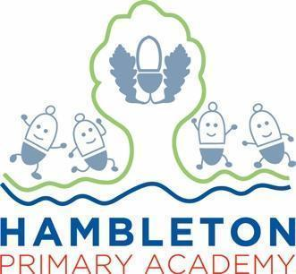

Subject Leader English Policy / Report

Whole School Curriculum Intent

At Hambleton Primary Academy we work together to ensure all our children achieve academic success whilst remaining healthy, happy and emotionally aware young people ready to move to the next stage of their education.

Subject Intent
In English at Hambleton, we teach pupils to speak, read and write fluently so that they can communicate their ideas and emotions to others.

Subject Specific Aims

English at Hambleton Primary Academy aims to ensure that all children;
- are taught to read fluently and with good understanding
- develop the habit of reading widely and often, for both pleasure and information
- acquire a wide vocabulary, an understanding of grammar and knowledge of linguistic conventions for reading, writing and spoken language
- appreciate a rich and varied literary heritage
- write clearly, accurately and coherently, adapting their language and style in and for a range of contexts, purposes and audiences
- use discussion in order to learn; they should be able to elaborate and explain clearly their understanding and ideas
- are competent in the arts of speaking and listening, making formal presentations, demonstrating to others and participating in debate.
Progression of knowledge and skills

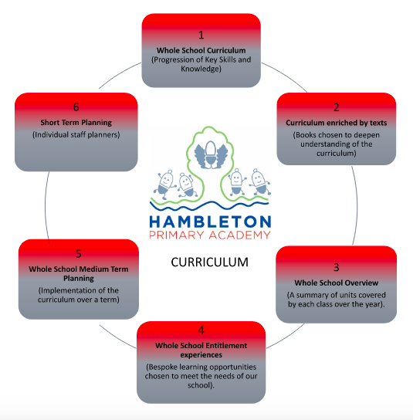

Whole School Curriculum Progression Map - Reading FINAL

Whole School Curriculum Progression Map - Writing FINAL

Subject Implementation - Writing
Hambleton Primary Academy seeks to provide an all-round education for children in a bright, stimulating and fun atmosphere. English is taught through Talk For Writing, which we have adapted and personalised to suit the needs of our children. Our curriculum is carefully planned to engage and excite all of our learners, through memorable ‘hook’ lessons, and exposure to a wide range of genres. We teach explicit skills and knowledge, genre writing and SPaG as outlined in the aims of The National Curriculum ensuring children are competent readers and writers.
High quality texts are at the core of our curriculum, and these are used to enrich our curriculum and develop an appreciation of literature and authors. We link our topics to our chosen English books for the term, allowing children to embed the cross curricular knowledge and have the opportunity for cross curricular writing to a high standard. All children are exposed to vocabulary rich texts which seek to ignite a passion for language alongside knowledge of linguistic conventions, developing their understanding of texts whilst encouraging them to develop their own writing ability, adapting their language and style to the audience and ultimately to emulate what they have read.
Subject Implementation - Phonics and Early Reading
We teach and learn using a systematic, synthetic phonics approach using the ‘Little Wandle Letters and Sounds’ scheme which has been implemented this year. Our aim is that all children will be reading fluently at an age appropriate level by Year 2. Teaching in smaller groups occurs, so teaching can be closely matched with children’s phonic knowledge through the use of constant, daily, formative assessment and informed further through half-termly summative assessments. Children who are at risk of developing gaps in their learning are swiftly identified through this rigorous assessment and tracking and appropriate, immediate interventions are planned for and delivered. As well as this, all children take home 3 books a week. One of the reading books is at the appropriate phonetic level, allowing pupils to read fluently and improve on this skill at home as well as at school. Pupils also take home a library book for pleasure.

At Hambleton, we believe it is the right of every child to experience and listen to high quality books and stories. In doing so, children hear the enjoyment and fluency of an experienced reader. This awakens them to the exciting concepts of plot, character, settings and vocabulary that are beyond their own reading and ignites a lifelong love of reading. To facilitate this, we have daily story time, where classes explore their class text. We also highly encourage our parents to make reading a priority when learning at home and to read to their children whatever their age using reading records to promote and monitor this.

Fundamental Great British Values
At Hambleton, we understand our responsibility in preparing children for their next stage of education and for the opportunities, responsibilities and experiences of later life, laying the foundations so that they can take their place successfully in modern British society. We understand how this subject has an underpinning link to British values. The spiritual, moral, social and cultural development of each child is central to everything that we do as a school. This is evidenced through our inclusive teaching and learning, our environment and through the many opportunities provided for our children to understand democracy, law, liberty, mutual respect, and tolerance. Hambleton’s staff also model this daily. Over recent years, we have ensured our curriculum is designed to ensure that children are given regular opportunities to immerse themselves in unfamiliar cultures, with new units added and texts purchased to support the development of understanding in this area. This is evident in Monday assemblies, which are centred around a book based on events in the world and expose the children to British Values and respect and tolerance of others.

Planning
Our curriculum is thoughtfully planned to engage and inspire all our learners. Our whole school curriculum and long term plans allow English to embed cross curricular learning, as certain books are chosen and taught at certain points in the year in line with what is being taught in other subjects in order to enrich our curriculum further. Therefore, pupils have the opportunity to include and embed knowledge they have acquired across the curriculum.
When planning writing, we follow Talk For Writing, yet we have adapted this to suit the needs of our pupils. There is a consistent approach in which pupils experience a ‘hook’ lesson to immerse them in the unit, then are exposed to a well written piece of writing of a certain genre with specific and appropriate SPaG points chosen by the teacher. This text also has rich vocabulary. Pupils then learn the text in KS1 with actions and pictures (text map), in KS2 they learn specific vocabulary with actions and pictures, ensuring the language, genre structure and SPaG is taught and is being embedded. This is followed by specific SPaG teaching, writing opportunities and finally the innovation and independent writing stages outlined in Pie Corbett’s Talk for Writing.
Link toT4W document:
https://docs.google.com/document/d/1HzQzOozivr-c_1jC5jxg6hi7yNUJDRu9/edit
With regards to early reading, in Phonics we follow a clear and consistent planning structure alongside the Little Wandle Letters and Sounds scheme with consistent phrases used throughout school. This avoids cognitive overload for pupils and allows them to make accelerated progress. Staff all follow the same structure with consistent phrases.
Link to Little Wandle monitoring sheet:
https://docs.google.com/document/d/1NG6inHSLPB_Qk__Zbs6Takp2PRC0znDc/edit#heading=h.gjdgxs

Collecting Evidence
At Hambleton, we are able to monitor progress within English through a range of evidence. In Early Years a floor book is regularly completed which evidences children’s learning and the language that they are using. Both Nursery and Reception upload evidence onto the EEXAT online learning journey system. KS1 and KS2 complete work in their English books each lesson to evidence their learning. On a half termly basis, we examine books and planning across all year groups and observe teaching during learning walks, ensuring that targets are being worked towards in line with our school development plan. We also collate a pupil voice through interviews. Our Governors are well informed of standards through termly Governor Meetings, where subject updates on attainment and development for Mathematics are shared, analysed and clarified.
We meet termly with the academy trust RIG and QIG groups where we discuss our evidence and share our school’s vision and action plan. Here we discuss our strengths and areas for improvement, developing new ideas to take into our own setting.

COVID-19 Impact
Due to the recent pandemic, we understand that children have missed many learning opportunities in this core subject. As part of online learning, English was being taught daily in all classes with live lessons including online reading. This allowed children to make progress, as they were still reading, writing and learning when at home. We also introduced Bug Club, which is an online reading website to allow pupils to read more at home and for us to track reading as well as assess progress. We also pre-assess our children prior to new topics of learning to identify any gaps, and complete post-assessments to ensure that these have been addressed through teaching and learning. We have used government funding to implement intervention groups for children who have been identified as requiring extra support due to missed opportunities through lockdown and additional TA support in classrooms.
During and after the pandemic, we recognised that whole class phonics was not as effective and changes could be made to accelerate progress for all students. Therefore we introduced Little Wandle Letters and Sounds, but we stream phonics from Reception to year 2 to ensure gaps are being filled and we are meeting the needs of pupils.
We have also continued with daily reading in class, and at the end of the day every teacher reads to their class to model fluency as well as exposing pupils to texts and language beyond that which they can read independently.

Able, Gifted and Talented Pupils
Key skills and knowledge needed for each year group are used to assess pupils and are assessed against and added to our subject data collections. Teachers can clearly see children working at greater depth for English and can effectively plan opportunities for these children. The subject leader supports teachers in supporting greater depth pupils and ensuring breadth and balance. The subject leader will work with staff to ensure the development of vocabulary, reasoning, inference and self assessment and improvement which deliver appropriate challenges for AGT pupils within lessons.

SEND and PP Pupils
At our school we teach English to all children, whatever their ability. It is part of the school curriculum policy to provide a broad and balanced education to all children. We provide learning opportunities that are matched to the needs of children. Work in all subjects are differentiated to suit the needs of pupils, specifically using Personal Plans (PPs) to achieve this. To aid children in reading and writing in all subjects, we use WIDGIT, and online programme that creates symbols for specific words to aid reading and understanding. Similarly word mats created using WIDGIT are colour coded in line with colourful semantics, to further help SEND pupils and their grammatical understanding and sentence formation.
In all lessons, vocabulary is also constantly modelled and repeated back to target children both during group and independent and during carpet time discussions.
We have experienced TA’s who are trained to take out intervention groups which may include SEND children. This will provide children with the opportunity to develop their English skills through a more guided, small group or 1:1 teaching sequence. TAs are aware of pupils’ IEPS and targets on their personal plans.

Enrichment opportunities
The English curriculum is widely enriched with charity events, after school clubs, trips and visits including:
Enrichment Activity Examples | Further Information
Buddy Reading | Classes were paired up (older with younger children) and children read with someone from another year group. It was lovely to see pupils share their favourite stories and find pleasure in reading around school.  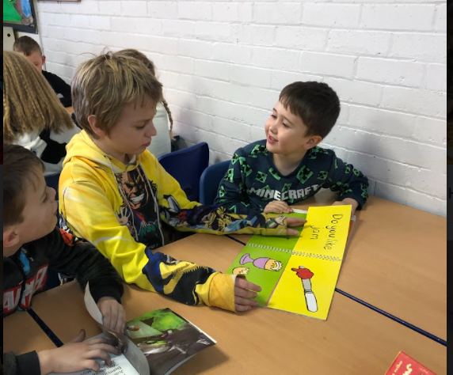
PJ Reading Day | The children and teachers came into school in their pyjamas and shared their favourite books. In assembly, staff shared their favourite books and authors, then in class children shared their stories too.  We had biscuits and book time and immersed ourselves in literature all day.
World Book Day | The children brought their favourite books to school and dressed up as their favourite character or wore pyjamas. Every class received a surprise book wrapped up in their classroom (chosen by teachers based on a theme for the day). Then we spent the day exploring the book and making cross curricular links with DT, art, dance and music and more. Every class shared their class book and then showcased their work in assembly. It was a lovely day exploring literature and its links to other subjects for a full day allowing full immersion.  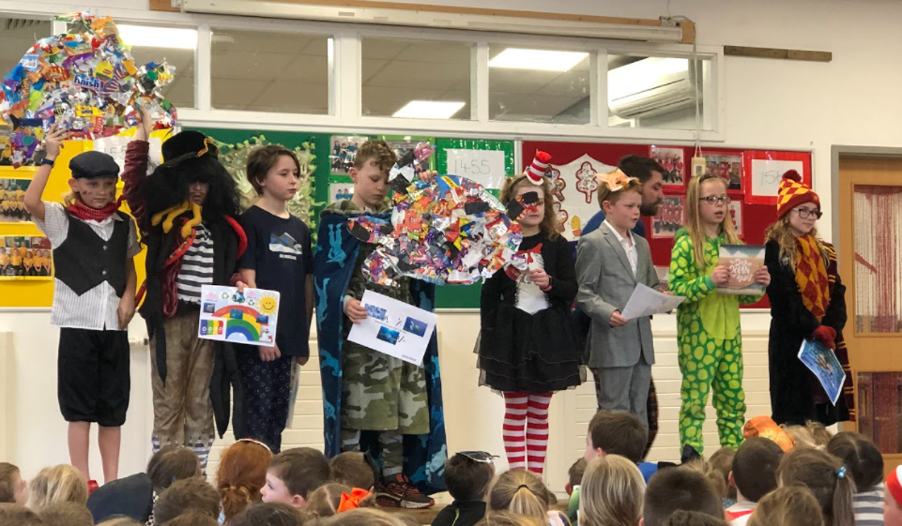  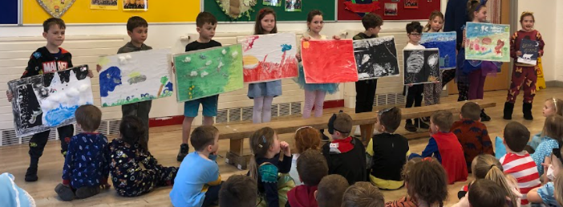  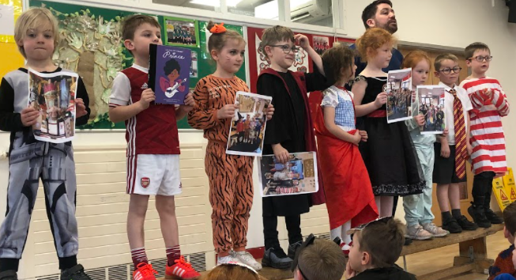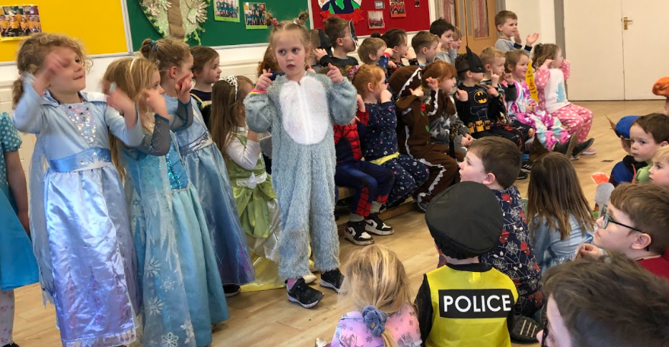
Secret Readers | In Reception a surprise parent comes in and reads to the class weekly which engages and excites the pupils during story time. This promotes reading for pleasure weekly.

Targets

To embed the T4W approach in school and that all staff have been trained
To ensure children are challenges to edit and improve their work

To ensure cross curricular writing is evident in books
To embed the new book led curriculum
To develop children’s understanding of the importance of reading in all curriculum areas
To ensure phonics is planned and taught to a high standard and that children have access to phonics linked texts
Ensure all classes have a high quality class text for shared reading and that this is done regularly
To upskill staff on their knowledge of quality authors and texts through staff book club and display
Monitor and observe the current teaching of spelling across the school

Impact of Personal or Staff Training

Course | Impact
New books were ordered and staff were trained on the new system and purpose of it. | Each child receives a book for fluency (phonic level), breadth (book band colour) and pleasure (library book). Staff understand this and are on board with the process and purpose of it.
GoRead and new book system (I completed online training and then training delivered to all staff by myself) | All staff understand the new book system in school.
Little Wandle Training (online CPD sessions) for Beth Whitehouse, Abbie S, Georgina and Annie  BW trained KS1 staff and all TAs | KS1 staff aware of new approach to phonics and consistency across school to aid the implementation of Little Wandle.
Little Wandle Introduction training (online for BW) | Understanding how to use the website and how Little Wandle should be working across school.
WIKI and Lexonic training for all teaching staff (delivered by Estelle Bellamy) | Staff aware of the FCAT way of teaching etymology to help with their understanding of language. Staff now understand use of book marks and how to use them in school.
Little Wandle training for all TAs | All staff now understand the purpose of Little Wandle, and are ready to effectively follow the scheme in January.
Met with KS2 staff to go through expectations for writing and Talk for Writing across school. I shared the planning structure and the reasons for this approach. I shared Pie Corbett’s books with staff and helped plan the first units for Spring 1. | Staff are much more confident with the Talk For Writing approach for fiction and non-fiction across school. As a result, they are planning a T4W unit for the start of Spring one.  We use a hybrid approach which includes more writing opportunities to suit the needs of our pupils.
Meet with staff regularly to plan T4W units to | This ensures staff are receiving guidance with T4W, there is a consistent approach through school and the progress of T4W is continuing. At first it was in KS1, where T4W is now embedded. Then in year 3, and as a result T4W is being implemented due to regular meetings. This term (Spring 2 onwards) I will be turning my focus to upper KS2.
English feedback meeting with all staff to discuss the progress and barriers T4W. | In this meeting KS2 staff mentioned that creating text maps was difficult due to the age and maturity of their current classes. As a result we adapted this stage in KS2 turning the focus to vocabulary and creating actions and images for this. I will be monitoring the progress.
Learning walks and book scrutinies are completed every half term and feedback is given to SLT and then staff in staff meetings. | English is being monitored closely and continually improved.
Personal online training on ELibrary.  I then shared this with staff. | KS2 started using the E library and loved it, and now KS1 are in the process of using it. It has a wide range of books and greatly promotes reading for pleasure. Our pupils have taken out a large amount of loans and have been loving Ebooks since the launch.
QIGs and RIGs attended termly. | This allows me to meet other English leads across FCAT. We share ideas and good practice or issues we are facing. It is brilliant for my own development as well as a great way to share and receive information.
BW visited Unity to discuss reading assessment, as well as having an online meeting with GL NGRT about their reading assessments. | I organised the meeting with NGRT following advice shared on a RIG, then compared it to Accelerated Readers which is used at Unity. Going to unity allowed me to see how another FCAT school organises and assess their reading and how we could use parts of this at Hambleton. I am still in communication with GL about the reading assessments.
Regular Little Wandle Phonics meetings, training and observations | To ensure consistency I make sure to observe, catch up with and model sessions for phonics.
KS1 and KS2 Talk for Writing Training is booked in for April-May

Assessment / Measuring Impact
Ongoing assessment and review is fundamental to everyday teaching at Hambleton Academy. Teachers are constantly making judgements with regards to attainment in lessons to inform planning and to ensure differentiation. Children are given constant feedback throughout each lesson using a ‘fix it’ approach to marking. As such, verbal feedback within the lesson is crucial in ensuring key skills are taught and assessed for individual children. Teachers then record any formative assessment within their planners. At the end of a unit of work, children complete a ‘Hot Task’ demonstrating their clear progress when compared to the ‘Cold Tasks’ completed at the start of the writing unit. Pupils are also assessed on their reading and phonics every half term to ensure gaps are being filled. Attainment is reported termly via data captures stating whether children are working towards the expected standard, working at age related expectations or working at greater depth. From this data, we can adapt teaching focuses to ensure key skills are being addressed and promoted adequately. Parents are informed of their child’s attainment and effort on a termly basis through Parents’ Evenings and end of Year Reports.

Future Targets
- To improve the school wide status and respect for the library through library clubs and monitors.
- To continue to embed Talk For Writing throughout school.
- To continue to develop the consistency and progress of phonics through Little Wandle.
- To implement a new spelling scheme.

B Whitehouse - September 2022

