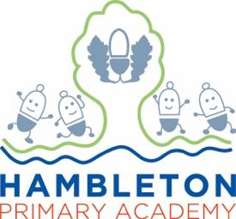

Subject Leader Geography Policy / Report
Whole School Curriculum Intent
At Hambleton Primary Academy we work together to ensure all our children achieve academic success whilst remaining healthy, happy and emotionally aware young people ready to move to the next stage of their education.

Subject Intent:

Through Geography at Hambleton Primary Academy children will be equipped with knowledge about diverse places, people, resources and natural and human environments, together with a deep understanding of the Earth’s key physical and human processes

Subject Specific Aims:

Geography at Hambleton Primary Academy aims to ensure that all children;

- develop contextual knowledge of the location of globally significant places – both terrestrial and marine – including their defining physical and human characteristics and how these provide a geographical context for understanding the actions of processes
- understand the processes that give rise to key physical and human geographical features of the world, how these are interdependent and how they bring about spatial variation and change over time
- are competent in the geographical skills needed to:
- collect, analyse and communicate with a range of data gathered through experiences of fieldwork that deepen their understanding of geographical processes
- interpret a range of sources of geographical information, including maps, diagrams, globes, aerial photographs and Geographical Information Systems (GIS)
- communicate geographical information in a variety of ways, including through maps, numerical and quantitative skills and writing at length.

Progression of knowledge and skills

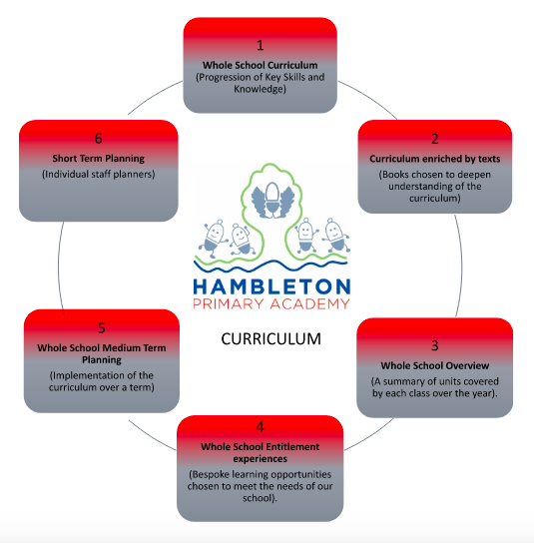
Hambleton Geography_Curriculum June 2022.docx

Subject Implementation

Our Geography curriculum is designed so that planned progression is built into the key skills and knowledge to help children understand the world, the environments, places near and far and the processes that create or affect them. Our aim is to provide the children with a breadth of memorable experiences, to shape them into curious and considerate global citizens. By the time they transition into secondary school, they will be well equipped with the skills and knowledge to explore the world around them and have a greater understanding of their planet. Our children will also develop knowledge of our community and locality through local visits to ensure that they not only appreciate and respect the area but they take stewardship of their surroundings.

Fundamental Great British Values:

We promote a respect for and understanding of different faiths, cultures and lifestyles. The spiritual, moral, social and cultural development of each child is central to everything that we do as a school and forms part of our school drivers of diversity, resilience, community and environment. This is evidenced through our inclusive teaching and learning, our inclusive environment and through the many opportunities provided for our children to understand democracy, law, liberty, mutual respect and tolerance.
At Hambleton Primary Academy, we understand clearly our responsibility in preparing children for their next stage of education and for the opportunities, responsibilities and experiences of later life, laying the foundations so that they can take their place successfully in modern British society. We teach our children to show mutual respect for the environment within our school and wider afield and teach global citizenship through a range of curriculum areas so that children understand how their actions can have an impact on the lives of others

Planning:

Our Geography planning provides broad and balanced learning for all our children. We use a variety of teaching and learning styles in our geography lessons. We believe in whole-class teaching methods, and we combine these with enquiry-based research activities. We encourage children to ask as well as answer geographical questions, they are free to challenge opinions and ideas through debating about real life issues.
We offer them the opportunity to use a variety of data, such as maps, statistics, graphs, pictures, and aerial photographs, and we enable them to use ICT in geography lessons where this serves to enhance their learning. Children take part in role-play and discussions, and they present reports to the rest of the class. They engage in a wide variety of problem-solving activities. Wherever possible, we involve the children in ‘real’ geographical activities, for example research of a local environmental problem, or use of websites to investigate a current issue.

We recognise the fact that there are children of widely different geographical abilities in all classes, and we provide suitable learning opportunities for all children by matching the challenge of the task to the ability of the child. We achieve this by:

- setting tasks which are open-ended and can have a variety of responses;
- setting tasks of increasing difficulty, some children not completing all tasks;
- grouping children by ability in the room, and setting different tasks to each ability group;
- providing resources of different complexity, according to the ability of the child;
- using classroom assistants to support the work of individual children or groups of children.

Our curriculum is carefully planned using The National Curriculum, to engage and excite all of our learners, ensuring all children are taught progressive geographical skills and concepts. Geography lessons are differentiated through additional support and challenge. In EYFS, children begin to develop their geographical knowledge through their study of ‘Understanding of the World- The Natural World’ and ‘People, Culture and Communities.’ Children are provided with experiences to enable them to explore, observe and discuss things in their immediate environment and how environments might vary from one another. Children are taught to make observations of animals and plants, explain why some things occur and talk about changes, know some similarities and differences between the natural world around them and contrasting environments and draw information from a simple map.
These types of experiences include:
- Visits to the surrounding area- shops and parks
- Continuous provision experiences linked to different seasons eg autumn objects to explore
- Making maps.
- Inviting parents to share their knowledge and experiences to extend children’s learning and vocabulary.
- Discussion about religions/cultures eg when learning about Maya’s

Collecting evidence:

Evidence of progress and attainment in geography is continuously collected throughout the year in a variety of ways including discussions with pupils, observations, planning checks, teacher discussions, photographs and work scrutiny.

Covid 19 impact:

During the first lockdown from March 2020 and the subsequent lockdown in January 2021, all children received support for home learning across the curriculum. Geography was included as part of the topic work set on Google Classroom throughout the period. For example, Year 1 and 2 looked at direction and map work which was cross curricular including compass points, coordinates and direction.
There is the expectation that class teachers are providing recap for work from previous learning to ensure sticky learning and continuity with the curriculum.
As the restrictions in school have lifted, we are now able to offer geography visits to develop fieldwork skills and human and physical features, carry out book scrutinies and pupil interviews.
Many opportunities to develop mapping skills and fieldwork opportunities were missed due to lockdown, so a whole school outdoor geography day will be carried out in the summer term to develop these skills and plug some of the gaps.

Able, Gifted and Talented Pupils:

Key skills and knowledge needed for each year group are used to assess pupils against and added to our subject data collections. Teachers can clearly see children working at greater depth for geography and can effectively plan opportunities for these children. Challenge time at the end of each lesson allows pupils to build on the skills and knowledge that they have gained.

SEND and PP Pupils
At our school we teach Geography to all children, whatever their ability. It is part of the school curriculum policy to provide a broad and balanced education to all children. We provide learning opportunities that are matched to the needs of children with learning difficulties. Work in Geography takes into account the targets set for individual children in their Personal Plans (PPs). We have experienced TA’s who are trained to take out intervention groups which may include SEND children. This will provide children with the opportunity to develop their Geography through a more guided teaching sequence if required.
We enable all pupils to have access to the full range of activities involved in learning Geography. Where
children are to participate in activities outside the classroom, for example, orienteering, we carry out a risk assessment prior to the activity, to ensure that the activity is safe and appropriate for all pupils.

Enrichment opportunities:

Enrichment is the key to developing exciting relevant and meaningful learning opportunities in geography. Opportunities provided at Hambleton Primary Academy include:

Year Group | Enrichment opportunity
EYFS visit the local shops.  Discussing features of the school environment | 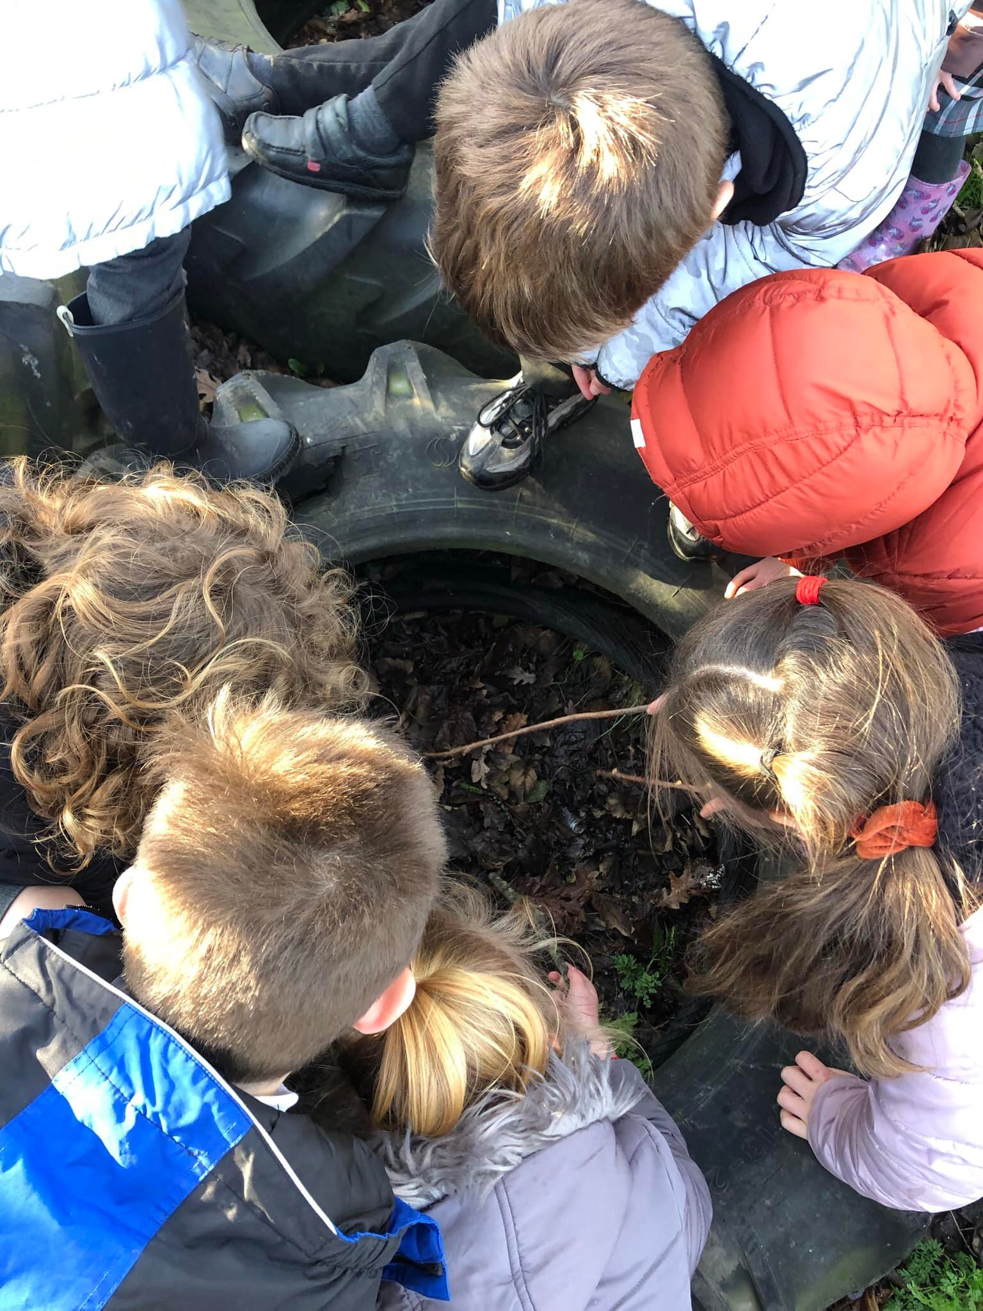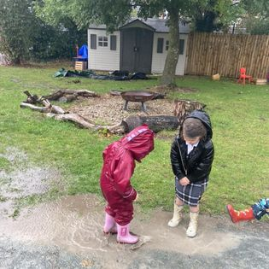
Year 1 Study of the school grounds, identifying the physical features of their environment and discussing the changes over time | 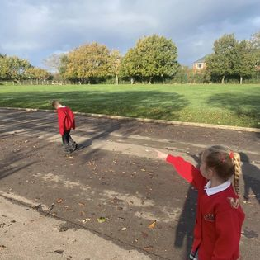
Year 2 went to visit the park and local shops to look at human and Physical features | 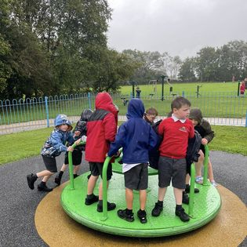
Year 3 Looked at how Hambleton has change over time.
Year 4 Rivers - visiting the River Wyre and using VR headsets to follow the River Wyre to the sea | 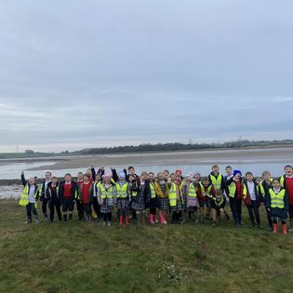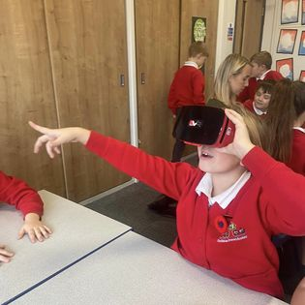

Year 5 Using VR headsets to explore the world - with the emphasis on what is our impact on our world and local area. | 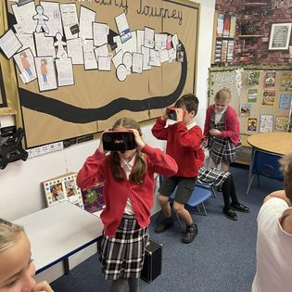
Year 6 Investigating coastal regions looking at the Sand Dunes in Blackpool. | 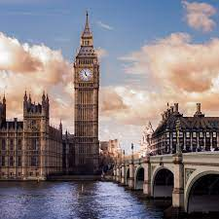

Targets:

To implement progression in Geography Key skills  This will:  -Improve standards of learning across the school  -Enable children to build on previous learning experience  Ensure children are being challenged appropriately to improve their independent work  Provide opportunities for ‘sticky learning’, embedding knowledge/Geography skills.  To ensure that staff understand progression in all year groups and are following the skills document | Once a full Monitoring Cycle has been completed, outcomes will be clear and relevant changes will be put in place, if required:  Is the progression clear?  Collate evidence of:  cross curricular writing  independent work  Challenge time  To ensure “sticky learning” is embedded within the curriculum
To raise the profile of field skills and ensure they are being taught effectively throughout school.  This will:  -Provide opportunities for self-reflection and ensure children can confidently use geographical skills.  Staff are able to plan and deliver lessons confidently | Monitoring Cycle  Pupil Voice  - Questions are asked that develop learning either verbally or within tasks.  - To be able to see better progression in children’s ability using field skills.  - Evidence of planning/lesson observations/evidence of progression in pupils
To provide in house CPD to all staff to ensure that staff are confident teaching Geography  This will:  Ensure staff are aware of skills from previous year groups and how this is built upon throughout school | Children will develop learning  “Sticky Learning” embedded with knowledge of geographic skills

Impact of Staff Training:

Subject Lead CPD  Staff CPD  Subject Leader Development | JA attended New to Geography Subject lead March 2020 (pre-Covid).  JA to provide staff CPD on what Geography should look like across school.  Subject Leader Development Training – ideas shared and integrated into provision at school via FCAT QIG

Assessment/Measuring Impact:

Assessment of geography is ongoing and is used to inform next steps in learning. This information comes from a variety of sources including questioning, discussion, observing as well as children’s recorded work.

- Planning and book scrutiny is carried out to ensure that all the skills are being taught effectively and to ensure that there is clear progress throughout the school.
- A clear marking policy is used across the school.
- Pupil voice - through monitoring children are asked about what topics they have been learning about in geography, assess their understanding of physical and human geography. What aspects of the subject they have enjoyed.
Throughout all geography topics the pupils are assessed against the key skills taught and their knowledge and understanding of the subject. This is reported termly by the class teacher in our data captures , stating whether they are working at age related expectations, working at greater depth or working towards the expected standard. The data captures are used to monitor the progress of all cohorts as well as groups of pupils including pupil premium and SEND.
Children’s prior knowledge is assessed through geography questions, at the beginning of a lesson and at the end of a lesson through a challenge question.

Future Targets
- To arrange Geography Day across the whole school to provide children with the opportunity to be immersed in field skills.
- To build upon the working document I’ve shared amongst FCAT Geography subject leads of websites and enrichment ideas.
- To monitor and improve the key progression document to include diverse countries of study.

Joanne Abbott – September 2022

