Subject Leader Maths Policy / Report

Whole School Curriculum Intent

At Hambleton Primary Academy we work together to ensure all our children achieve academic success whilst remaining healthy, happy and emotionally aware young people ready to move to the next stage of their education.

Subject Intent
Through Maths at Hambleton Primary Academy children will broaden and deepen their mathematical understanding, enabling them to master the fundamentals of mathematics and develop the skills they need for the 21st century.

Subject Specific Aims

Maths at Hambleton Primary Academy aims to ensure that all children;
- Become fluent in the fundamentals of Mathematics so that pupils develop conceptual understanding and the ability to recall and apply knowledge rapidly and accurately.
- Reason mathematically by following a line of enquiry, recognising relationships and generalisations and developing an argument, justification or proof using mathematical language.
- Can solve problems by applying their Maths to routine and non routine problems with increasing sophistication, including breaking down problems into a series of small steps.

Progression of knowledge and skills

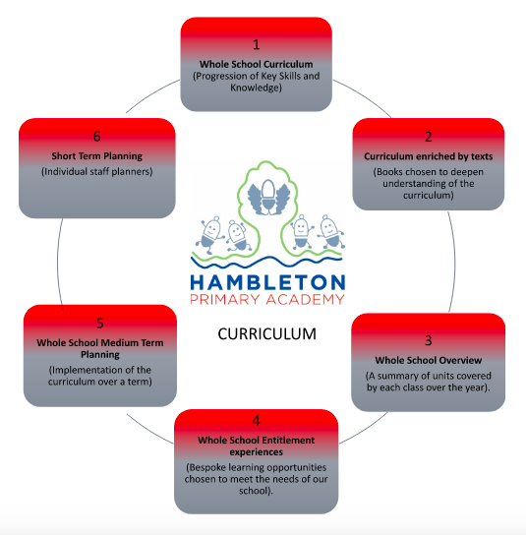

https://drive.google.com/file/d/1AHYPLLsqxsZZ5mZUt9_1yT7BGvdWCRvl/view

Subject Implementation
Hambleton Primary Academy seeks to provide an all-round education for children in a bright, stimulating and fun atmosphere. At Hambleton, we follow a ‘Mastery Maths’ approach in Maths allowing pupils to explore a range of ways to approach an answer. Children are encouraged to use concrete, pictorial and abstract techniques when reasoning and problem solving. They will focus on breaking problems down into small steps and using their fluency skills and prior learning to make links to new learning. Teaching Maths gives children the opportunity to be immersed within the subject and provides choices later in life.

Fundamental Great British Values
At Hambleton, we understand our responsibility in preparing children for their next stage of education and for the opportunities, responsibilities and experiences of later life, laying the foundations so that they can take their place successfully in modern British society. We understand how this subject has an underpinning link to British values. The spiritual, moral, social and cultural development of each child is central to everything that we do as a school. Our Maths work reflects our inclusive environment and through the many opportunities provided for our children, they develop understanding of democracy, law, liberty, mutual respect and tolerance. The work that children do outside their normal lessons encourages independent study and helps them to become increasingly responsible for their own learning. The planned activities that children do within the classroom encourage them to work together and respect each other’s views. We present children with real-life situations in their mathematics work such as ‘the spending of money’. We group children so that they work together, and we give them the chance to discuss their ideas and results.
Planning
Our curriculum is thoughtfully planned to engage and inspire all our learners. Our whole school curriculum (a progression of knowledge and skills taken from the White Rose Scheme of work) and long term plans, map out the Maths units covered each half term for each class. These plans define the skills and knowledge we teach to ensure an appropriate balance and distribution of work across each term and each year. Additionally, planning and teaching in Maths is fully inclusive ensuring that all children can access the curriculum at their level. Knowledge and skills are progressively built upon as children journey through our school. Cross-curricular links are emphasised, enabling the children to apply their skills and knowledge in other areas of the curriculum. Enrichment activities are carefully planned to ensure that children have experiences beyond the classroom that may inspire them to choose careers which deal with mathematical concepts.
In addition we have carefully planned a structured approach to the way we teach our lessons. This ensures that children have the opportunity to revisit previous learning, understand new concepts quicker, have access to a range of representations and have the confidence to answer and discuss questions.

Based on the changes made to the Early Years Foundation Stage Framework in 2021, children begin to develop their understanding of number through a play based approach. They learn to sort, arrange, order and distribute items before number is introduced. Children learnt to use number names and learn to count as part of their play activities. They also create collaboratively, share ideas, resources and Mathematical skills.

The range of skills shown through different continuous provision activities are;
- Sorting
- Ordering
- Counting
- Arranging
- Matching
- Measuring

Collecting Evidence
At Hambleton, we are able to monitor progress within mathematics through a range of evidence. In Early Years a floor book is regularly completed which evidences children’s learning and the language that they are using. Both Nursery and Reception upload Maths evidence onto the EEXAT online learning journey system. KS1 and KS2 complete Maths books each lesson to evidence their learning. On a half termly basis, we examine books and planning across all year groups and observe teaching, ensuring that targets are being worked towards in line with our school development plan. We also collate a pupil voice through interviews. Our Governors are well informed of standards through termly Governor Meetings, where subject updates on attainment and development for Mathematics are shared, analysed and clarified.
We meet termly with the academy trust QIG groups where we discuss our evidence and share our school’s vision and action plan. Here we discuss our strengths and areas for improvement, developing new ideas to take into our own setting.

COVID-19 Impact
Due to the recent pandemic, we understand that children have missed many learning opportunities in this core subject. The 2021/2022 White Rose scheme that we follow at Hambleton has added catch-up lessons into our small steps, which focus on building on the skills that children have missed or may need consolidating. We also pre-assess our children prior to new topics of learning to identify any gaps, and complete post-assessments to ensure that these have been addressed through teaching and learning. We have used government funding to implement intervention groups for children who have been identified as requiring extra support due to missed opportunities through lockdown and additional TA support in classrooms.
During the recent disruption due to the COVID 19 pandemic, staff continued to use the White Rose planning materials to ensure pupils' progress was consistent with their planned teaching schedule. In December 2021, we began using the Ready to Progress – Curriculum Prioritisation documentation from the NCETM. Teachers used this to identify key gaps in children’s learning. Teachers then refer back to this to provide opportunities to secure learning building them into the teaching sequence.
As a result of the pandemic and disruption to face to face teaching, fluency is a key area which is a priority for mathematics teaching at Hambleton. This is to ensure pupils will become fluent in the fundamentals of mathematics, so that pupils have the ability to recall and apply knowledge rapidly and accurately. Fluency sessions will be taught either discreetly or embedded into lesson design. In 2021/2022 KS1 and the Maths lead will take part in the NCETM Mastering Number Project.

Able, Gifted and Talented Pupils
Key skills and knowledge needed for each year group are used to assess pupils and are assessed against and added to our subject data collections. Teachers can clearly see children working at greater depth for Maths and can effectively plan opportunities for these children. The subject leader supports teachers in supporting greater depth pupils and ensuring breadth and balance. The subject leader will work with staff to ensure the development of reasoning and problem solving opportunities which deliver appropriate stretch for AGT pupils within lessons.

SEND and PP Pupils
At our school we teach Maths to all children, whatever their ability. It is part of the school curriculum policy to provide a broad and balanced education to all children. We provide learning opportunities that are matched to the needs of children with learning difficulties. Work in Maths takes into account the targets set for individual children in their Personal Plans (PPs).
We have experienced TA’s who are trained to take out intervention groups which may include SEND children. This will provide children with the opportunity to develop their Maths through a more guided teaching sequence. In Maths this is done through use of manipulatives, pictorial representations then the introduction of more abstract methods. Vocabulary is constantly modelled and repeated back to target children both during group and independent and during carpet time discussions.

Enrichment opportunities
The Maths curriculum is widely enriched with charity events, after school clubs, trips and visits including:
Enrichment Activity Examples | Further Information
NSPCC Number Day | EYFS, KS1 and KS2 took part in a house number day for the NSPCC. This promoted number across school and developed children's understanding on how to donate (dealing with and understanding the value of money). Children created Maths games, completed Maths quizzes, predicted the total donations made and completed Maths challenges which involved moving around school.  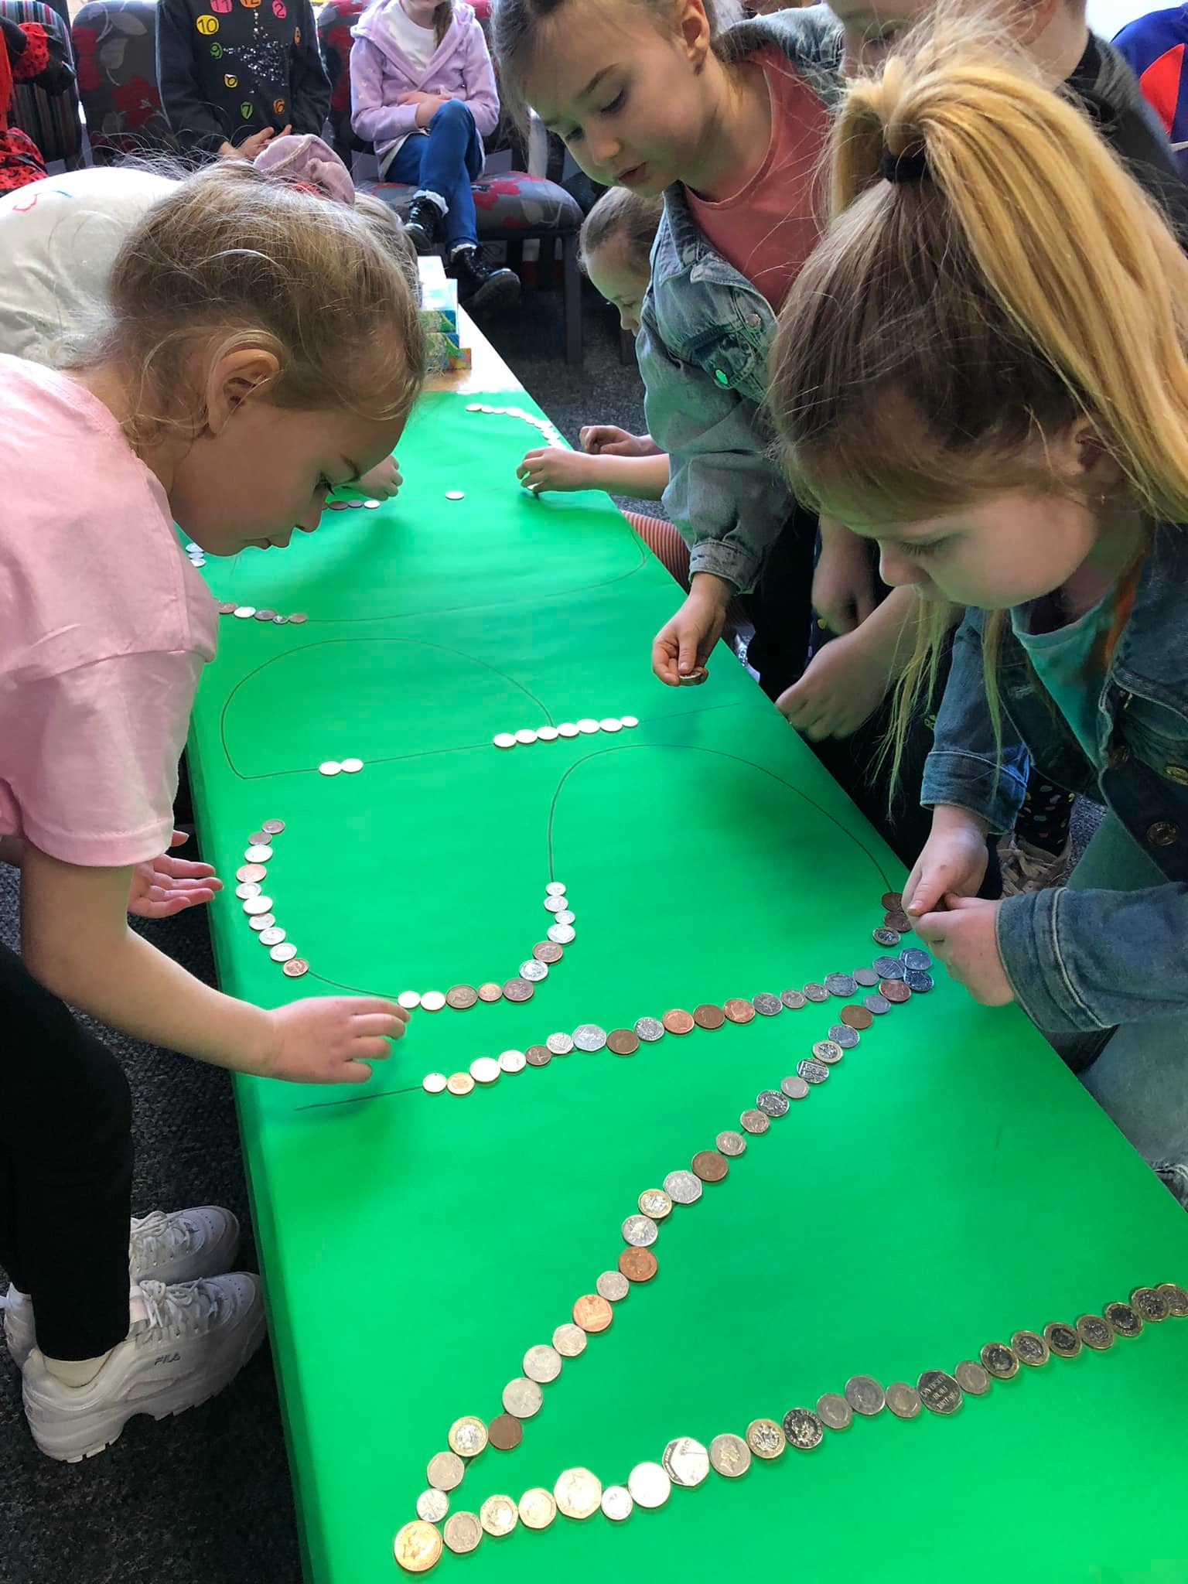  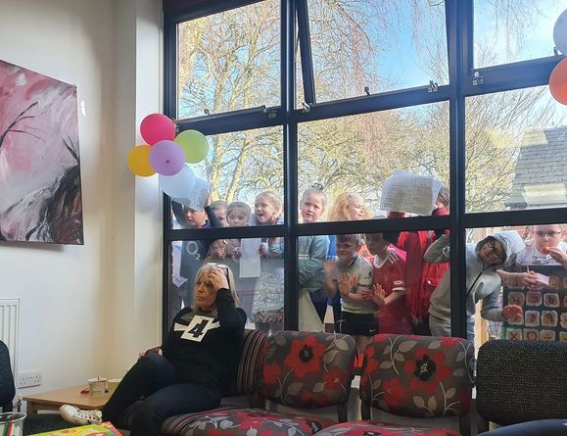
KS1 Italian Restaurant | Year 2 Children set up their own Italian restaurant where they learnt to make money. They learnt how to add up totals and provide change to the customers. Their parents and families were invited in to come and sample their food and to test out their counting skills.  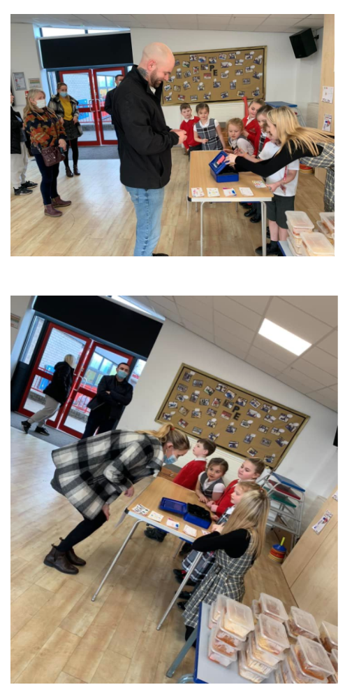
Year 6- Travel on a bus | After learning how to read and interpret time tables in class children in Year 6 will have the opportunity to put this into a real life context. Reading and using a bus timetable. This will prepare the children for transitioning into High school.
HSBC Online | Years 3 and 4 will learn about the value of money and how to save using online banking tools from the HSBC.

Targets

To further embed the Masteru Maths approach across school. | -Improve standards of reasoning and problem solving across the school  -Ensure that there is no ‘lost learning’ in lessons. All children have the opportunity to make progress during each part of the lesson.
To continue to develop the use of concrete and pictorial methods in Maths lessons using the updated White Rose Scheme of Work. | -Will give the children more independence when completing reasoning and problem solving questions.  -Children will enjoy learning about Maths  -Low ability children will be able to access Maths with more independence.  -Higher ability children will be able to explain Mathematical concepts using better vocabulary.

Impact of Staff Training

Subject Leader provided training for all staff.  2021-22 | - Expectations of Mastery Maths made clear to all staff including how to plan (including reasoning), what children’s books should look like, where to find relevant resources and the development of times table rockstars.  - Regular monitoring feedback with staff to ensure consistency and to unpick any concerns or misconceptions with Mastery Maths.
KS1 staff attending the Mastery Maths Hub  2021-22 | - Trialling new strategies in their own lessons including the use of concrete-pictorial and abstract methods of teaching.  - Introduction of STEM sentences to secure mathematical vocabulary and to help children to reason in KS1.  - Development of new resources. These are being ordered and space is being made to store them.  - More flexibility to teach smaller steps to allow all children to master the new maths concepts.
Maths lead and Y4 teacher attending Mastery Maths Hub  2021-22 | - Introduction of new LO layout using the concrete-pictorial-abstract methods.  - More opportunities for the whole class to work together on the same objective. Children progressing at the same rate.  - More opportunities for practical activities- less focus on worksheets.  - Opportunities to think outside of the box when challenging the HA.
AR coaching and mentoring NQT’s and RQT’s  2021-22 | - Coaching and training is centred around the Mastery Maths approach. This information can then be passed on to new teachers in the coming years.  - New staff have the confidence to trial new methods and techniques in their lessons. They welcome being observed by different class teachers.  - Constant moulding of staff to teach in the ‘Hambleton way’.
Maths lead and TP attended ‘embedding Maths Mastery’ hub  2022-23 | - Reflection on the Maths policy and resources. Developed this as a whole school to ensure that it remains progressive.  - Developed fluency across school using a counting stick technique to teach from.
Non-Examples and Your turn my turn CPD  2022-23 | - New strategies included in lessons to provide opportunities for children to discuss, elaborate and share new thoughts and ideas.  - Maths lesson structure put in place to ensure that this is done in every lesson by every child.
Team Teach  2022-23 | - Lesson structure being taught consistently across school.  - New strategies being trialled and used by teachers in their own lessons.  - Improved teaching across school.

Assessment / Measuring Impact
Ongoing assessment and review is fundamental to everyday teaching at Hambleton Academy. Teachers are constantly making judgements with regards to attainment in lessons to inform planning and to ensure differentiation. Children are given constant feedback throughout each lesson using a ‘fix it’ approach to marking. As such, verbal feedback within the lesson is crucial in ensuring key skills are taught and assessed for individual children. Teachers then record any formative assessment within their planners. At the end of a unit of work, children complete the White Rose Maths assessment. This is used to outline which areas the children may need further support in and to highlight their attainment in the subject. Attainment is reported termly via data captures stating whether children are working towards the expected standard, working at age related expectations or working at greater depth. From this data, we can adapt teaching focuses to ensure key skills are being addressed and promoted adequately. Parents are informed of their child’s attainment and effort on a termly basis through Parents’ Evenings and end of Year Reports.
Teachers record their assessments on their medium term plan. This is then used to plan future Maths lessons and to inform the new class teacher in the following year.

Future Targets
- To continue to develop the ‘Mastery Maths’ teaching approach across school. We will continue to look at ‘Representation and Structure’ ensuring that teachers are choosing the correct representations to support learning.
- Ensure that children are drawing and using the representations independently to discuss and explain their learning.
- Fluency to continue to be developed across school to ensure children can move between different contexts and representations of mathematics to recognise relationships an make connections.
- Continue to support the teaching of Maths through team teaching.

A.Riches- February 2023

