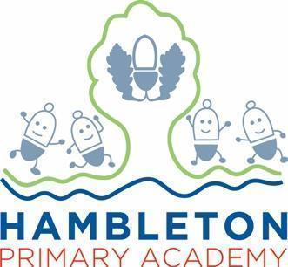

Subject Leader Music Policy / Report

Whole School Curriculum Intent
At Hambleton Primary Academy we work together to ensure all our children achieve academic success whilst remaining healthy, happy and emotionally aware young people ready to move to the next stage of their education.

Subject Intent
Through Music at Hambleton Primary Academy, children will be able to gain a firm understanding of what music is through listening, singing, playing, evaluating, analysing, and composing across a wide variety of historical periods, styles, traditions, and musical genres. We are committed to developing a curiosity for the subject, as well as an understanding and acceptance of the validity and importance of all types of music, and an unbiased respect for the role that music may wish to be expressed in any person’s life. We aim to provide children with the opportunity to progress to the next level of their creative excellence.

Subject Specific Aims
Music at Hambleton Primary Academy aims to ensure that all children;
• know and understand how sounds are made and then organised into musical structures;
• know how music is made through a variety of instruments;
• know how music is composed and written down;
• know how music is influenced by the time, place and purpose for which it was written;
• develop the interrelated skills of performing, composing and appreciating music.

Progression of knowledge and skills

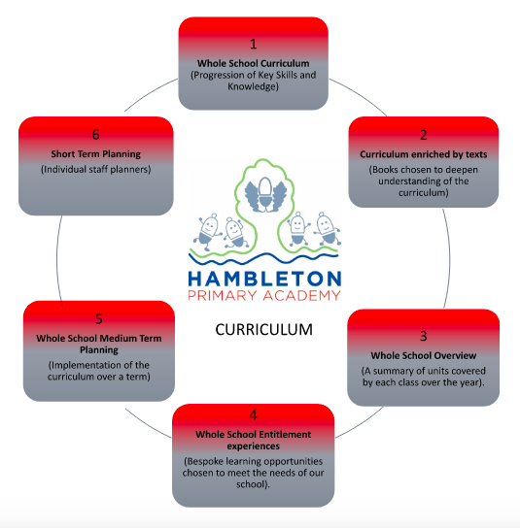

Music curriculum

Subject Implementation
The music curriculum ensures children sing, listen, play, compose, perform and evaluate and is taught through key skills. This is embedded in the classroom activities as well as various concerts and performances and the learning of instruments. Through the musical program Charanga, teachers are able to produce inclusive lessons for all children to access the musical curriculum in a fun and engaging way, further promoting a love of learning. Teachers deliver music following the Charanga programme, designed specifically for the teaching of music in primary schools. Charanga lessons are planned in sequences to provide children with the opportunities to review, remember, deepen and apply their understanding. The elements of music are taught in classroom lessons so that children are able to use some of the language of music to dissect it, and understand how it is made, played, appreciated and analysed. In the classroom children learn how to play an instrument as well as a variety of percussion instruments. Playing various instruments enables children to use a range of methods to create notes, as well as how to read basic music notation. They also learn how to compose, focusing on different dimensions of music, which in turn feeds their understanding when listening, playing, or analysing music. Composing or performing using body percussion and vocal sounds is also part of the curriculum, which develops the understanding of musical elements without the added complexity of an instrument.

Fundamental Great British Values
At Hambleton, we understand our responsibility in preparing children for their next stage of education and for the opportunities, responsibilities and experiences of later life, laying the foundations so that they can take their place successfully in modern British society. We understand how this subject has an underpinning link to British values. The spiritual, moral, social and cultural development of each child is central to everything that we do as a school. Our Music work reflects our inclusive environment and through the many opportunities provided for our children, they develop understanding of democracy, law, liberty, mutual respect and tolerance. Opportunities to make links with other cultures and religions are actively sought through our curriculum. For example, the whole school were involved in African drumming sessions which also taught them the culture and customs behind it.

Planning
A music specialist from The Lancashire Music Service teaches lessons on a rota basis throughout Key Stage Two, which involves composing using ICT and learning to play the Ukulele. In addition to this, all children in school are taught music by their class teacher. The teachers use the Charanga scheme of work for music as the basis for its curriculum planning. We have adapted the scheme so that the topics that the children study in music build upon prior learning. While there are opportunities for children of all abilities to develop their skills and knowledge in each teaching unit, the progression planned into the scheme of work means that the children are increasingly challenged as theymove through the school.
We carry out the curriculum planning in music in three phases (long-term, medium-term and short-term).
The long-term plan maps the music topics studied in each term during the key stage. The subject leader
devises this plan in conjunction with teaching colleagues in each year group. Sometimes the children study
music topics in conjunction with other subjects, particularly at Key Stage 1. Through this programme of
study we teach the knowledge, skills and understanding set out in the National Curriculum.
The medium-term plans, which we have adopted from Charanga, provide the key skills covered in those
units.
Some short term planning is written by the specialist music teacher, which lists the specific learning objectives for each lesson. Evidence of lessons will be recorded in the Music Floor books completed by the class teacher. In addition, the class teacher will write the short term plans linked to their Charanga lesson which will be written in their planner.
Our music planning is geared to three aspects of progress:
• increasing breadth and range of musical experiences;
• increasing challenge and difficulty in musical activities;
• increasing confidence, sensitivity and creativity in the children’s music-making.

Collecting Evidence
Evidence is collected throughout the year and in a variety of different ways. These include, planning in Staff Planners, subject monitoring (floorbook scrutinies, walk throughs and pupil voice), staff discussions (meeting notes) and data captures. All classes have a Music Floorbook. Here they record what they did in each lesson, what was said (pupil voice) and what was learnt. Performances are uploaded onto our Google drive with links using QR codes in floorbooks. In addition to this, Hambleton’s Facebook Page is used to collect and record examples of performances too.

COVID-19 Impact
During the first lockdown from March 2020 and the subsequent lockdowns in January 2021 all children received comprehensive support for home learning by all members of staff across the curriculum. Music was included as part of the topic work set on Google Classroom throughout the period. For example, during the first lockdown we held a whole school music compilation where children sang parts of a song, which was then edited to create a whole school performance. Although resources weren’t as readily available at home, staff did endeavour to cover units where possible during periods of remote learning. Units were often adapted or presented to children through themed days to suit home learning. When children returned to school, staff did try to cover missed units which were not covered during lockdown but due to time constraints, these were not all taught. A target for this year is to work with and support staff in ensuring full curriculum coverage in Music. There is also the expectation that class teachers are providing recap for work from previous learning to ensure sticky learning and a continuity with the curriculum. In addition, enrichment activities such as afterschool clubs, visitors to school and linking opportunities with other schools were unable to take place from Spring 2020. As restrictions ease, these opportunities will begin to be available to children again. We have already taken our school choir to perform at the Winter Gardens.

Able, Gifted and Talented Pupils
Key skills and knowledge needed for each year group are used to assess pupils and are assessed against and added to our subject data collections. Teachers can clearly see children working at greater depth for Music and can effectively plan opportunities for these children. The subject leader supports teachers in supporting greater depth pupils and ensuring breadth and balance. The subject leader will work with staff to ensure the development of techniques and opportunities which deliver appropriate stretch for AGT pupils within lessons.

SEN
Music has a rare and unique ability to bring people together; music making can make a whole class, school and community feel connected to others and part of something bigger. At Hambleton we celebrate the inclusion of pupils with special educational needs and disabilities as it does the leaps in technology that have made available new tools and adapted instruments, leading to improved access and greater choice for all pupils to realise their creative potential. We set high expectations for every pupil, whatever their prior attainment. Teachers use appropriate assessment to set targets which are deliberately ambitious. Potential areas of difficulty should be identified and addressed at the outset. Lessons are planned to address potential areas of difficulty and to remove barriers to pupil achievement.

Enrichment opportunities

Enrichment Activity Examples | Further Information
Choir | Our school choir meets weekly and involve children from a range of classes from Key Stage 2 and a range of abilities. We have performed in a number of places, including the Winter Gardens and our school music concert.  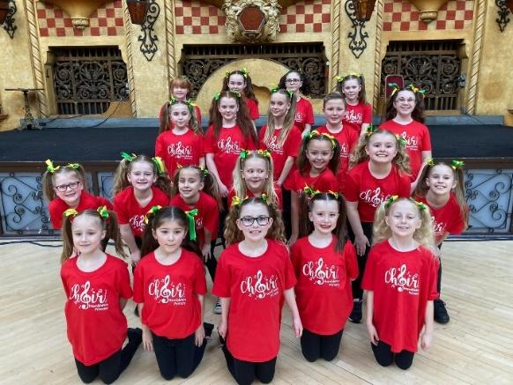
Band | We have selected a number of children from Years 5 and 6 to attend a weekly band session with a music specialist from Lancashire Music Service. They play the drums, keyboard, bass and a couple of singers. As the band become more established, they will be performing to audiences. Their first performance will be at the Winter gardens in Feb 2023
Ukulele | As part of wider opportunities, all classes in key stage 2 have had the opportunity to learn the Ukulele. This is a class strategy which also involves the teacher learning.  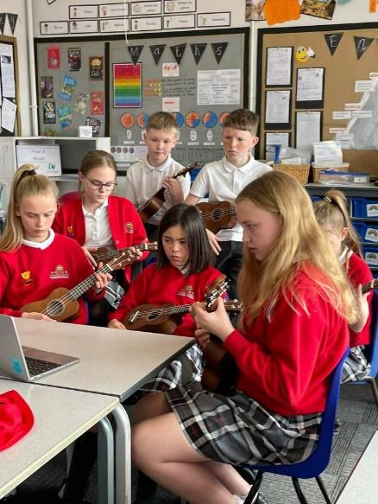
African drumming | Our Music week , enables us to invite some African drummers into school, who delivered workshops throughout school

Targets

To ensure good quality music lessons are consistently taught within school | -Improve music ability across the school  -Give children (and their teacher) a love of music  -Enable children to have experienced learning an instrument  -Provides opportunities for children to progress to private music lessons
To provide opportunities for children to perform to an audience | -Help build children’s confidence in their ability  -Gives children opportunities to work in a group  -Provides parents the opportunities to see their child perform

Impact of Staff Training

Subject Leader provided training for all staff.  Charanga online webinars available for all staff | - Availability of resources during lessons and how to use them effectively  - Providing the key skills explanation to ensure teacher confidence and explanation of terminology.  - How to use Charanga effectively and increase confidence.

Assessment / Measuring Impact
Ongoing assessment and review is fundamental to everyday teaching at Hambleton Academy. Teachers are constantly making judgements with regards to attainment in lessons to inform planning and adaptive learning. Verbal feedback within the lesson is crucial in ensuring key skills are taught and assessed for individual children. Teachers then record any formative assessment within their planners. Attainment is reported termly via data captures stating whether children are working towards the expected standard, working at age related expectations or working at greater depth. From this data, we can adapt teaching focuses to ensure key skills are being addressed and promoted adequately. Parents are informed of their child’s attainment and effort on a termly basis through Parents’ Evenings and end of Year Reports.

Future Targets
- To look at Long Term plan to ensure classes are given opportunities to embed skills taught by LMS in Ukulele, by providing them with more sessions
- Develop our Rock Band more, training up more students and giving them opportunities to perform
- Explore the 2021 Model Music Curriculum and ensure our units of work taken from Charanga comply with the curriculum we are wanting to embed at Hambleton

Charlotte Blundell - September 2022

