Special Educational Needs and Disability (SEND) Policy

Person responsible for the policy | SENCO Charlotte Blundell (NASENCO award)  Contact details 01253 700331
Date review: | September 2025
Next review | September 2026

Introduction
Hambleton is an inclusive Primary Academy with a three plus nursery setting, situated in the rural village of Hambleton, Lancashire. Hambleton Academy is part of the Fylde Coast Academy Trust (FCAT). As an inclusive academy we are committed to ensuring every child has access to an education which meets their needs and prepares them for adulthood. Hambleton Academy is committed to working with all our pupils, families and a range of external partners to ensure all aspects of academy life are accessible and appropriately adapted to meet a wide range of individual needs.

Our SEND Intent Statement
All FCAT academies strive to provide an inclusive and welcoming education for all learners, enabling children with SEND to be ‘the best they can be,’ now and in the future.
Hambleton Academy aims to achieve this intent by embedding the following principles:
- Children come first.
- Positive relationships underpin all our work.
- High expectations for all – understanding that everyone given the correct support can achieve. (FCAT Improvement Model)

At Hambleton Academy we aim to achieve this intent by ensuring all our children are Happy, Proud and Ambitious.

Definition of SEND
The definition of SEND used across Hambleton Academy is taken from the SEND Code of Practice which states a child or young person has SEND if they have:
“A learning difficulty or disability which calls for special educational provision to be made for him or her. * A child of compulsory school age or a young person has a learning difficulty or disability if he or she: has a significantly greater difficulty in learning than the majority of others of the same age, or has a disability which prevents or hinders him or her* from making use of facilities of a kind generally provided for others of the same age in mainstream schools.” (SEND Code of Practice, January 2015 updated 2020). Introduction section xii & xiv Pages 15 & 16)
*him/her/they/them

Categories of SEND
SEND is recognised as four broad areas of need:
- Communication and Interaction
- Cognition and Learning
- Social, Emotional and Mental Health
- Sensory and/or Physical Needs.
At Hambleton Academy we recognise children may have multiple needs. A child’s primary area of need is the need which is creating the main barrier to learning.

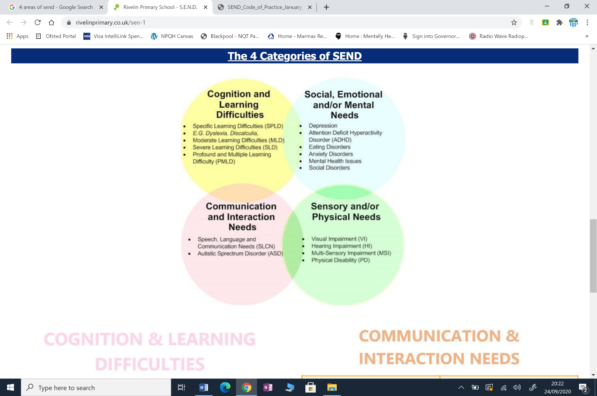

Figure 1: Categories of need
Many children identified with SEND needs are well placed in our inclusive mainstream provision. As an inclusive academy we strive to meet an increasing number of our children’s needs through High Quality Adaptive Teaching and a developing Trauma Informed Approach.

Creating Enabling Learning Environments
Hambleton Academy aims to provide children with learning environments which are:
- Emotionally supportive, with an atmosphere of encouragement and respect of individual needs.
- Welcoming for children with diverse needs and where reasonable adjustments are made so the curriculum is accessible for all.
- Well-resourced with appropriately adapted resources, including ICT.
- High quality, structured and tidy learning spaces appropriate to the age and developmental needs of the children.

Ensuring Effective SEND Provision
To enable Hambleton Academy to provide high quality provision for children with SEND the following eight areas of practice are developed across our academy:
- Effective Leadership of SEND, ensuring clear direction and accountability for SEND provision.
- Early and accurate assessment and identification of need, with systems and processes which enable our SENCO to work closely with teachers, TAs and parent/ carers to support the early identification of children with SEND. Early identification is the process where concerns about an individual are noted and acted upon as soon as they become apparent; this could be prior to a child entering nursery provisions to a need arising in year 6.
- High Quality Adaptive Teaching and Learning and a developing Trauma Informed Approach for all children including those with SEND.
- A graduated and holistic approach to SEND provision which is responsive to the needs, development and wellbeing of the children.
- Effective monitoring, tracking and evaluation of progress and attainment of children with SEND.
- The efficient use of resources to support children’s needs including staff access to SEND CPD (Continuing Professional Development).
- SEND improvement processes to support the identification of success and address areas which require development.
- Systems which ensure our academy meets the statutory responsibilities for children with SEND.

Working in Partnership
Staff at Hambleton Academy are committed to working in partnership with integrity and an outward mind set with the following stakeholders:
- Children with SEND - listening to and responding to pupil voice.
- Parent/carers of children with SEND - working in partnership to support their child.
- External agencies -supporting children, their families and staff. At Hambleton Academy we work in partnership with educational specialists and external agencies, including health, children social care, as well as Lancashire Local Authority SEND team.
- Colleagues across our academy and Trust - working together to develop shared staff expertise and support.

Roles and Responsibilities
All leaders at Hambleton Academy are leaders of SEND and therefore have a responsibility to include developing SEND provision and meeting the needs of children with SEND as part of their leadership roles.
To ensure clear direction and accountability for SEND provision at Hambleton Academy the SLT and SENCO (Mrs Charlotte Blundell) are responsible for ensuring staff work with children and their families to support identification of SEND needs and support staff to provide children with the support they require, at a level appropriate to their needs.
All teachers at Hambleton Academy are responsible for meeting the needs and the progress of all children in their class including those with SEND.
In this policy the term ‘teachers’ encompasses Teaching Assistants who work alongside teachers to support and teach our children.

Interventions
Interventions are used across Hambleton Academy to support children to progress and secure positive outcomes. An intervention is defined as, “Any action or series of actions which are taken specifically to meet the particular identified needs of a pupil.” (5 supporting Documents for Early Identification of Children’s Needs, 2021, asset.nasen.org.uk)

Graduated Approach to supporting pupils with SEND.
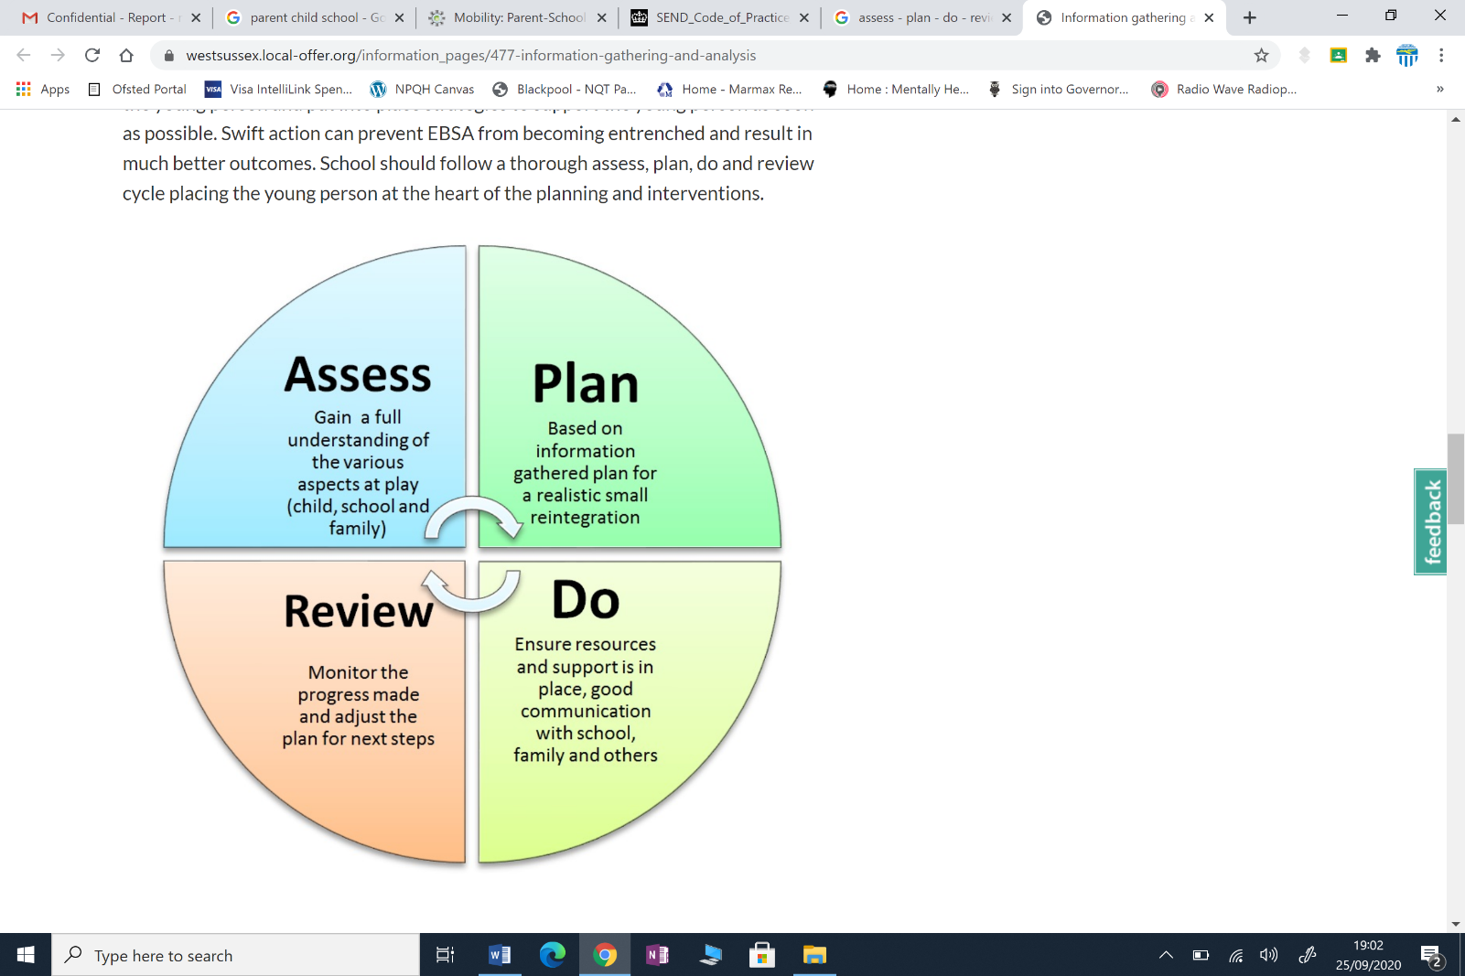
At Hambleton Academy we follow the Assess-Plan-Do Review cycle to monitor the impact of interventions, helping our staff to develop a growing understanding of children’s needs and effective ways to support children with SEND.

Figure 2: Assess, Plan, Do and Review Cycle (APDR)
The Assess, Plan, Do, Review cycle is part of Hambleton’s graduated SEND provision. Parents/ Carers and children will be supported to be involved at all stages of the graduated approach.

Graduated SEND Provision

1. Universal Provision
The first stage of provision for all our children at Hambleton Academy including those with SEND is High Quality Adaptive Teaching and a developing Trauma Informed Approach to meeting need.
If children’s needs are being met, universal provision continues.

2. Universal + Provision
If children’s needs are identified as not progressing as expected, further micro interventions, adaptations and monitoring (Universal +) will be implemented as part of Universal + provision. Successful micro interventions and adaptations will be recorded as part of the individual academies monitoring and transition information. This information will be shared with staff via the child’s One Page Profile.
In addition, when the SENCO has information which confirms a child requires reasonable adjustments to meet their need, the adjustment will be recorded as part of monitoring and transition information.

3. Targeted SEN Support
If children’s needs are assessed as not being fully met and children are identified as requiring provision which is, “Different from or additional to that normally available to pupils of the same age,” they will receive targeted SEN support. (SEND Code of Practice, section 6 para 6.15 Page 94)
These children will be on the SEN register, coded K. These children will have a Sen Support Plan. The Sen Support Plan will detail the targeted, timed interventions the children will receive.
Sen Support Plan will be reviewed at least termly with families, children and staff as part of the assess, plan, do, review cycle. If children’s outcomes are met, and no further outcomes are necessary the child will return to universal provision.
If outcomes are not met, children will continue to receive SEN support. If needed, as part of our graduated SEND provision, additional external agency support will be sought to help develop the interventions being provided and ensure there are no unmet SEND needs.

4. Specialist SEND support. -Education Health and Care Plan (EHCP)
For identified children it may be appropriate to progress to an EHC needs assessment to support more complex needs. The SENCO will coordinate the necessary specialist support and prepare the documentation for the external assessment panel.
The assessment panel is an external body of professionals who will decide based upon all the evidence whether it is appropriate for an EHC plan to be issued or for a child to remain on Targeted SEN support.
A child’s EHCP will include detailed information about the their needs, the arrangements to support the child, identified provision and agreed outcomes for the end of the child’s current key stage.
Children with an EHCP will be on the SEN register, coded E. These children will have a Specialist Support Plan (E). The Specialist SEN Support Plan will detail the targeted, timed interventions detailed in the child’s EHCP section F.
Progress towards the end of key stage outcomes identified in the child’s EHCPs will be reviewed at least termly with families, children and staff and will include an Annual Review.
Annual reviews will always include parents/carers and children. The external agencies supporting the child should attend the review and provide advice.
If outcomes are met, and no further outcomes are necessary, an EHCP can cease at the annual review and the child will return to the appropriate level of Hambleton Academy’s graduated SEND provision.
If a child is working towards outcomes in their EHCP, the plan will be maintained.

If needs cannot be met, as stated in the EHCP, the SENCO will call an emergency Annual Review to seek further specialist advice including the consideration of specialist or alternative provision.

SEN Register.
Hambleton Academy has a SEN register. The register enables Senior Leaders, teachers and support staff to be aware of children receiving targeted or specialist SEND provision.

Hambleton Academy also has a monitoring list of children who are receiving Universal + provision. The SENCO will ensure these records are accurate and kept up to date.

Curriculum Entitlement
All pupils with SEN at Hambleton Academy will access a broad and balanced curriculum appropriate to the child’s age, development and SEN needs.

Assessment
All children including children with SEND, will be assessed formatively to ensure barriers to learning can be broken down, gaps in learning can be quickly addressed and interventions adapted to meet need. This is the start of the Assess, Plan, Do, Review cycle.
The Assess, Plan, Do, Review cycle for children on the SEN register will be completed formally at least termly.
Children will also be assessed using a range of summative assessments. Their progress and attainment will be tracked and monitored to ensure there is a positive impact of SEND provision or to identify areas requiring development, these will be actioned.

Ambitious End points
Assessment information will be used to enable staff at Hambleton Academy to understand each child’s starting point. From these starting points ambitious end points will be identified for children with SEND.

Transition
Hambleton Academy recognises times of transition are challenging for all children and particularly for children with SEND. Therefore, our SENCO will coordinate meetings and or discussions with children, parents and feeder and destination schools, to ensure effective and efficient communication and transfer of information. At Hambleton Academy we also recognise transition takes place every time a learner moves class. The SENCO will coordinate the transfer of information as appropriate to ensure that no gaps to learning occur during these times.

Staff Development
To develop staff awareness and expertise in SEND Hambleton Academy supports the SENCO to facilitate appropriate training opportunities for all. Our SENCO also attend the Quality Improvement Group (QIG) for SENCOs and receive support from the Director for SEND and colleagues across FCAT.

The Local Offer
Hambleton Academy works in partnership with Lancashire Local Authority as an agency partner in the development, review and publication of the Lancashire Local Offer. The Lancashire Local Offer gives children with SEND and their families’ information about the support services Lancashire local authority provides for children with SEND. This includes access to impartial advice from the SEND Information Advice and Support Services (SENDIASS).
The Local Offer can be accessed through this link https://www.lancashire.gov.uk/children-education-families/special-educational-needs-and-disabilities/
There is also a link available on our school websites.
Date reviewed: September 2025
Date to review policy: September 2026

