Hambleton Academy Special Educational Needs and Disability (SEND) Policy

Introduction
Hambleton Academy is an inclusive, non-selective school located in the North West of Lancashire. We believe that every child has the right to access education that meets their needs and prepares them well for adulthood. As an inclusive Academy, we are committed to working collaboratively with pupils, their families and external partners to ensure that all aspects of school life are accessible and appropriately adapted to meet the wide range of individual needs.
Hambleton staff team are dedicated to ensuring mainstream provision is as accessible as possible and meets the needs of pupils with SEND. Early identification and effective programmes of support are key to ensuring pupils with SEND can be the ‘best they can be’. This provision allows pupils with SEND to make progress in line with their peers and within national expectations.

Hambleton SEND Intent Statement
At Hambleton Academy we work together to ensure all our pupils can be the best they can be in a caring and inclusive environment.
We aim to achieve our intent by embedding our school values in all we do, in particular we ensure we:

- are ambitious for all our pupils’ future choices
- demonstrate pride by taking every opportunity to celebrate individual achievement
- strive for individual excellence

Definition of SEND
The term SEND (Special Educational Needs and Disabilities) encompasses a wide range of needs. The SEND code of Practice (January 2015) states that “A child or young person has SEND if they have a learning difficulty or disability that calls for special educational provision to be made for him or her. At compulsory school age this means he or she has a significantly greater difficulty
in learning than the majority of others the same age, or, has a disability which prevents or hinders him or her from making use of the facilities of a kind generally provided for others of the same age in mainstream schools”. (SEND Code of Practice – January 2015. Introduction section xii & xiv Pages 15 &16)

Categories of SEND
Whilst there is a wide spectrum of individual and additional needs, SEND is recognised as four broad areas of need:
- cognition and learning
- social, emotional and mental health
- communication and interaction
- sensory and/or physical needs
These areas can be multiple and overlapping.

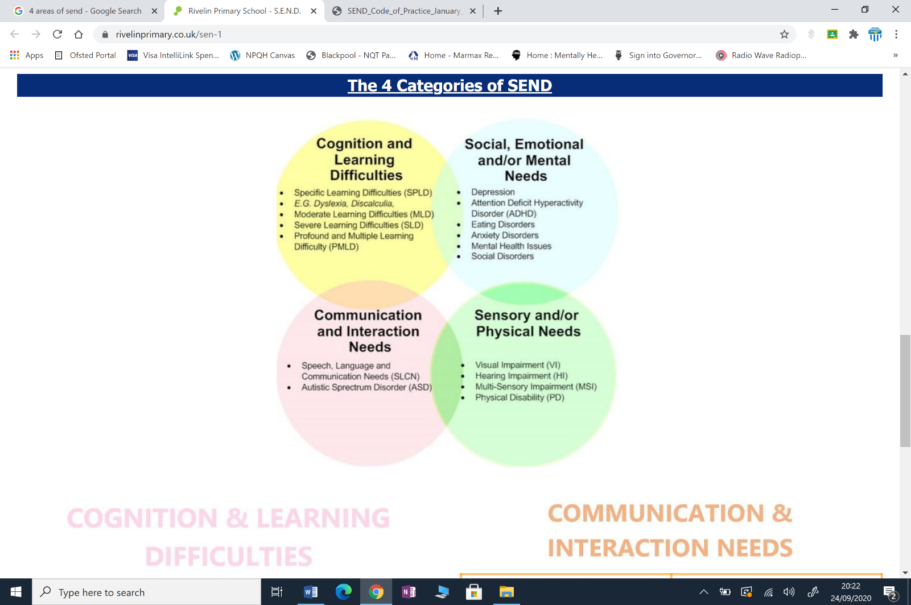

Effective SEND Provision

Ensuring the Principles of Effective SEND Provision are present across Hambleton Academy
Hambleton Academy strives to incorporate the following principles into their provision for pupils with SEND:
- Early Identification of need
- Learner engagement
- Timely and accurate record keeping
- Challenging, realistic target setting
- Small step approaches
- Adopting the “Assess – Plan – Do – Review” cycle
- Clear, effective and honest communication
- Shared staff expertise and support
- Effective and appropriate interventions and support
- Fair and equal access to all extra-curricular provision, clubs and activities providing opportunities to foster and develop interests and talents

Developing inclusive pedagogy
Hambleton Academy develop inclusive pedagogy by applying the following principles:
- Responding positively to the diverse needs that learners present
- Working collaboratively to overcoming potential barriers to learning
- Supporting every teacher to work alongside each Subject Leader, to ensure that provision and access to the curriculum is made in each subject and lesson
- Adapting and varying approaches to teaching and learning to ensure each pupil is the ‘best they can be’ evidenced through high levels of progress and attainment
- Providing opportunities for pupils to display their individual strengths and talents

Creating Enabling Learning Environments
Hambleton Academy offers an enabling learning environment for our pupils by being:
- Emotionally supportive with an atmosphere of encouragement and respect of individual needs
- Welcoming for learners with diverse needs
- Well-resourced with appropriately adapted resources, including ICT

In addition Hambleton ensures we:
- Have a Special Educational Needs Coordinator – Charlotte Blundell
- Keep a register of pupils with SEND
- Ensure all pupils with identified SEND needs receive support at a level appropriate to their needs
- Publish an annual: SEND Information Report, SEND policy and accessibility plan via their website

Roles and Responsibilities
Hambleton Academy is committed to the distributed leadership of provision for SEND across each year group. This includes all teachers and staff being teachers of and accountable for pupils with SEND.

Identification of Leaners with SEND
Hambleton Academy is committed to the early identification of pupils with SEND. The Senco, Charlotte Blundell, and external providers such as speech and language therapists, works closely with teachers to upskill them in identification of pupils with SEND.

Graduated Approach to supporting pupils with SEND
In accordance with the SEND Code of Practice, Hambleton Academy follows the Assess-Plan-Do Review approach to managing and supporting learners with SEND. Parents/ Carers and learners are involved at all stages to ensure that individual needs are met.
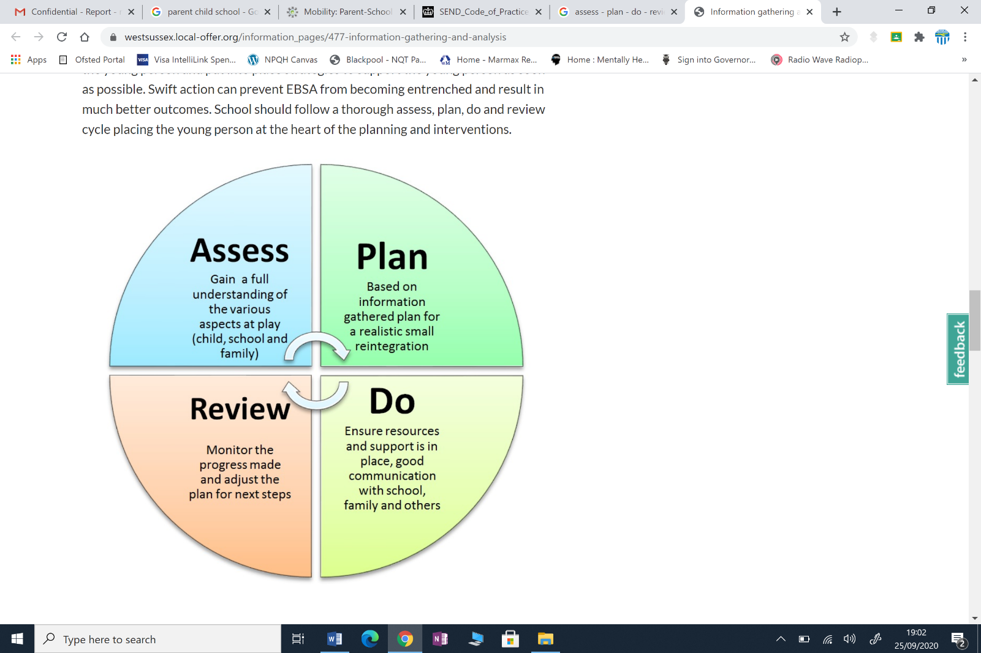

1. Quality First Teaching
The first stage of provision for all pupils in Hambleton is Quality First Teaching (QFT) including adaptive teaching strategies to improve outcomes for children with SEND and ensure inclusive classroom practice. This includes
- Explicit Instruction
- Clear, simple language for explanations
- Checking understanding frequently
- Instructions supported with images, diagrams. At Hambleton this includes the use of Widget symbols
- Modelling how to complete a task
- Cognitive and metacognitive strategies
- Recalling previously learnt content
- Small step approach to knowledge
- Asking questions to help children think about how to approach a task
- Scaffolding
- Using visually, verbal and written support
- Reducing levels of scaffolding over time
- Flexible grouping
- To meet need in different areas
- Pupils learning from one another
- Use of technology
- Adaptive technology for accessing the curriculum
- Adaptive technology for recording work
- Programmes to support learning
- Physical Aids to support access to the curriculum
- Including hearing aids, pencil grips, writing slants,
The graduated assess, plan, do, review model will be used to support learners who are identified as not making age related expectations. At Hambleton there will be two cycles of assess, plan, do review before a SEN support plan is actioned. This plan will be formatively assessed throughout the cycle. Parents, staff and where appropriate, the child, will be involved.

2. SEND Support Plan
Children identified as requiring provision that is additional to and different from their peers are identified as requiring SEND support.
These children will be on the SEND register, coded K. Children coded K on the SEND Register will have a one page profile and SEND support plan which will identify strategies, interventions and outcomes to address barriers to learning.
These plans will be reviewed at least termly with family, staff and where appropriate, the child, as part of the assess plan do review cycle.

It may be appropriate to progress to an EHC needs assessment to support more complex needs. The SENDCO will coordinate the necessary specialist support and prepare the assessment documentation for the assessment panel. The assessment panel is an external body of professionals who will make a decision based upon all the evidence from all of the professionals whether it is appropriate to have a plan issued or to remain on SEN support.

3. Education Health and Care Plan (EHCP) – SEND Support Plan ‘E’
Education, Health and Care plans include detailed information about the childrens’ needs, the arrangements to support the learners, identified provisions and agreed outcomes for the end of the child’s current key stage. These children will be on the SEND register, coded E. Children coded E on the SEND Register will have a one page profile and SEND support plan which will identify strategies, interventions and outcomes to address barriers to learning.

Progress towards the outcomes for these leaners will take place at least three times a year and will include an Annual Review.
Annual reviews will always include parents/carers and pupils. The multidisciplinary team supporting the young people will be invited to attend the review and provide advice.

Assessment
All children at Hambleton Academy including learners with SEND will be assessed formatively on a daily basis to ensure gaps in learning can be quickly addressed and strategies adapted to meet need. Children will also be assessed using a range of assessments and their progress and attainment will be tracked and monitored through data captures as part of Hambleton’s summative assessment cycle.

Transition
At Hambleton Academy, we recognise that times of transition can be challenging for all our children and particularly for children with SEND. To ensure effective and efficient communication and transfer of information when children enter school, the SENDCO will coordinate meetings and/or discussions with parents, feeder nurseries or schools and where appropriate the child. When children transfer to another school, the SENDCO will liaise with the school, parents and child. Hambleton recognises that transition takes place every time a child moves class year on year. The SENDCO will coordinate the transfer of information as appropriate to ensure that no gaps to learning occur at this time. At Hambleton the staff use a shared drive to ensure information is available and accessible at all times.

Staff Development
Hambleton recognises all teachers and TAs are teachers of children with SEND. Staff receive training to ensure that they are the best they can be and are able to provide a varied and interesting curriculum that meets the needs of all of our learners
In order to develop staff awareness and expertise in the area of SEND, the SENDCO at Hambleton has completed her NASENCO award and is committed to ongoing training. She also attends the Trusts Quality Improvement Group or SEND.

Multi agency work
The staff at Hambleton Academy value working in partnership with other agencies, such as health, social services and Lancashire Local Authority SEND teams, to meet the needs of all our pupils.

The Local Offer
Hambleton works in partnership with Lancashire Local Authority agency as part of the local offer for SEND.
Lancashire Local Offer can be viewed via this link
https://www.lancashire.gov.uk/children-education-families/special-educational-needs-and-disabilities/your-local-offer/
Date of the policy September 2024
Date to review policy September 2025

