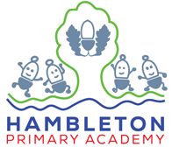  English  Our topic this half term: Tales from East  Our books this half term: Cloudbusting by Malorie Blackman | 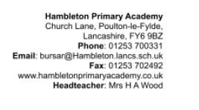  In our English this half term we will be following the Talk-4-Writing Process (using the Poetry Narrative ‘Cloudbusting’ by Malor Blackman) we will be writing a Diary Entry in role as a character. Alongside this, the children will have short writing opportunities linked to the book in order to be fully immersed into the narrative.
Maths | In our Maths this half term we will be focusing on; statistics, shape, position and direction. We will be continuing using the White Rose Maths scheme of work which breaks these bigger units of work into smaller steps which allows the children to understand the knowledge and skills within each of these units.
Science | In our Science this half term we will be looking at ‘Living things and their habitats’. Within this unit, we will be examining the different life cycles of plants, insects, birds and mammals. We will be comparing the similarities and differences between these and how each living thing reproduces.
PSHE/RSE | In our PSHE/RSE lessons this half term, our unit of study is ‘Changing Me’. In this unit we will be looking at our self/body image, discussing the different changes our bodies undergo throughout puberty, contraception, our growing responsibility as young adults, coping with change and the transition into Year 6.
RE | In our RE this half term we will be continuing with our work around  ‘Sikhism’. This time we will be looking at commitment and how the Sikh community show their commitment to God. Looking at the 5K’s and discussing their importance to the Sikhs, the different ceremonies and journeys a Sikh can undertake to show their commitment to God. | 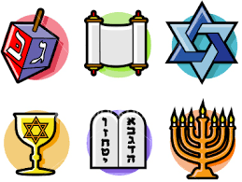
DT | In our DT this half term, we will be Adapting a traditional recipe, understanding that the nutritional value of a recipe alters if you remove, substitute or add additional ingredients. Writing an amended method for a recipe to incorporate the relevant changes to ingredients. Designing appealing packaging to reflect a recipe. researching existing recipes to inform ingredient choices. | 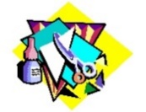
History | In our History lessons this half term we will be focusing on the ‘Golden Age of Islam’ within this unit we will be starting with a fantastic outreach session from the people at the Lancashire History Service, we will then be looking at; the legacy of the Golden Age of Islam in the world today, citizens of Baghdad – everyday life, school and education, the House of Wisdom and many other great aspects of the Golden Age of Islam! | 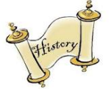
PE | This term we will be looking at athletics, preparing for the Sports Day event and practising different types or races, long jump, triple jump and all other aspects of athletics. We will also be holding our annual Sports’ Week, which will focus on this year’s Summer Olympics, which will be held in Paris.
French | In our French lesson this half term, we will be looking at different animal habitats which links to our science unit this half term. We will read, write and say different types of habitats, animals and the features of these habitats.
Music | In our music this half term, we will be focusing on ‘Life Cycles’ and incorporating the following themes into this: Lullabies, Lesson Time, Deadlines, Work sounds, Later in Life and the Underworld.
Our enrichments this half term: School Sleepover!

