Our topic this half term: Inside the Toy Box!
Our books this half term: The Gingerbread Man, Bagpuss and the Old Mans Beard, Little Rabbit Foo Foo, Lost in a Toy Museum, White Hen and Fox, A Dark, Dark Tale.
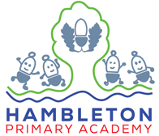  English | This half term we will transition from our Drawing Club approach from Reception to following the school curriculum for writing. We will explore a different range of stories including traditional tales, animations from the past, adventure stories and a spooky story! The children will learn to use adjectives to describe the characters and immerse themselves into the setting. The children will write their own sentences to create their own simple stories. We will be working hard to make sure that we use capital letters for the start of our sentences, as well as for names of people and days of the week. We will also focus on using full stops at the end of our sentence.  Handwriting – In Year One we will teach the children to form pre-cursive letters. We will encourage the children to form letters from the line. This half term we will be looking at letter families long ladder letters and curly caterpillar letters.  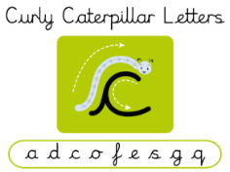  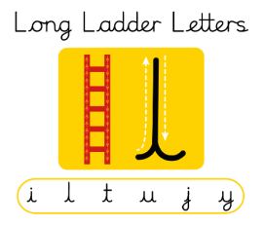 | 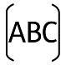
Maths | The main area that will cover this term is Place Value (within 10). We are working to improve our fluency with number as we follow a mastery approach, for children to work on mastering mathematical concepts. Children will be introduced to Place Value for the first time, which will be the basis for eventually working with numbers bigger than 10. We will work on skills such as, using a number line, finding one more and one less, comparing numbers using vocabulary greater than, less than and equal to, and many other interesting concepts! | 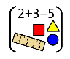
Science | This term in Year 1 Science, we will be exploring Animals Including Humans. We will begin by learning to identify and name different groups of animals, starting with mammals and non-mammals, before diving deeper into the distinct features of fish, birds, amphibians, and reptiles. Children will investigate what different creatures eat and practice grouping animals by their diet as carnivores, herbivores, or omnivores. We'll also compare a variety of animals side-by-side to spot their unique characteristics, from scales and feathers to fur and fins. Finally, we will focus on our own bodies by naming basic human body parts and connecting them directly to our five senses through fun, interactive discovery. | 
PSHE/RSE | This half term we will be reflecting on ‘Being Me in My World’. We will focus on who we can ask for help when we feel worried, our rights and responsibilities as a member our Year 1 class and knowing how we can make our class a safe space, by thinking about what makes us feel safe. We will also continue to adapt our PSHE lessons to meet the needs of our class, therefore lots of one-off lessons will happen when conversations arise. | 
RE | This term, we will be looking at Christianity and considering the question, ‘Does God want Christians to look after the world?’. We will learn about the Christian Creation Story and the concept of creation. We will look at ways in which everybody can help to keep the world a nice place for everybody to live. We will also consider why it is important to respect and look after the things that people have created. | 
PE | This term, we will be looking at key skills in PE such as, hopping, skipping, running, throwing and catching and bouncing. We will develop these fundamental skills by practising and applying them to each lesson and working on resilience when things are harder.  Our PE days are Tuesday and Thursday. | 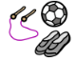
Music | In Music, we will be completing two units which are, ‘Number’ and ‘Ourselves’. Within these units of work, we will explore ways of using our voices expressively by singing and performing with actions to create an expressive story. We will also develop a sense of steady beat through using body percussion, movement and instruments. | 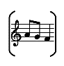
History | History is the centre of our topic, ‘Inside the Toy Box’. We are going to be exploring how toys have changed over time by comparing these to the toys we like to play with. The children will have the opportunity to explore these and compare them to the toys and games that we like to play with now. We will use this as an exciting opportunity to connect with members of our community and interview people to find out interesting information about the toys they once played with. We will use all of this to help us build a sense of chronology. | 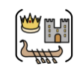
DT | This half term, our Year 1 designers and engineers will zoom into an action-packed Design and Technology unit on Woodwork and Cars! We will launch our project by designing, planning, and crafting our very own custom wooden vehicles. Working like real craftspeople, the children will select special tools to safely cut out different shapes of wood and experiment with various ways of joining their materials together. They will discover the secrets of motion by exploring wheels and axles, carefully attaching them so their cars can roll into action! Finally, young engineers will test their completed vehicles on the track to measure how far they travel and proudly evaluate their finished designs. | 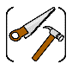
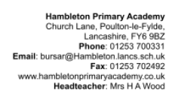
Our enrichment this half term:
Toy day – Children to bring in their favourite toy and compare these to toys from the past – Wednesday 14th October 2026

