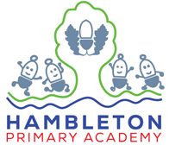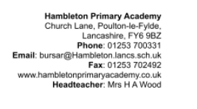

| English | In English we will be exploring the world of adventure and mystery as we become writers using our own imaginations in the style of Roald Dahl. Many of our budding readers are enthusiased by his writing and I can’t wait to see them immerse themselves into the wonderful world of adventure. |  |
| --- | --- | --- |
| Maths | As Mathematicians we will be continuing our work on addition and subtraction, including new methods to exchange when crossing tens and hundreds. We will also delve into multiplication and division. By the end of Year 3 we need to know our 2,3,5,10,4 and 8 times tables, bring on TTRS. |  |
| Science | Our unit of science will be forces and magnets and as scientists we will explore friction and it’s use on surfaces then look at magnets and their strengths and uses. We will get to be investigators as we look at methods, become researchers, display data and write conclusions. |  |
| PSHE/RSE | In PSHE we are moving on to looking at what it means to ‘Being Me in My World’ as we understand choices, rewards and consequences and the impact these things have on ourselves. We will understand and value ourselves before looking at how group work is valuable and unavoidable in today’s society. |  |
| RE | In RE this half term, our religion will be Christianity and we will be exploring the significance of the Christmas story to Christians by asking the Key Question – Has Christmas lost its true meaning? |  |
| PE | As sportspeople we will become dancers! We will work solo, in partners and in small groups to explore movements and narrative then include these in our own complex dance phrases. Check out Facebook for updates on our performances! |  |
| Geography | In geography this half term we will be exploring human and physical features and their purpose, including why they are where they are. We will be exploring Hambleton then comparing directly to New York, I wonder how many similarities and differences there will be. |  |
| Computing | In Computing we will be building a robot with Lego following instructions and evaluating as we go. We will then programme the Robot to pull objects and then investigate how we can pull heavy objects by increasing the friction by changing the tyres. |  |
| Art | As Artists in Year 3 we will be exploring charcoal (an old shirt / top will be needed please!) and creating gestural mark making whereby we will be free flowing and imaginative. Skills will be built on from Year 2 and new knowledge will be learnt as we become artists creating an atmospheric drawing. |  |
| French | Now we have been introduced to the French language, our second unit will be animals. We will learn 10 nouns and use these through reading, writing, speaking and listening activities. Mrs Parkinson will continue to be our expert teacher. |  |

