English | In English, we are using our class read, ‘The Land of Roar’ to inspire lots of writing opportunities! We will be writing predictions, descriptions, letters, instructions, stories and even making our own ‘Top Trumps’ cards. Children will be immersed into the world of dragons, and will even have the opportunity to design their own. | 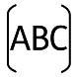
Maths | In our Maths this half term we beginning the new academic year focusing on place value of numbers up to 10,000. We will delve deep into the understanding of these numbers, which we will then use to help us understand how to use different methods to solve addition and subtraction problems. We will also complete a unit on measurement, where we will learn about area. Although measurement is also explored throughout our place value unit. | 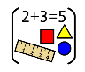
Science | In Science this term, we will be learning all about Animals Including Humans. We will be learning about the human digestive system, and we will be able to name the parts and describe each function. We will also learn about the different types of teeth in the human body, before moving onto using food chains to identify producers, predators and prey. | 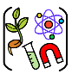
PSHE/RSE | In our PSHE/RSE lessons this half term we will be looking at “Being Me in My World”. In this unit, we will be looking at where we fit into our community and how we are an important part of both our class and school teams. We will learn about rights, responsibilities, democracy, rewards and consequences. An important part of this unit is understanding how our actions can affect other people. | 
RE | In RE, we will be learning all about the religion of Buddhism. We will be learning about the life of Buddha and whether it is possible for everyone to be happy. We will explore themes such as, whether money can make people happy and what makes us happy as individuals. | 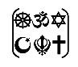
PE | We will start off the year by looking at a ‘Net and Wall’ unit. In this, we will learn different throwing actions, catching skills and striking a ball. Alongside this, we will complete a dance unit called, ‘Sparks Might Fly’, where we will take inspiration from all things electrical! | 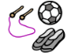
French | In our French this half term, we will be learning about conversation, greetings and age. This will build nicely on the French-speaking skills we learnt in Year 3. | 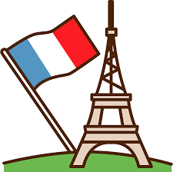
Music | In Music this term, we will be listening and appraising music. We will be responding to music from two different centuries with a two-part song and rhythmic composition. In our second unit, we will explore pentatonic melodies and syncopated rhymes. | 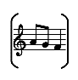
History | This term we will be learning all about the Suffragette movement and how they campaigned for women’s voting rights. We will start off by looking at how voting has evolved from the 19th Century to the modern day. We will learn about the key figure Emeline Pankhurst and her part in the actions of the WSPU. | 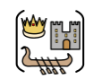
DT | Our focus in DT is woodwork, where we will learn how to be safe with tools and create a product using new and previous skills. | 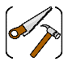
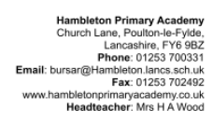
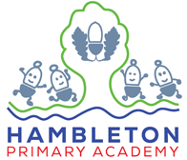
Our topic this half term: Power to the People!
Our books this half term: People Power, Fantastically Great Women Who Changed the World, Little People, Big Dreams: Emmeline Pankhurst, Suffragette: The Battle for Equality.
Class read: ‘The Land of Roar’
Our enrichment this half term:
Edith Rigby Outreach Session

