English | In our English this half term we will be focusing on writing themed around the book, ‘Escape from Pompeii’. will have the opportunity to write various pieces such as, setting descriptions, narratives, fact files, non-chronological reports and poetry. | 
Maths | This half term we will be continuing our work on multiplication, where children are learning how to be fluent in their times table knowledge. Children will develop their understanding of factors, factor pairs and how to multiply and divide 2- and 3-digit numbers. | 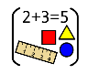
Science | This half term, we will be looking at sound! This is an exciting unit of work with lots of practical learning. Children will learn how different instruments make their sounds and understand how dolphins and whales communicate through sound under water. | 
PSHE/RSE | In our PSHE/RSE lessons this half term, we will be focusing on celebrating differences. In this, we will be learning about how we can form our own opinions of people without the influence of others and how to overcome situations such as bullying. | 
RE | In our RE this half term, we will be asking the big question “Could the Buddha’s teachings make the world a better place?’’ Children will learn about Buddhist beliefs, such as the eightfold path and how this helps Buddhists to live their lives. | 
PE | This half term, we will complete two units in PE. We will continue our unit on gymnatics where children will learn a range of balances, travels and rolls. Also, invasion games, where children will look at the skills involved in a range of games, but specifically focusing on skills linked to netball. | 
French | In our French this half term, we be learning about the weather both in France and the UK and how to speak about it in French. | 
History | Our history unit this half term is the Romans! Children will learn about what life was like in Rome, including understanding the timeline of key events. They will also learn about the Roman impact on Britain and how it shaped the way we live today. | 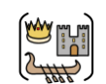
DT | This half term, our DT unit is textiles! Children will be putting their sewing skills to the test and making our own iPad cases. | 
Music | This half term we will complete a unit on Food and Drink, where we will learn to use our voices expressively and to sing in a round. | 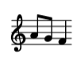
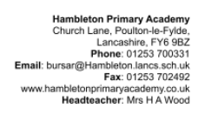
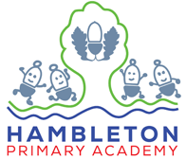
Our topic this half term: Volcano Venture: A Roman Adventure!
Our book this half term: Escape from Pompeii and The Great Chocoplot

Our enrichment this half term:
Roman out reach session.

