English | In English this half term we will be learning about Greek myths and legends through a mysterious ‘cursed banquet’. In this unit of work, there will be lots of writing opportunities including, incident reports, witness statements, narratives, descriptive scenes, persuasive writing and our own legends. | 
Maths | We will focus on fractions and decimals this half term. We will also continue our hard work on multiplication, as we get ready for the Multiplication Test Check in June 2026! | 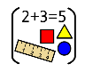
Science | In Science this half term, we will be learning about classification and changing habitats. We will understand how living things can be grouped in different ways and how there can be both human and natural impacts on different habitats. | 
PSHE/RSE | In our PSHE this half term we will be focussing on the topic ‘Healthy Me’. We will learn about healthy friendships and relationships and how we can keep our bodies and minds healthy. | 
RE | In RE this half term, we will be asking the big question: What is the best way for a Buddhist to lead a good life? We will learn about the Noble Eightfold Path, and how Buddhists use this to live a good life. | 
PE | This term we are focusing on gymnastics and athletics. We will learn a range of throwing techniques such as, push, pull and sling. | 
French | We will learn how to talk and write about our homes, including the type of house we have and what rooms we do/don’t have. | 
Music | In Music this half term, we are lucky enough to have ukulele lessons with Lancashire Music Service! | 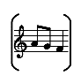
History | In History this term we are learning all about the Ancient Greeks. We will learn about life in Ancient Greece, including the importance of the Greek Gods. We will compare Athens and Sparta and learn about Greek democracy in comparison to modern British democracy. We will also learn about famous philosophers. | 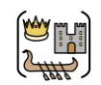
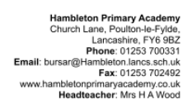

Our enrichment this half term:
We will have an Outreach session to enrich our learning in History.
Sports week!

Our topic this half term: Groovy Greeks!
Our book this half term: The Accidental Pirates

