English | In our English this half term we will be focusing on a selection of non-fiction and fiction books and poems all about World War 1. During this unit we will be focussing on creative and immersive writing, allowing pupils to express themselves and explore a range of genres. They will be writing descriptive pieces, poems, inner monologues and letters. | 
Maths | In our Maths this half term we beginning the new academic year focusing on place value of numbers up to 1,000,000. We will use this knowledge to help us understand how to use a formal method to solve addition and subtraction problems. We will then move onto multiplication and division where we will again look at formal and informal methods to help answer tricky questions. | 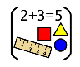
Science | In our Science this half term we will be focusing on “mixtures and solutions”. In this unit we will begin to understand how solids liquids and gasses can be formed to create solutions and mixtures, then learn how these properties can be reversed using filtration, freezing, melting, boiling; also investigating properties that can’t be reversed. | 
PSHE/RSE | In our PSHE/RSE lessons this half term we will be looking at “Being Me in My World”. We will be discussing our hopes and dreams for the year ahead, our responsibilities as a citizen and as a member of our school and identifying expectations for our class. | 
RE | In RE this half term, we will be asking the big question “How far would a Sikh go for his/her religion?” We will explore this question together and then look at what Sikhs do for their religion and discuss what other people do for their own religion. | 
PE | We will start off by looking at “Invasion games” focusing on the skills and tactics needed to be successful in these games as a team. We will also be having weekly swimming lessons on Fridays, which continue throughout the year. | 
French | In our French this half term, we will be continuing with our phonetics and then using what we have learnt to discuss our family home focusing on “Pets”. | 
Music | In Music this term, we will be listening and appraising music. We will be discussing similarities and differences between songs, our likes and dislikes and identifying style indicators of music. We will be finding the pulse of music and using correct musical language throughout. | 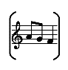
History | This half term in our History we will be investigating many aspects of World War 1. We will be learning about the war whilst focussing on the impact it had on our local area, the North West. | 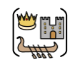
DT | We will learn basic tool safety and create a product with a purpose using previous and new woodwork skills. | 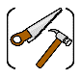
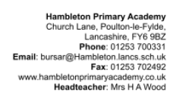
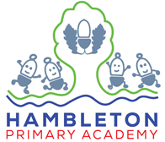
Our topic this half term: World War 1
Our book this half term: War Horse, Armistice Runner and Archie’s War

Our enrichment this half term:
Outreach Sessions in History.
Forest School

