English | In our English this half term we will be writing non-chronological reports and creating our very own Dragon Handler Manuals. We will be discussing dragons, as these are mythical creatures in Norse mythology. We will have plenty of opportunities to explore other text types throughout this unit. | 
Maths | The areas that will be covered this half term are: fractions, ratio and units of measure. Throughout these areas we will always be looking to use and apply these skills in real life situations. | 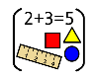
Science | In our science this term, we are going to be exploring inheritance and evolution. We will be studying the scientific phenomena of natural selection and the theory of evolution by Charles Darwin. | 
PSHE/RSE | In our PSHE this half term we will be focussing on the topic ‘Celebrating Differences’. We will be discussing what makes us unique and how we celebrate this. We will also be discussing how it is unfair to treat people differently because of their differences. We will be focusing on empathy throughout. | 
RE | In our RE this half term, we will be asking the big question: Is anything eternal? We are focusing on the Christian religion and the theme of salvation. We will be discussing the Christian belief on eternal life and how Christians believe this is achieved | 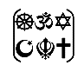
PE | In PE this half term, we will be focusing on the skill of dribbling, travelling with different  balls/equipment and intercepting at the right time. Additionally, we will be continuing with the skill of balance by looking at weight balances and creating balances when weight or height doesn’t match. | 
French | In our French this half term, we will be focussing on the topic ‘The Weekend’. We will learn new vocabulary to enable us to talk about our hobbies and what we do out of school. We will also continue to learn how to tell the time in French. | 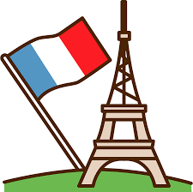
Music | In Music this half term, we will be studying the topic ‘Journeys’ where we will be learning how to sing in three-part harmonies. | 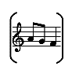
History | This half term in our history we will be learning all about the Vikings. We will be focusing on how and why the Vikings invaded Britain. We will be looking at time lines, artefacts and discussing cause and effect of the invasion. | 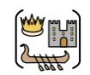
DT | This half term the children will be fully immersed by having their own DT dedicated week. The unit of work is focused around textiles. We will be, planning, designing and making our own designs using a range of fabrics. | 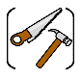
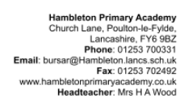
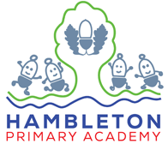
Our topic this half term: Ancient Mythology
Our book this half term: The Dragon’s Hoard by Lori Don

Our enrichment this half term:
We will be welcoming a Christian Visitor.

