English | In English this half term we will be reading, writing and exploring a  range of genres. We will be further exploring the theme of short stories, writing a range of genres including diaries, reviews, dialogue and short stories. | 
Maths | The areas that will be covered this half term are: shape and angles, ratio,  algebra and consolidating the learning we already have covered. Throughout these areas we will always be looking to use and apply these skills in real life situations. | 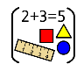
Science | Our Science this half term we will be focusing on circulation and health. We will be exploring the heart and circulatory system through models and enquiries and considering how lifestyle choices affect our health. | 
PSHE/RSE | In our PSHE this half term we will be focussing on the topic Changing Me.  We will be learning about self-image and self-esteem, changes in our bodies how babies develop and healthy relationships. We will be covering this at the end of this half term and the start of next half term. | 
RE | In our RE this half term, we will be asking the big question: Does belief in  Akhirah (life after death) help Muslims lead good lives? We are focusing on  the religion of Islam and the theme of beliefs and moral values. We will be  exploring this over summer 1 and 2. | 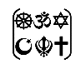
PE | This term we are focusing on striking and fielding games, such as rounders, and the skills we need. We will be working on a range of skills from: catching, striking, fieldwork in teams and throwing with a range of techniques (underarm/overarm). | 
French | We will continue to learn how to talk about ‘Healthy Lifestyles’ in French. We will learn words for healthy and unhealthy food and drinks, how to talk  about activities that keep us healthy and we will write a healthy recipe. | 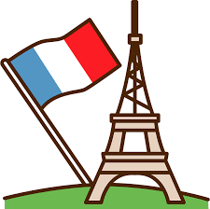
Music | In Music this half term, we are continuing to be work alongside  Lancashire’s Music Service. We will be learning more about how to play the  trumpet. | 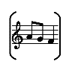
History | In History this term we are learning all about the Maya civilisation and  how it contrasts with Anglo-Saxon Britain. We will be learning about where  and how they lived and their settlements by comparing and  contrasting. | 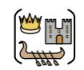
DT | In DT this term we will be focussing on cooking and food. We will be  learning about healthy eating, what makes a healthy diet and what a  balanced three course meal entails. | 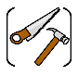
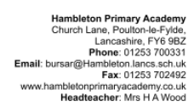
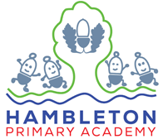
Our topic this half term: Perseverance
Our book this half term: The Rainplayer oy David Wisnieski

Our enrichment this half term:
We will have an Outreach session to enrich our learning in History

