Child friendly PE Policy

What is PE at Hambleton?

We at Hambleton will help you:
‘To develop your physical potential, to help you to be ‘the best that you can be’ and to help you to prepare for the future, living a healthy, active life, in accordance to our school rights.’
We aim for you:
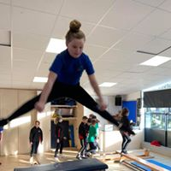
To participate in high quality PE sessions
To develop positive attitudes towards Physical Activity (PA)
To learn how Physical Activity affects the body
To develop and explore physical skills with increasing control
To apply skills in a range of competition style scenarios
To feel included and challenged

What Do We Wear for PE?
House coloured T-shirts
Plain black PE shorts, joggers or leggings
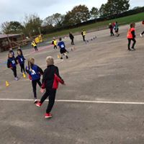
School PE jumper
Black pumps or trainers
All jewellery must be removed
Long hair must be tied back
For swimming, an appropriate swimming costume and cap are needed
Permission slips are needed for goggles.

How Often Do We Have PE?
-Each class has PE two hours per week, taking part in both Physical Activity (PA) and learning key information to help them with their Physical Education (PE).

Can I Represent Hambleton?
Throughout your time at Hambleton you can represent the school in lots of different School Sports (SS) both in, and outside of school.
In school, you can represent the school in the following School Sports (SS):
-Sports day- you can represent your house colour
-At the end of each half term you will have a competition based on what you have been taught
Against other schools in events such as:
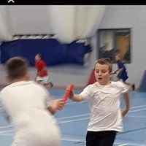
- Football
- Rugby
- Dance
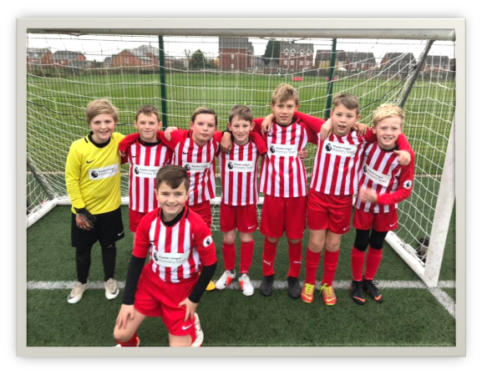
- Netball
- Athletics
- Basketball

