Hamilton Uniform Policy

Committee: | Trust Board
Approved on: | July 2021
Next review date: | July 2022
Updated/Reviewed on: | June 2021

The governing body of Esprit Multi-Academy Trust schools believe that school uniform is important in building the pupils’ sense of identity and belonging to the community of their academy. It instils a sense of pride in the academy and supports positive behaviour. It is one of the symbols of the ethos of the academy and protects children from social pressures whatever their race, religion, gender or background. Other advantages to having a school uniform are linked to security, as a uniform enables pupils to be identified easily and means that any intruders can be identified swiftly.

The Governors of our academy also believe that a school uniform is an important contributor to the overall success of the academy and, therefore, expect that the school uniform will be worn by all children – including those in the Nursery.

This policy document outlines:
- The reasons for having a school uniform
- What the school uniform consists of
- Making the uniform accessible
- How the school will deal with non-adherence

What the school uniform consists of:

Boys | Grey trousers / Shorts can be worn in the summer  White polo shirt, preferably with the academy logo  Blue academy jumper, preferably with the academy logo  Grey / black socks  Black school shoes
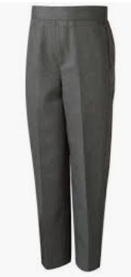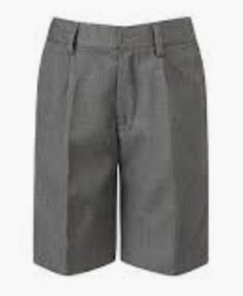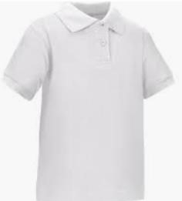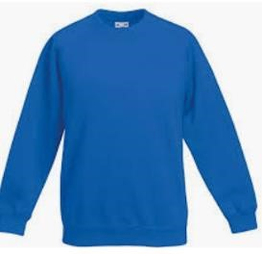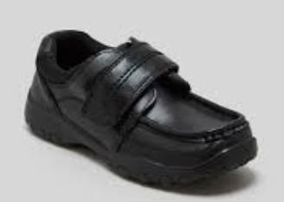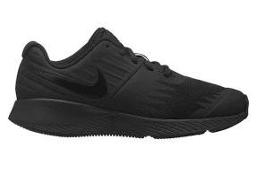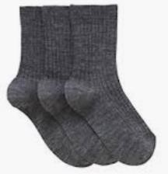

Girls | Grey skirt, pinafore or trousers  Skirts and/or summer dresses (blue and white check) can be worn in summer.  White polo shirt, preferably with the academy logo  Blue academy jumper or cardigan, preferably with the academy logo  White socks, black / grey tights in winter  Black school shoes
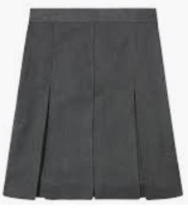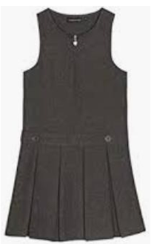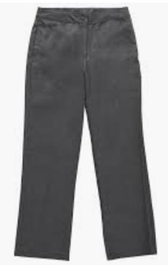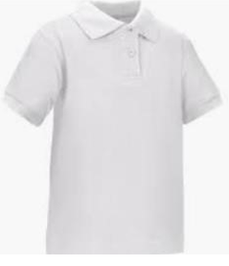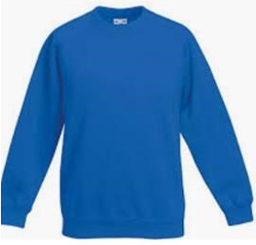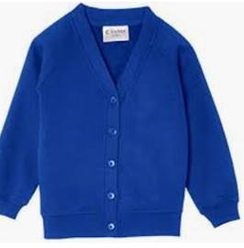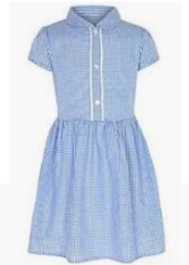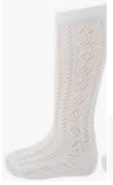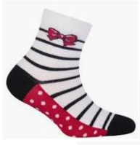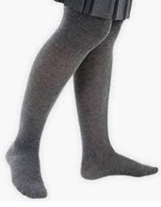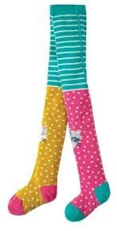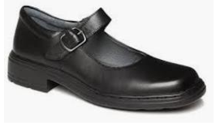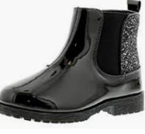
General | Warm and waterproof coat with hood  Sun hat when sunny  Water bottle with a sports lid  EYFS children – All in one waterproof suit and wellies  Book bag (No backpacks)  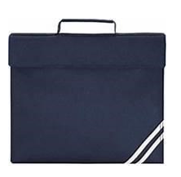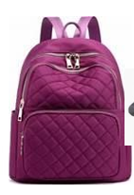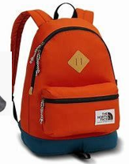
P.E. Kit  ALL children | Black shorts  White T-shirt, preferably with the academy logo  Black pumps  P.E. cordless pump bag
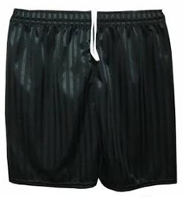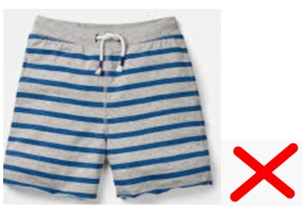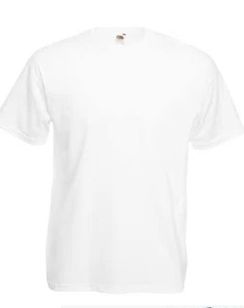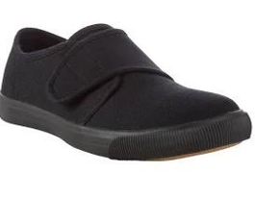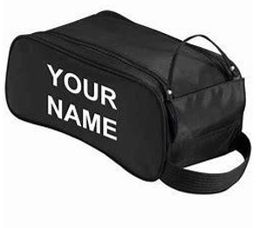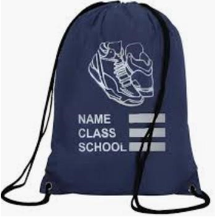
P.E. Kit  Key Stage 1 | Grey jogging bottoms  Grey jogging hoody, preferably with the academy logo  Trainers to be worn with jogging suit
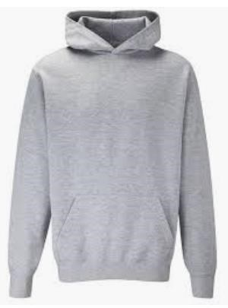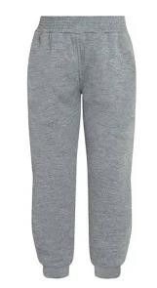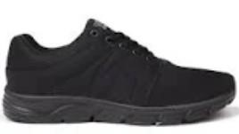

Uniform can be purchased from the National School wear Centre, Stafford Street, Hanley, Stoke-on-Trent. ST1 1LS

Uniform guidance
- All items of school uniform must be clearly labelled with the child’s name.
- Additional guidance will be given with regards to changes to seasonal uniform.

Jewelry
- Jewelry must not be worn including earrings.
- Standard ‘non-toy’ watches may be worn in Key Stage 1 although the academy cannot take responsibility for them and they must be removed for P.E. lessons. No smart / iwatches are allowed.

Hair
- Long hair must be tied back.
- No dyed, shaved lines or patterned hairstyles are allowed in the academy.
- Back and sides of hair should be no shorter than a Grade 1 cut.
- Hair accessories should be small, plain and in academy colours (e.g. no large bows). No tinsel or coloured braids.

Footwear
- Children’s footwear must be black, with a secure fastening (buckles, laces or Velcro).
- Shoes with a ‘high heel’ are not permitted.
- Trainers are only part of the outdoor P.E. uniform and should not be work at other times during the academy day. They should only be worn on the days when pupils wear their grey jogging suits to school.

In the interest of health & safety, these items are NOT permitted in the academy:
- Umbrellas
- Sunglasses (unless prescription)
- Pumps should not be worn with jogging suits – pupils will change into these if needed.
- Open-toed sandals, shoes with raised heels, clogs or mules should also not be worn. These are not suitable or safe, especially at playtimes
- Jewellery – Strictly no chains, rings or earrings to be worn. If your child arrives at the academy wearing earrings, you will be asked to remove them before the child enters. Alternatively, you will be contacted to attend the academy to remove your child’s earrings.
- Make up, nail polish and temporary tattoos must not be worn (unless under extenuating circumstances)
- Corded P.E. bags and back pack bags

Accessibility to academy uniform
The governing body recognises the need to ensure that the uniform is affordable and will work with the academy to ensure they use any donated uniform to hold ‘good as new’ sales, which are regular and well publicised.
- The academy will also ensure that parents or carers where necessary, know about any local authority schemes that can provide school clothing grants or other help towards the cost of school clothing.
- The governing body recognises its obligations to accommodate reasonable religious requirements within the official academy uniform and to ensure it is not discriminatory on the grounds of gender, race, religion or belief.

Please be aware that what is and is not acceptable will be decided by the academy in line with this policy and the academy’s decision is final.

Please note that by sending your child to Hamilton Academy, you are agreeing to ensure that your child abides by this policy.
If you have any queries or questions regarding any aspect of uniform, jewelry or hair style, please speak to a member of academy staff.

