Behaviour Policy

Three key aspects of ‘What We Stand For’ underpin our approach to our principles around behaviour. We strive to ensure that the following aspects are a permanent part of our culture:

- A calm, positive and structured environment that enables students to feel safe and achieve their ‘personal bests’ across the school.
- Partnerships with families, and others that develop a consistency of approaches and enhance opportunities and well-being for students and families.
- A culture where everyone is supported and challenged and treated with dignity and respect.

This document includes a behaviour management policy for promoting positive behaviours proactively and managing minor incidents and a positive handling policy for managing physically challenging behaviours (including physical restraint). In line with Keeping Children Safe in Education (2022) our behaviour policy emphasises measures to prevent bullying, including cyber-bullying, prejudice-based and discriminatory bullying.

The policy has been prepared for the support of all teaching and support staff who come into contact with pupils and for volunteers working within the school to explain the school's arrangements for care and control. Its contents are available to parents and pupils. The following policy is about the Schools Behaviour Management and Positive Handling policies and it should be made available to all. This can be accessed via our website. This policy includes information on the use of reasonable force” to control or restrain pupils.

Teaching and non-teaching staff work in ‘loco parentis’ and should always operate with an appropriate ‘Duty of Care’ as they could be liable for a claim of negligence if they fail to follow the guidance within this policy.

Following the Team Teach principles, Hamilton school strive to develop shared values, which promote attitude, skills and knowledge, needed to implement a calm, safe and happy learning environment. We strive to positively handle behaviour with verbal and non-verbal techniques that support de-escalation in holistic ways and where necessary, safe and effective physical interventions.

This policy will be reviewed annually.
Approach to promoting and managing behaviour

Arnett’s diagram: The link between intensity of emotions and behaviour

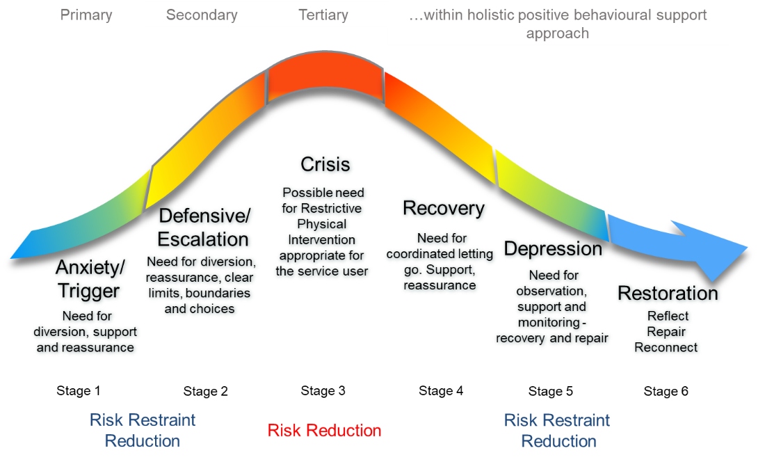

Stage 1. Something pleasant, frightening or aversive happens which triggers an increase in arousal. The person may become anxious, angry or excited.

Stage 2. Arousal continues to build either rapidly (seconds) or slowly (minutes, hours or days) depending on trigger, the presence of other triggering events and individual levels in ‘arousability’. The person may become irritable, demanding, threatening or abusive, less able to cope with everyday demands.

Stage 3. Arousal peaks and person loses control. The person may become aggressive, destructive or self injurious.

Stage 4. Arousal levels start to drop and the person begins to calm. However, further stressors whilst arousal is still fairly high may cause rapid increases in arousal and further incidents as arousal peaks again.

Stage 5. Arousal drops sharply, sometimes falling below the individual’s comfortable level, causing the person to become sleepy, tired or miserable for a while
Baseline - Arousal returns to the optimal comfort level

All human emotions and behaviour may be applied to this diagram. This diagram is, therefore, a convenient point of reference for both the assessment of behaviour, as well as of its intervention and management.

Please note that pupils who are agitated on arrival to school may not be in the build-up phase of the diagram. They may be in the post-crisis phase, in response to an episode, either on transport or at home. It may even be a continuation of a situation which occurred on the previous day (week, month) . Should this be the case, these pupils may need additional time to defuse or calm down, before placing them in any situation which requires concentration or compliance.

Behaviour Expectations

In our context it is vital that there is a consistency of approaches and that our staff provide that for students. Staff are trained in effective techniques for working alongside students with a diagnosis of ASD. Our students benefit from clear boundaries and routines. The Senior Leadership Team (SLT) monitor the effectiveness of behaviour management and intervene where appropriate, with support from the Pastoral and Inclusion team. There is a continual process of reflection and evaluation to ensure consistency is maintained, which is also important to help identify any areas of support and further training that is needed. We strive on our ability to demonstrate flexibility when a need arises; thus offering our students an individualised program to support them through their school life.

All staff have a responsibility to safeguard our pupils and to monitor any changes to their behaviour that may cause concern. Bullying is not tolerated at Hamilton School and effective strategies are in place, personalised to the needs of the pupils about the acceptance, tolerance and inclusivity around their peers and adults, in school, families or the community.

Staff hold a level of accountability in ensuring any disclosures or cause for concern regarding a child’s online safety are recorded and monitored. Following that, parents are informed and on all accounts, everyone is further educated in how to stay safe, or how to keep others safe, online.

Behaviour Management

Classroom teachers work closely with their teams to ensure consistent and effective behaviour strategies are in place. Some students have a Positive Behaviour Plan (PBP). These documents explicitly set out the types of behaviours and sensory needs of concern that a particular student may exhibit and provide strategies to effectively manage them. We work vigorously to ensure de-escalation techniques are in place and that a child’s high-interest activities are used to motivate and engage them. Parents have copies of the PBP’s and are encouraged to sign them.These will be regularly reviewed as new challenges arise. There is a responsibility with class teams to follow whole school approaches and to record behaviours of concern. Regular CPD covering ‘Behaviour’ and ‘Climate for Learning’ is provided to all staff throughout the academic year and as part of their induction, as this is a key aspect of our work.

Our school environment and the facilities that we have are organised in such a way as to promote good behaviour and reduce the potential for negative behaviour. A great deal of attention is given to managing transitions throughout the day. We ensure that spaces are not overcrowded at changeover times and care is given to the different combinations of students in any given area at any given time. Visual resources, clear planning and appropriate use of language are the main strategies that are provided to ensure smooth transitions.

In order for behaviour to be at its optimum levels to facilitate important learning, we work very closely with parents and other agencies. Parents are informed of positive and negative behaviour and we develop joint strategies to ensure that negative behaviour is reduced. At Hamilton, we use Class Dojo, this is a vital tool to ensure regular communication between school and families at home. It is used alongside verbal conversations to develop an effective home-school link. The Pastoral and Inclusion Team will help provide support with this focus.

The school employs an Occupational Therapist, Speech and Language Therapist and an Educational Psychologist. They collaboratively work with class teams to devise strategies and give advice regarding certain behavioural issues. They will then continue to monitor the student to ensure the strategies are effective. We also work with other outside agencies such as CAMHS and the school nurse. If we feel a placement at our school isn’t appropriate for a student, we will also use the services of the various organisations and consult with SENAR.

In our positive environment, we strive to reward good learning behaviour. Praise and rewards are determined on an individual level. The use of symbols such as the one for ‘good’ are effective in supporting our teaching of good behaviour. Due to the nature of our students, we also need to explicitly teach aspects of appropriately good behaviour and this is done through our PSHE programme. For example, behaviour that is appropriate in ‘public’ places and that which is appropriate in ‘private’ spaces. Sanctions are also personalised and it is important that staff can distinguish between behaviour that challenges which is due to the student’s autism and that which isn’t.

When behaviour that challenges occurs, we always seek to understand the underlying causes as they are not always obvious. As part of our school mission of striving to transform lives, we focus on not only managing behaviours that challenge but also help to provide the tools our students need to positively self-regulate when these incidents occur. It is important for us to teach them emotions and how to identify these within themselves, differentiating this according to their level of understanding. This will coincide with our PSHE curriculum and will be an essential feature within their learning programmes. We follow the principles set out in “The Stages and Management of a Critical Incident” (Arnett 1989 and Clements & Zarkowska 2001). See Appendix 1 for a representation in the form of a diagram. Our overriding priority is to adopt a calm and measured approach. We look for behaviour triggers and analyse patterns in order to improve behaviour. Our recording system enables us to be pro-active and to use data to support our strategies.

Positive Handling

As previous mentioned, some students have a Positive Behaviour Plan (PBP). These documents explicitly set out the types of behaviours and sensory needs of concern that a particular student may exhibit and provide strategies to effectively manage them. On the PBP’s are agreed ‘non-restrictive’ and ‘restrictive’ interventions that parents must be informed of and agree to, to support that pupil’s needs when it comes to behaviour that challenges.

We use the TeamTeach Approach to enhance behaviour management. All staff receive initial training and regular refreshers in TeamTeach strategies. This supports the philosophy that approximately 95% of all so-called challenging behaviours can be addressed using positive non-physical intervention. As part of our intervention work, we use some non-restrictive and restrictive manual handling techniques. Non-restrictive handling requires no ‘Team Teach’ physical restraint procedures and instead involves de-escalation techniques which are specific for your child. A restrictive physical restraint is a taught and trained manoeuvre from ‘Team Teach’ where your child has put themselves or others in danger and they need to be physically removed from a situation to ensure their safety. In school we evaluate the Interventions needed to enable our pupils to be calm and happy.
These restraints are used as an absolute last resort and as a school our policy is “hands off”, however at times, these restrictive holds can be necessary.

All staff have received training with regards to recording behaviour via the behaviour database system. (Accessed via: Sleuth). The database allows low level / frequent and high risk behaviours to be recorded in appropriate detail and analysed to provide focused feedback to support the student. We offer regular support around the database system, completing whole school training around climate and focus groups for the behaviour database, Sleuth.

The Children Act 1989 makes clear that in any decision involving a child the paramount consideration must be the child’s welfare. Paramount means it should be the first thing people think about and it should take precedence over all over considerations. For that reason, staff need to carefully consider what is in the best interest of the child, both in the short term and the longer term.

In emergency circumstances, a student may need to use an additional space in a ‘time out’ situation for a very short period. This may be a shared space around school that could be made available, or outside. This should only be when one of two criteria are relevant:

- The imminent risks of danger to themselves are so great that not to use time out for the student would be dangerous.
- The imminent risks of a student hurting others are so great that not to use time out for the student would be dangerous to others

Staff need to keep calm in these situations as their behaviour will impact on the student if not. In these situations, it is useful to try and do 3 things:

1 Remove the audience
2 Reduce language and listen
3 Think how a change of face may help the situation.

In the case of any such instance occurring it is vital that time out is kept to an absolute minimum, which will be dependent on each individual circumstance. It is imperative that staff record full details of the incident on the recording system and to have a full debrief, therefore continuing a professional discussion regarding strategies being adopted and suggestions for any approaches to be amended or fully changed. It is then important that Positive Behaviour Plans are kept up to date. This strategy is underpinned with judgements being made regarding the severity of the situation, and there are no alternatives. If a reflection room needs to be used it is due to the fact that there is a serious risk of harm against others or to themselves.

Every effort will be made to ensure that all staff at Hamilton School:

- Understand their responsibilities in the context of their duty of care to keep children and adults safe.
- Understand that the paramount consideration is the welfare of the individual child
- Understand that ‘reasonable’ force means that it is necessary, proportionate and reasonable in the circumstances.
- Are provided with appropriate training to manage risk and this training is maintained at an appropriate level.

The Education and Inspections Act 2006 gives examples of the types of circumstances in which use of reasonable force may be legally defensible.

• Self – injuring
• Causing injury to other children, staff, parents and visitors
• Causing significant damage to property

The paramount consideration is for staff to work in the best interests of the child. Reasonable force will only be used when no other effective alternatives are available.

It is essential to make risk assessments when considering the use of reasonable force. Staff should balance the risk of taking action against the risk of not taking action. The Health and Safety Executive (HSE) has developed a 5 step approach to risk assessment. This can easily be applied to situations where staff need to make a decision whether to use de-escalation or physical contact.

1. Look for hazards.
2. Decide who might be harmed and how
3. Evaluate the risk and decide on the necessary and proportionate action.
4. Record your findings.
5. Review and revise if necessary.

It is not always possible to predict all risks relating to a specific behaviour of a child. When an unforeseeable risk presents itself a “dynamic risk assessment” can be undertaken. This means that staff do a mental risk assessment and then act in the best interests of the child. Once a risk has been identified, or if the risk is already known, then a planned risk assessment needs to be put in writing. If physical touch or restraint is required, the Positive Behaviour Plan (PBP) will state what interventions are necessary. Staff, including SLT, will identify these and parents are informed. This is then discussed with parents and, ideally, their signature is gained.

Racist incidents will be logged and parents will be informed in line with LA guidelines. These are also reported to the Local Authority regularly. Given the nature of our students, it is important that these issues are handled skilfully.

Appropriate sanctions will be applied to any student who is found to have made malicious accusations against school staff. If an allegation is made against a member of staff, the quick resolution of this should be the main priority with all concerned. At any stage of consideration or investigation, all unnecessary delays should be eradicated. Staff should not be suspended as a default response to an allegation. An individual should only be suspended if there is no reasonable alternative. If suspension is deemed appropriate, the reasons and justification should be recorded by the school in detail and the individual should be notified of these. Allegations that are found to have been malicious should be removed from personnel records and any that are not substantiated, are unfounded or malicious should not be referred to within employer references.

We acknowledge Hamilton School's legal duties under the Equality Act 2010 in respect to pupils with special educational needs (SEN).

Complaints:

The availability of this policy should reduce the likelihood of complaints but may not eliminate them.

All allegations will be investigated thoroughly; however, it is the responsibility of the person making the allegation/complaint to prove any inappropriate actions by the staff member.

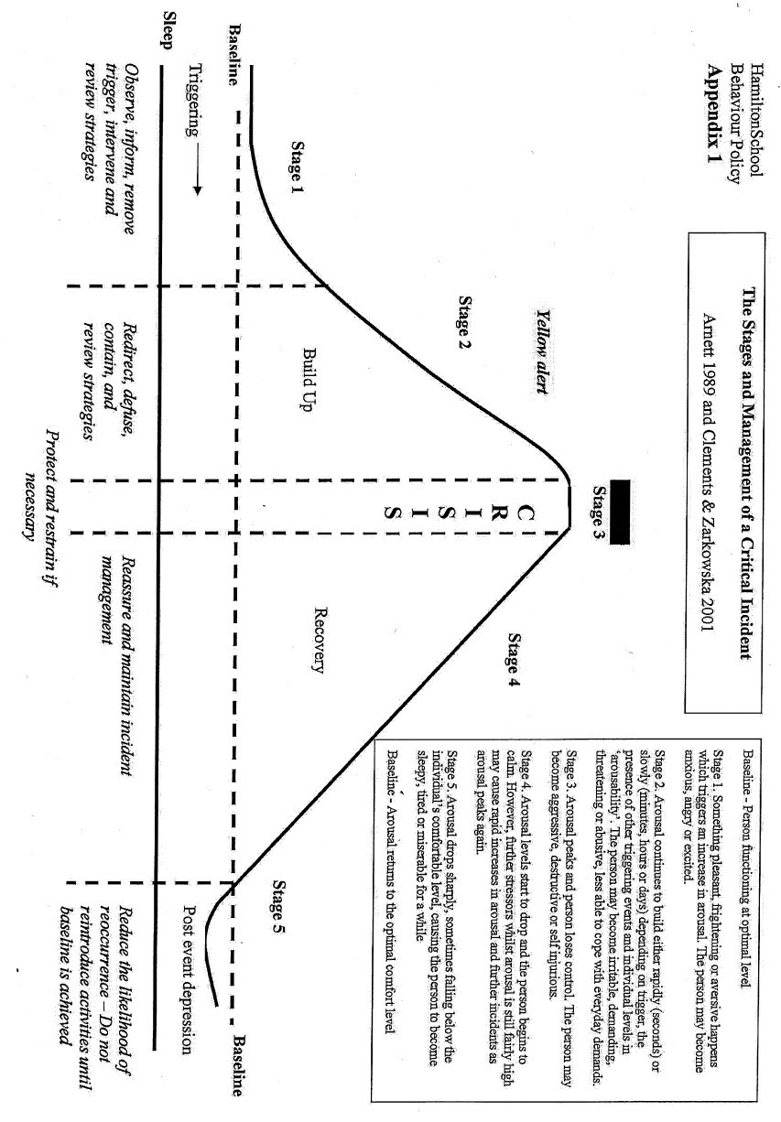
6

