

ASSESSMENT POLICY

Date of Review | Autumn 2024
Date for next review | Autumn 2025
Committee responsible | FGB
Authorisation | Ryan Brown

HANSLOPE PRIMARY SCHOOL
ASSESSMENT POLICY

Principles of assessment:
Effective assessment must be fit for purpose. It is an integral part of teaching and learning, providing evidence to inform our teaching through formative and summative methods. It is a continuous process in which both teacher, pupil and the wider school community are active and effective participants. Assessment will be applied consistently across the school and will be both manageable and useful.

Aims and objectives:

- To enable our pupils to demonstrate what they know, understand and can apply in their work.
- To allow teachers to plan work that accurately reflects the needs of the child.
- To help our children understand what they need to do next to improve their work.
- To provide information for parents that enable them to support their child’s learning.
- To contribute towards accountability data.

All assessment will also take into account the criteria of the National Curriculum (2014).

Assessment at Hanslope:
Assessment at Hanslope follows the principle that information will only be accurate and valuable if it is a result of rich and immersive learning opportunities. It should not seek to label children’s achievements but instead to remove the ceiling on attainment and support children in making the next steps in their learning. Assessment takes into account children’s strengths as well as areas where they need support.

Formative Assessment:
The vast majority of our assessment is formative and on-going which enables:
- Teachers to identify how pupils are performing on a continuing basis and to use this information to address misconceptions, provide appropriate support to close gaps or to extend knowledge, evaluate teaching and plan future lessons which enable pupils to acquire new knowledge, skills and understanding in an accumulative fashion.
- Pupils to measure their knowledge and understanding against learning objectives, and identify areas in which they need to improve
- Parents to gain a broad picture of where their child’s strengths and weaknesses lie, and what they need to do to improve

The most common forms used are:
- Effective questioning in class
- Informal tests which assess pupils’ retention of facts and consolidate learning
- Observation and instant intervention
- Marking- feedback and next steps (See Marking Policy), including enabling pupils to self-mark and correct their own work where appropriate
- Pupil self-evaluation of knowledge, skills and understanding – often at the start or end of a topic or unit of work
- Recording of assessment against objectives taught within each curriculum area
- Scrutiny of books
- Pupil Progress Meetings

Summative Assessment:
This may take place at the end of a particular unit of work, or at the end of each term and informs the teacher of how well children have understood and retained their learning. It is also used to show progress over a period of time.
- School leaders, including subject leaders, to monitor the performance of pupil cohorts, identify where interventions may be required, and work with teachers to ensure pupils are supported to achieve sufficient progress and attainment
- Teachers to evaluate learning at the end of a unit or period and the impact of their own teaching
- Pupils to understand how well they have learned and understood a topic or course of work taught over a period of time. It should be used to provide feedback on how they can improve
- Parents to stay informed about the achievement, progress and wider outcomes of their child across a period

The most common forms used are:
- End of unit assessments against specific objectives taught
- End of Year tests in reading, grammar and maths
- Unaided pieces of writing
- End of topic scaffolded tasks / questions which assess the skills, knowledge and understanding that pupils have acquired.

In addition, there are National Curriculum summative assessments which measure children’s abilities against national standards:
- Phonic Screening Check (Years 1 and 2)
- KS1 Assessments (End of Year 2)
- Times Tables Check (Year 4)
- KS2 Assessment (End of Year 6)

Management and evaluation of assessment:

Foundation:
We use the school assessment tool Sonar. A baseline is completed within the first few weeks looking at Communication and Language, PSED, Physical Development, English and Mathematics. We use the EYFS Formative Assessment every half term. This enables EYFS staff to track individual pupil’s progress against the Development Matters age bands as to whether the pupil is emerging, developing or secure in each strand. From this, the EYFS lead is able to monitor attainment and implement appropriate interventions and support if needed. The Assessment Leader is able to follow progress through the Sonar assessment tool. Staff are always assessing children through daily interactions. Teacher led activities are planned in English and Maths where practical activities are assessed though questioning and observation and then recorded as : needs revisiting (intervention), emerging and secure. These formative assessments then provide next steps in the planning so that all children can make progress.

Years 1 to 6:
Children’s performance is measured against their Age Related Expectations.

Subject Leaders will monitor the progress of each cohort and work with class teachers to ensure that gaps are identified and closed. They will also consider the impact of the curriculum on all pupils’ progress including those with identified special needs: to review the curriculum to check that it is appropriately designed and with adequate coverage (intent); and to ensure that delivery of the curriculum (implementation) enables pupils retention of key concepts and acquire key skills / knowledge that they will need for later life.

Core subjects
In order to ensure that our assessment system is rigorous and consistent across the school, we have adopted a tracking system (‘Sonar’) which is used by teachers from Year EYFS to Year 6. The system is designed to make formative judgements accessible and simple for teachers to use to enable focussed progress and attainment analysis. Class teachers view details for individual pupils, groups and classes, while subject leaders and senior management can get a whole school view of progress throughout the curriculum.

Tracking for Reading, Writing, Maths and Science will be recorded onto the Sonar data system at the end of every term. Once a term the Assessment Leader will analyse the data and report back to the Headteacher, individual class teachers and the Governing Body on the findings.

Foundation subjects
Progress in all Foundation subjects will be reported at the end of each term. Formative / summative assessments (see above) will be used to form the teacher’s judgement in line with the skills / learning objectives that have been taught. Pupils will be identified as: below, working towards, expected or above the expected level.

Reporting to Parents:
Parents’ Consultation Evenings will take place termly and be held in school.

At the end of the Autumn and Spring Term parents of children in KS1 and KS2 will receive a progress report regarding their child’s attainment.

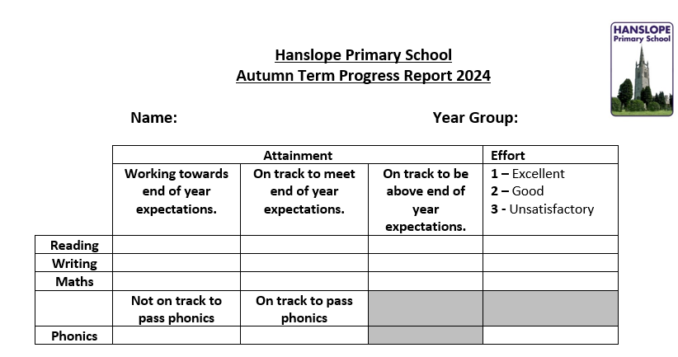
Year One

Year 1
Year Two
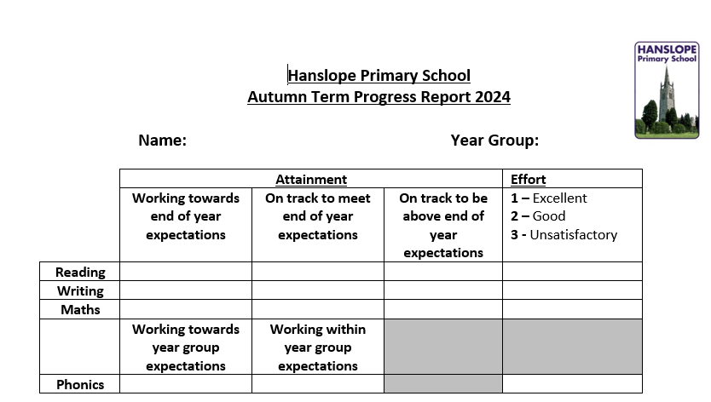

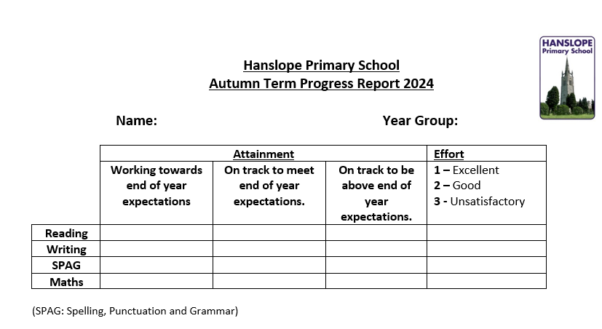
UKS2/LKS2

Pupil’s individual progression towards attaining the key knowledge and skills for each subject area in the broad and balanced curriculum will be conveyed through the end of year report in the summer term. For each subject the skills and knowledge will be broken into statements with attainment descriptors of working towards, working at the expected level and secure. This will enable parents to see how their child has progressed against specific elements across the curriculum as well as to identify their individual strengths and weaknesses.

Parents are encouraged to contact their child’s teacher at any time should they have queries or concerns regarding their progress/attainment. All teachers’ emails can be found on the staff section of the school website.

Parents of pupils who have a SEN Support Plan will receive termly reviews and will be given an opportunity to discuss this with the class teacher.

EYFS, Phonics screening, Multiplication Table Check, KS1 and KS2 end of Key Stage results are reported to both parents and the LA. In addition, parents will be given comparative information (if available) about the attainment of pupils of the same age in the school and about the attainment of pupils of the same age nationally in the previous academic year.

Monitoring, Evaluation and Review
The monitoring of the implementation of this policy is the responsibility of the headteacher. The school will review this policy on a regular basis and assess its implementation.

Reference to:
DFE Assessment Principles
Sonar
Marking Policy

