Autism is neurodivergent or developmental condition that affects the way someone thinks about things and interacts with the world. It is not a mental health condition.

Autism is a spectrum condition. This means each person experiences autism differently. They may experience different autistic traits to greater or lesser extents. They may also need more support with some things than others.

### **While every person is different, some common features of autism include**

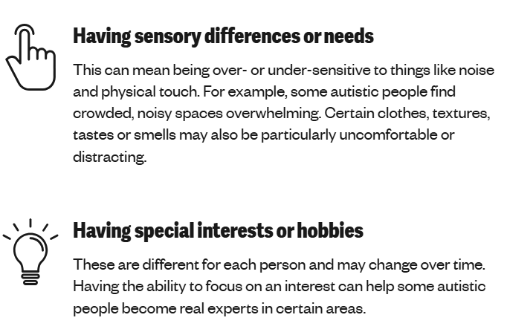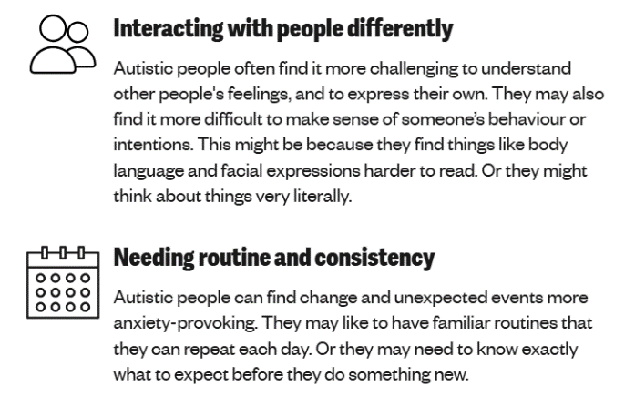

## Autism diagnosis and support

If you think your child may be autistic but they have not yet been assessed, speak to a professional about this. They can talk things through with you and help to arrange a referral if needed. You can speak to:

* your GP
* a health visitor
* your child’s teacher
* the Special Educational Needs Coordinator (SENCO) at your child’s school
* a private healthcare provider, if this is an affordable option for you
* another kind of professional supporting your child, such as a therapist

You can find out how autism assessments work on the [NHS website](https://www.nhs.uk/conditions/autism/getting-diagnosed/how-to-get-diagnosed/). It might also be helpful to have a look at [NHS Right to Choose](https://www.england.nhs.uk/wp-content/uploads/2017/03/patient-leaflet-digital.pdf). If you live in England, this means you have the right to choose which service the NHS refers your child to for an assessment. You can speak to your GP about what the options are and what the waiting lists are for each service.

## Autism and mental health

Just like anyone, autistic children and teenagers will have times when they feel good about their mental health. They may also have times when they feel more anxious, low or stressed.

But some research suggests that autistic young people can be more likely to experience a mental health issue such as [anxiety](https://www.youngminds.org.uk/parent/parents-a-z-mental-health-guide/anxiety/) at some point. Each autistic person’s experience will be different and more research is needed to understand this.

## What you can do to support your child with Autism

* Keep daily routines as predictable as possible.
* Give space to recharge.
* Help people in your child’s life to understand their wants and needs.
* Support your child to understand what helps them.
* Get to know they sensory preferences.
* Help them understand social situations and how to deal with conflict.