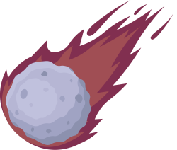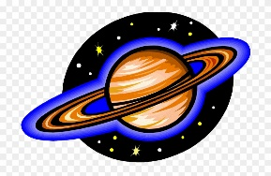

**Year 5 Curriculum News**

**Autumn Two 2020**

**Home Learning!**

Spellings, reading and times tables should be practised on a daily basis. Weekly Home Learning will be set through Microsoft Teams.

It would be helpful for children to discuss what they have learnt with you and observe the night sky, especially the moon and constellations.

In English there will be a number of texts that will inspire writing. The main texts will be The Jamie Drake Equation by Christopher Edge, Laika the Astronaut by Owen Davey and Hidden Figures.

This half term we are going to develop children’s use of more complex punctuation such as hyphens, dashes, brackets, colons and semi colons. They will also continue to develop their use of complex sentences, concentrating especially on different sentence openers and balancing description, speech and action.

We will study biographies, looking at their features and structure. Children will then write their own based on some of the amazing people that we learn about through the main topic. We will also look at persuasive writing and different persuasive devices. We will look at advertising and how companies persuade consumers to part with their money as well as persuasive letters.

In the final week children will look at play scripts and in particular A Christmas Carol.

In maths the children will be focussing on fractions, decimals and percentages this half term. They will be learning to compare and order fractions whose denominators are all multiples of the same number. Then they will identify, name and write equivalent fractions of a given fraction. After that they will move on to recognising mixed numbers and improper fractions and converting from one form to the other, as well as adding and subtracting fractions with the same denominator and denominators that are multiples of the same number. They will recap their knowledge of rounding and will round decimals with 2 decimal places to the nearest whole number and to 1 decimal place. We will then move on to solving problems involving number up to 3 decimal places

Finally, children will recognise the per cent symbol (%) and understand that per cent relates to “number of parts per 100”, and write percentages as a corresponding fraction and decimal.

We will also be recapping place value and the four operations throughout our maths lessons.

This term our topic will be focused on Our Solar System, the Earth, Moon and Sun. The majority of the topic will be based on science and as scientist’s the children will learn about the different planets, comparing them to Earth and finding out more in-depth facts about each planet that orbits our Sun. They will be able to describe the movement of the Earth and other planets, relative to the Sun in the Solar System as well as the movement of the Moon relative to Earth. They will also study Earth’s rotation to explain day and night.

As historians, children will learn about the Space Race and be able to add significant events on a time line. Children will also learn about different animals that have gone into space, considering the ethics of this and also animal rights. Children will also learn about significant figures who have been involved with space travel including Katherine Johnson, Mary Jackson and Dorothy Vaughan.

As artist’s, children will create collages inspired by the works of Karen Lynch and Hannah Hoch. They will study their work and create different types of collages.

In DT, children will bake biscuits, following a recipe and then ice them to show the different phases of the moon. They will also use tools such as hammers, nails and wood, to recreate star constellations of their choice as well as find out more information about the constellation.

In computing, the children will be looking at digital mapping. They will read satellite images, maps and ground-level photography as well as looking at the key role they play in disaster relief.

In RE, the children will continue learning about Islam, focusing on where it originates, their beliefs and use of the Qur’an and why it is important.

**Maths**

**English**

**Topic: Out Of This World**