We shall be learning how to:

Recognise the place value of each digit in a three /four-digit number (thousands, hundreds, tens, ones), order numbers up to and beyond 1000, read and write numbers up to 1000 and beyond in numerals and words, solve number problems in a variety of contexts.

Add and subtract numbers with up to 4 digits, estimate the answer to a calculation and use the inverse operation to check answers, solve missing number problems, using number facts, place value and more complex addition and subtraction. We will recap our learning on the properties of 2D and 3D shapes and then further our understanding. **We will also recap some of our previous knowledge to ensure that information is consolidated. There will also be a big focus on timetables recall, doing so quickly and efficiently with daily practice.**

**Maths**



Our focus text this half term will be the Wild Way Home, by Sohpie Kirtly. We will use this, and a range of other texts to inspire our writing. We shall be looking at narrative openers and identifying different types of sentences to help strucutre our writing. We will also be looking at dairy entries, linking with our Stone Age learning, thinking carefully about tenses and emotive language. We will also look at instructional writing and using adverbs to add detail and direction. Finally we will have a short poetry focus, enjoying and adpating poems.

**All our learning will be supported with weekly reading sessions and reading comprehensions.**

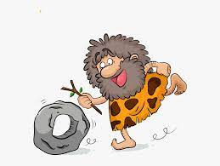

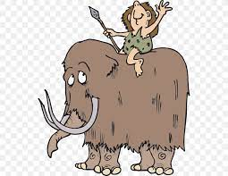

Our topic for this half term is ‘The Stone Age.’ As historians we will begin our learning by investigating historical artefacts and through this investigation, explore what life was like in the Stone Age. We will look at the Strone age in relation to our previous historical learning and where on a timeline this period fits. During our studies we shall be discussing similarities and differences between people and artefacts, such as the difference between the early and later Stone Age. As geographers we will be investigating the era further by identifying key geographical areas using maps, globes and atlases. As artists, we shall be using a variety of techniques and mediums, when recreating cave art and historical structures. We will also think carefully about food hygiene and preparing food safely. As scientists, we will focus this half term on investigating and developing our scientific enquiry skills through fun experiments. During RE lessons, we will focus on the idea of belonging, how this relates to Christianity and comparing this to other faiths. In our PSHE sessions we shall be focussing on celebrating difference by considering identity, society and equality. Focus in computing shall be E-safety and the importance of appropriate use of the internet. To support this a theatre company will provide a production on the subject. As musicians we shall be rocking around the clock, performing and learning about rock and roll music.

**Year Four Curriculum News**

**The Stone Age**

**Autumn 2021**

**Home Learning**

Homework will be set in the second week and will be a timetable, where pupils select one activity per week and submit via teams.

Spellings will begin in week two and will be sent home on Monday’s to be tested on Friday. Reading and times tables should be done on a daily basis.

**Topic**