We shall be learning how to:

Year Three:

*make appropriate decisions about when to use understanding of place value for solving problems, including adding and subtracting.

* solve addition and subtraction problems in different contexts, using number facts, place value and counting (including money and measurements).

*use multiplication and division to derive facts and solve problems (including money and measurements). Secure the short division method

*show an angle as a measure of turn, (including right angles).

* make, draw and identify 2D/3Dshapes in different orientation.

Year Four

*use understanding of place value, counting and rounding to solve problems involving addition and subtraction.

*estimate, compare and calculate different measures including money in pounds and pence.

*use knowledge of place value and derived facts to multiply and divide mentally- including multiplying by 0 and 1 and dividing by 1.

*solve problems with multiplication and division, including with measures. (Using a formal method to divide).

*compare and classify shapes, including quadrilaterals and triangles, based on properties and sizes.

**\*In Year Three and Four we shall also develop our ability to explain and justify methods and solutions**.

**Maths**

**Topic**

**Home Learning** [](https://www.google.co.uk/url?sa=i&rct=j&q=&esrc=s&source=images&cd=&cad=rja&uact=8&ved=2ahUKEwjWt_vgj57aAhVNF8AKHZlBBbMQjRx6BAgAEAU&url=https://www.123rf.com/photo_59855553_stock-vector-natural-disaster-insurance-earthquake-icon-in-cartoon-style-isolated-on-white-background.html&psig=AOvVaw1zZAUciUQVz0qzgzCn7tm4&ust=1522845500455239)

The children are encouraged to read and practise their spellings and

times tables daily. (Year Three: x3, x4, x8/ Year Four: All tables up to x12)

Homework shall be set regularly on Microsoft Teams Classroom and/ or MyMaths.

[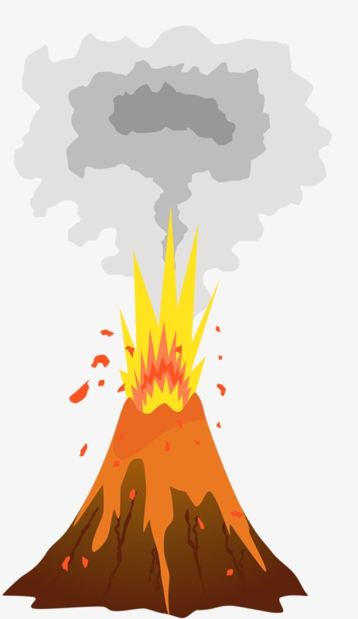](https://www.google.co.uk/url?sa=i&rct=j&q=&esrc=s&source=images&cd=&cad=rja&uact=8&ved=2ahUKEwj-rtabj57aAhXPWsAKHf6aAL8QjRx6BAgAEAU&url=https://pngtree.com/freepng/volcano-eruption_2797185.html&psig=AOvVaw2VX13iXywDoTWu0zVOce4i&ust=1522845352420013)Our topic this half term is ‘Earthquakes and Volcanoes.’ We shall be developing our ability to describe in simple terms, how volcanoes are formed and why earthquakes happen. We shall also consider the impact on people who live in areas prone to volcanic eruptions and earthquakes. As scientists, we shall be learning about forces and magnets. We shall undertake experiments, during which we shall make predictions and compare and make observations about how things move. We shall consider how magnets attract or repel each other. This important knowledge will be used to make connections within our topic. In art, we shall be looking at the life and works of the artists Rembrandt and Andy Warhol. We shall be continuing to develop our art skills when drawing portraits and printing, using both natural and man-made resources. In computing we shall be creating and manipulating images using Planet PDA.Net. Within French sessions, we shall begin to use a bilingual dictionary. We shall say what something is using ‘c’est’ before the noun. Within our lessons, we shall learn how to answer a range of questions using ‘oui’ or ‘non.’ Also, we shall extend our understanding of French numbers.

During our RE sessions, we shall be considering whether the Christmas narrative needs Mary. Through discussion, we shall be considering symbols of Mary and compare these with those of the Hindu faith. We shall also listen to Christian stories that include Mary and consider her role within them. In PHSE sessions we shall be focusing on drug and alcohol education. As part of RSE, Year Three shall be considering friendships, gender and stereotypes and Year Four shall be considering hygiene and growing up.

.



We shall: *read a range of texts as a stimulus for our learning, (fiction and non- fiction). These texts include: The Firework Maker’s Daughter by Philip Pullman and Escape from Pompeii- by Christine Balit. *write in a range of genres such as explanation texts, adventure stories and reports. *use different key skills. These will include: teaching prefix and subordinate clauses, plural and possessive-s, appropriate choice of pronouns and nouns, expanded noun phrases, apostrophes to mark plural possession, using commas with fronted adverbials, determiners and direct speech punctuation.

**Autumn Two 2020**

**Year 3/4 Curriculum News**

**Earthquakes and Volcanoes!**