

**Newsletter**

**Autumn 2**

**2021**

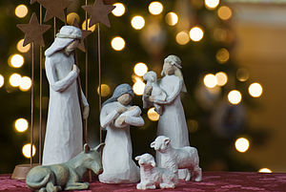

**Cards and Presents**

**Christmas Cards**

All cards must be in school by Monday 13th December and they will be given out on Wednesday 15th December. Cards for people outside of your child’s year group must be given to your child’s teacher to pass on.

**Christmas Presents**

Christmas presents can be exchanged during the last week of term. Please can they be in school between Monday 13th December and Wednesday 15th December and handed to your child’s teacher. The presents will be taken home on Thursday 16th December. Presents for people outside of your child’s year group must be handed to your child’s teacher. These will then be given out by staff on Thursday 16th December.

**Our Christmas Tree**

Many thanks to Mr and Mrs Modhwadia at Castlethorpe Post Office who been so generous once again and have given us a beautiful Christmas Tree. It really has cheered everyone up!

Some of our Year Six House and Vice Captains (Molly Gibbons, Willow Duffy-Monk, Iona Paton and Amber Smillie) have decorated our tree this year and have done a super job.

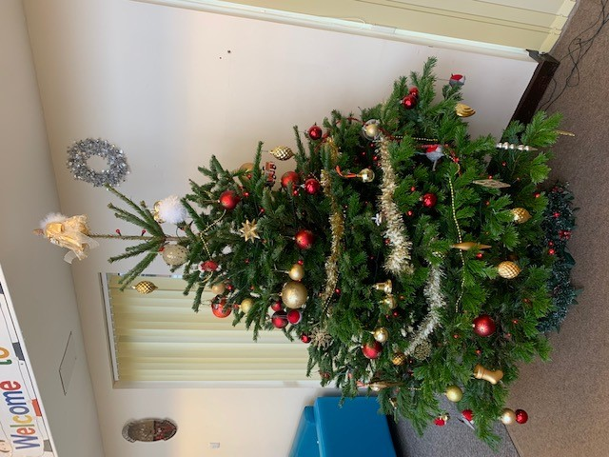

**Goodbye to Mrs Edwards**

The end of term sadly marks the time when we are saying goodbye to Mrs Edwards. After 8 years of working at Hanslope School, Mrs Edwards has helped many children as a class teacher and as our SENCo. She will be really missed by us all. We wish her all the best in her new career.

Mrs Edwards currently teaches Blackthorn Class. The parents of the children in this class have been informed that Miss Belam will be Blackthorn’s class teacher during the Spring Term.

**Year 6 Christingle Service**

We will be holding a Christingle Service in school on Tuesday 14th December. This will be filmed and sent to parents before the end of term.

Our Year Six children will be making their own Christingle orange during the morning and discussing its significance.

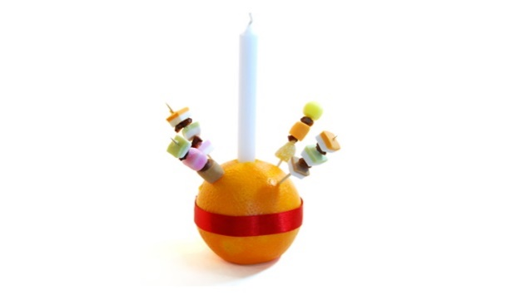

**Christmas Jumper Day, Christmas Lunch and Christmas Parties**

Thursday 16th December is a busy day! All children can wear a Christmas jumper instead of their school jumper with the rest of their school uniform and pay £1 to Save the Children.

Each child who wishes to take part will need to bring in their £1 between Monday and Thursday next week and give it to their teacher. The teachers will record receiving the money so we know exactly who should be wearing something Christmassy on the day.

Christmas lunch for those who have ordered will be served at lunch time.

All our classes will then have a Christmas Party in the afternoon.

**Diary Dates**

*Details for key events will follow nearer to the time.*



14th Dec Y6 Christingle Service

16th Dec Christmas Jumper Day – (uniform with a Christmas jumper)

Children’s Christmas Lunch Day

Children’s Christmas Party Day

End of Autumn 2

17th Dec  INSET Day for staff

4th Jan 2022 Spring Term begins

**Please note the children return to school on**

**Tuesday 4th January 2022.**

* ***Please note all the dates and times shown here are accurate at the time of the publication of this newsletter. Any unforeseen event may happen that could cause alterations to the information listed below; if this does occur we will endeavour to let you know as quickly as possible.***
* **Ryan Brown** ryan.brown@hanslope.milton-keynes.sch.uk