Menu Items Containing Allergens
3rd June 2024
 | 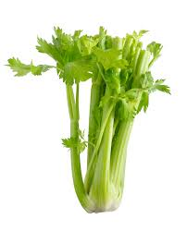 | 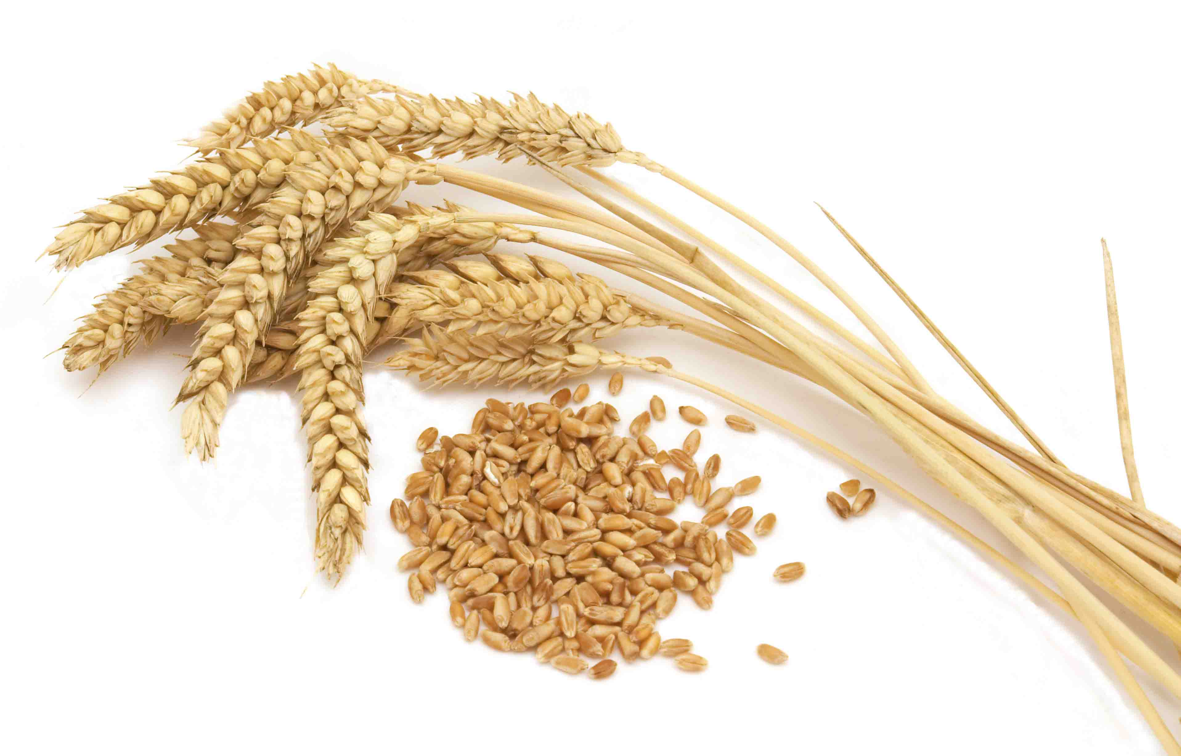 | 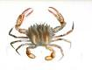 | 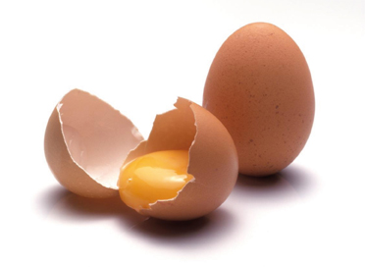 | 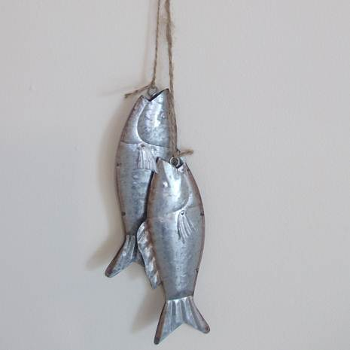 | 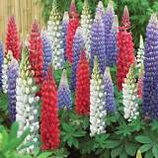 | 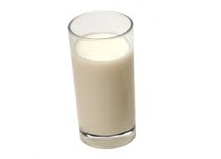 | 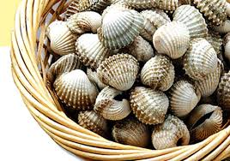 | 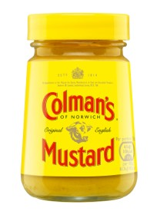 | 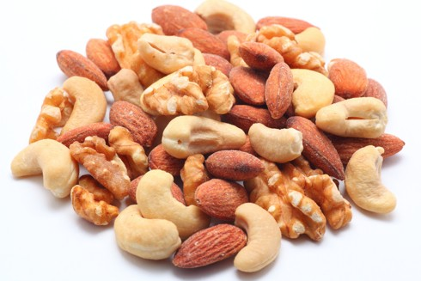 | 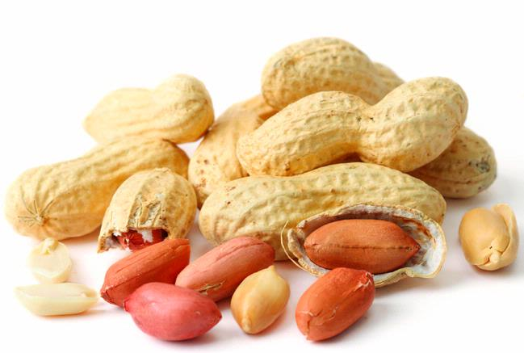 | 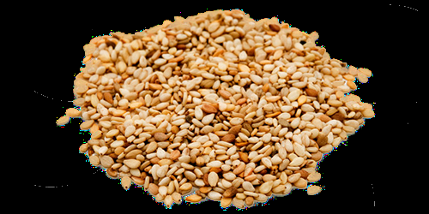 | 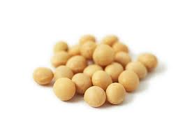 | 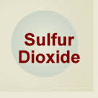
Menu Item | Celery | Gluten | Crustacean | Eggs | Fish | Lupin | Milk | Mollusc | Mustard | Nuts | Peanuts | Sesame  Seeds | Soya | Sulphur  Dioxide
Naan |  | x |  |  |  |  |  |  |  |  |  |  | x
Quorn |  |  |  | x
Pasta/Pastry |  | x |  | x |  |  | x
Cheese |  |  |  |  |  |  | x
Curry Sauce |  |  |  |  |  |  | x
Cheese/Onion Roll |  | x |  |  |  |  | x
Sausages |  | x |  |  |  |  | x
Lasagne | x | x |  | x |  |  | x |  | x |  |  |  | x
Veggie Sausage |  | x
Mac N’Cheese | x | x |  | x |  |  | x |  |  |  |  |  | x
Heinz Ketchup | x
Mayonnaise |  |  |  | x |  |  |  |  | x
Pizza Dough |  | x |  |  |  |  | x |  | X |  |  |  | X
Mashed Potato P/F |  |  |  |  |  |  | X
Veg Nuggets |  | x |  |  |  |  | x
Sponge |  | x |  | x |  |  | x
Ice Cream |  |  |  |  |  |  | x
pancakes |  | x |  |  |  |  | x
Yorkshire Pud |  | x |  | x |  |  | x

Menu Items Containing Allergens
10th June 2024
Menu Item | Celery | Gluten | Crustacean | Eggs | Fish | Lupin | Milk | Mollusc | Mustard | Nuts | Peanuts | Sesame  Seeds | Soya | Sulphur  Dioxide
Quorn |  |  |  | x
Pasta/Pastry |  | x |  | x |  |  | x
Cheese |  |  |  |  |  |  | x
pizza |  | x |  | x |  |  | x |  |  |  |  |  | x
Curry Sauce |  |  |  |  |  |  | x
Veggie Meatballs |  | x |  |  |  |  | x |  |  |  |  |  | x
Nann |  | x
Sausage |  | x
Veggie Sausage |  | x
Yorkshire Pud |  | x |  | x |  |  | x
Cheese, Onion Roll |  | x |  |  |  |  | x
Garlic Slice |  | x |  |  |  |  | x
Pork Meat balls |  | x |  | x |  |  | x
Fish Stars |  | x
Pancake |  | x |  |  |  |  | x
Heinz Ketchup | x
Chicken Nugget |  | x |  |  |  |  | x
Mayonnaise |  |  |  | x |  |  |  |  | x
Veggie Meatball |  | x |  | x |  |  | x |  | x |  |  |  | x
Mashed Potato P/F |  |  |  |  |  |  | X
Sponge |  | x |  | x |  |  | x
Ice Cream |  |  |  |  |  |  | x
Yoghurt |  |  |  |  |  |  | x

Menu Items Containing Allergens
17th June 2024
Menu Item | Celery | Gluten | Crustacean | Eggs | Fish | Lupin | Milk | Mollusc | Mustard | Nuts | Peanuts | Sesame  Seeds | Soya | Sulphur  Dioxide
Naan |  | x |  |  |  |  |  |  |  |  |  |  | x
Quorn |  |  |  | x
Pasta/Pastry |  | x |  | x |  |  | x
Cheese |  |  |  |  |  |  | x
Curry Sauce |  |  |  |  |  |  | x
Cheese/Onion Roll |  | x |  |  |  |  | x
Garlic Slice |  | x |  |  |  |  | x
Sausage |  | x
Veggie Sausage |  | x
Yorkshire Pud |  | x |  | x |  |  | x
Sausage Roll |  | x |  |  |  |  | x
Heinz Ketchup | x
Mayonnaise |  |  |  | x |  |  |  |  | x
Chicken Burgers |  | x |  | x |  |  | x
Mashed Potato P/F |  |  |  |  |  |  | X
Sponge |  | x |  | x |  |  | x
Ice Cream |  |  |  |  |  |  | x
Yoghurt |  |  |  |  |  |  | x

Menu Items Containing Allergens
24th June 2024
Menu Item | Celery | Gluten | Crustacean | Eggs | Fish | Lupin | Milk | Mollusc | Mustard | Nuts | Peanuts | Sesame  Seeds | Soya | Sulphur  Dioxide
Naan |  | x |  |  |  |  |  |  |  |  |  |  | x
Quorn |  |  |  | x
Pasta/Pastry |  | x |  | x |  |  | x
Cheese |  |  |  |  |  |  | x
Curry Sauce |  |  |  |  |  |  | x
Cheese/Onion Roll |  | x |  |  |  |  | x
Sausages |  | x |  |  |  |  | x
Lasagne | x | x |  | x |  |  | x |  | x |  |  |  | x
Veggie Sausage |  | x
Mac N’Cheese | x | x |  | x |  |  | x |  |  |  |  |  | x
Heinz Ketchup | x
Mayonnaise |  |  |  | x |  |  |  |  | x
Chicken Nuggets |  | x |  |  |  |  | x |  | X |  |  |  | X
Mashed Potato P/F |  |  |  |  |  |  | X
Veg Nuggets |  | x |  |  |  |  | x
Sponge |  | x |  | x |  |  | x
Ice Cream |  |  |  |  |  |  | x
pancakes |  | x |  |  |  |  | x
Yorkshire Pud |  | x |  | x |  |  | x

Menu Items Containing Allergens
1st July 2024
Menu Item | Celery | Gluten | Crustacean | Eggs | Fish | Lupin | Milk | Mollusc | Mustard | Nuts | Peanuts | Sesame  Seeds | Soya | Sulphur  Dioxide
Quorn |  |  |  | x
Pasta/Pastry |  | x |  | x |  |  | x
Cheese |  |  |  |  |  |  | x
pizza |  | x |  | x |  |  | x |  |  |  |  |  | x
Curry Sauce |  |  |  |  |  |  | x
Veggie Meatballs |  | x |  |  |  |  | x |  |  |  |  |  | x
Nann |  | x
Sausage |  | x
Veggie Sausage |  | x
Yorkshire Pud |  | x |  | x |  |  | x
Cheese, Onion Roll |  | x |  |  |  |  | x
Garlic Slice |  | x |  |  |  |  | x
Pork Meat balls |  | x |  | x |  |  | x
Fish Fingers |  | x
Pancake |  | x |  |  |  |  | x
Heinz Ketchup | x
Mayonnaise |  |  |  | x |  |  |  |  | x
Veggie Meatball |  | x |  | x |  |  | x |  | x |  |  |  | x
Mashed Potato P/F |  |  |  |  |  |  | X
Sponge |  | x |  | x |  |  | x
Ice Cream |  |  |  |  |  |  | x
Yoghurt |  |  |  |  |  |  | x

Menu Items Containing Allergens
8th July 2024
Menu Item | Celery | Gluten | Crustacean | Eggs | Fish | Lupin | Milk | Mollusc | Mustard | Nuts | Peanuts | Sesame  Seeds | Soya | Sulphur  Dioxide
Naan |  | x |  |  |  |  |  |  |  |  |  |  | x
Quorn |  |  |  | x
Pasta/Pastry |  | x |  | x |  |  | x
Cheese |  |  |  |  |  |  | x
Curry Sauce |  |  |  |  |  |  | x
Cheese/Onion Roll |  | x |  |  |  |  | x
Garlic Slice |  | x |  |  |  |  | x
Yorkshire Pud |  | x |  | x |  |  | x
Sausage Roll |  | x |  |  |  |  | x
Heinz Ketchup | x
Mayonnaise |  |  |  | x |  |  |  |  | x
Chicken Nuggets |  | x |  | x |  |  | x
Mashed Potato P/F |  |  |  |  |  |  | X
Sponge |  | x |  | x |  |  | x
Ice Cream |  |  |  |  |  |  | x
Yoghurt |  |  |  |  |  |  | x

Menu Items Containing Allergens
15th July 2024
Menu Item | Celery | Gluten | Crustacean | Eggs | Fish | Lupin | Milk | Mollusc | Mustard | Nuts | Peanuts | Sesame  Seeds | Soya | Sulphur  Dioxide
Naan |  | x |  |  |  |  |  |  |  |  |  |  | x
Quorn |  |  |  | x
Pasta/Pastry |  | x |  | x |  |  | x
Cheese |  |  |  |  |  |  | x
Curry Sauce |  |  |  |  |  |  | x
Cheese/Onion Roll |  | x |  |  |  |  | x
Sausages |  | x |  |  |  |  | x
Lasagne | x | x |  | x |  |  | x |  | x |  |  |  | x
Veggie Sausage |  | x
Mac N’Cheese | x | x |  | x |  |  | x |  |  |  |  |  | x
Heinz Ketchup | x
Mayonnaise |  |  |  | x |  |  |  |  | x
S/F Chicken |  | x |  |  |  |  | x |  | X |  |  |  | X
Mashed Potato P/F |  |  |  |  |  |  | X
Veg Nuggets |  | x |  |  |  |  | x
Sponge |  | x |  | x |  |  | x
Ice Cream |  |  |  |  |  |  | x
pancakes |  | x |  |  |  |  | x
Yorkshire Pud |  | x |  | x |  |  | x

