**English**

**“Frozen Planet”**

**Home Learning!**

Spellings, reading and times tables should be done on a daily basis.

Homework will be set on Teams and MyMaths.

**Maths**

We will develop understanding of:

*counting, place value and rounding to solve problems in different contexts (including Roman Numerals up to 1000).

*addition and subtraction problems, appropriately choosing relevant number facts, place value, mental or written methods to find a correct solution.

* the relationship between fractions, decimals and percentages (continued). *the properties of prime, composite, square and cube numbers. * placing and reading coordinates from a four-quadrant grid. **The children will continue to develop their understanding of formal methods. They will be encouraged to explain and give reasons for their mathematical thinking.**

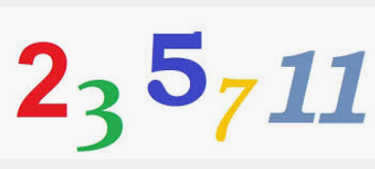

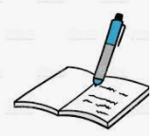 *We will use a range of texts to support our topic, such as “-Kenzuki’s Kingdom’ by Michael Morpurgo, ‘What a Wonderful World ‘by Leisa Stewart- Sharpe and ‘The Earth is Big’ by Steve Tomecek. *Both fiction and non-fiction texts will continue to inspire our writing.For example, we will further develop important literacy skills through writing both setting and character descriptions, creating a non-chronological report that uses the language of advertising and writing poetry based on different cultures. We will also further our understanding of biographies through our learning about Mark Beaumont.  **\***Throughout this study, we will continue to focus on a range of grammar and punctuation skills such as the correct use of inverted commas, brackets, dashes, commas for parenthesis and commas to separate clauses. We will revise our learning about how to organise texts and ensuring tenses are consistent.

This half term, our topic is ‘Which Country is the Greatest?’ As Geographers, we will be researching different countries around the world and making comparisons between their physical and human features. We will discuss aspects of key economic activity to and from the countries that we are researching. As Historians, we will find out about how significant events in history have helped shape a country, this will include looking at the impact of inspirational figures. We will consider more than one version of an event and how an historian may be attempting to persuade or give a viewpoint.

In Science, our focus will be forces and we will combine our learning with a design technology project. We will develop our understanding of gravity and the effect of air and water resistance. We will improve our knowledge of levers, pullies and gears by designing our own vehicle. In Design Technology, we will also design, make and evaluate a product using knowledge of different sewing techniques. As artists, we will create our own collagraph prints from reclaimed materials. In computing, we will be finding out about data and information-flat file databases. We will continue to learn about the importance of safety when using the computer, especially the sharing of information. In RE, we will explore the significance of the death of Jesus at Easter for Christians and the meaning of the word ‘sacrifice’. We will also find out about historical figures that are known to have made sacrifices. As Musicians, we will use a range of musical skills to respond to and appraise music. We will focus our learning on a composition to represent the festival of colour-Holi. Continuing from previous learning in French, we will learn to count from 1-40 and talk about where we live. In our French reading, writing and speaking we will be using subordinating conjunctions to add further detail to sentences. Throughout our PSHE sessions, we will discuss how to look after our health and wellbeing, including taking responsibility and setting goals. The main focus areas in PE sessions will be Badminton and Dance.

Spring Two

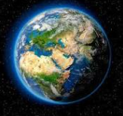 **Which Country is the Greatest?**