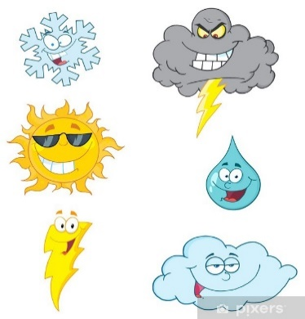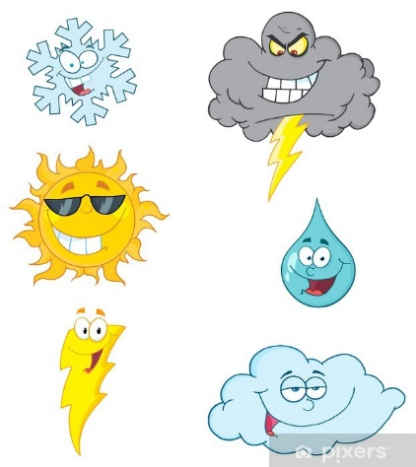

**Year 1 Summer 1 Curriculum News**

**Home Learning**

* Regularly share a book with your child. Identify sounds, discuss the characters, settings and plot.

* Practise alien words

* Practise tricky words which can be found inside your child’s home school book.

* Practise writing sentences with full stops, finger spaces and capital letters.

* Practise counting in 2s, 5s and 10s.

* Number bonds to 10

**Maths**

During our Maths sessions, we will develop our knowledge through lots of practical work and some written tasks.

We will:

* Add and subtract 10s from 2 digit numbers.

* Compare and measure different capacities.

* Recognise and explore 3d shapes and turns.

* Recognise odd and even numbers.

* Explore number bonds to 10 and adding/subtracting 10.

* Add/subtract 10/11/12.

* Counting in 2’s.

* Find totals of coins using number facts.

**English**

Where possible, English will be taught through topic sessions.

We will: * Read fiction and non-fiction books by a variety of authors.

* Write instructions of how to plant a bean.

* Film our very own weather report

* Write and label designs for flood resistant houses

* Write a piece of persuasive writing

* Create a poster advertisement

* Write sentences making sure we use capital letters, finger spaces and full stops.

* Ensure we are using the correct sounds when writing.

In phonics sessions we will continue to learn new phonemes and graphemes, using them in our reading and writing. We will keep reading real and alien (nonsense) words.

[This Photo](https://baileyresourcesproject.wikispaces.com/home) by Unknown Author is licensed under [CC BY-SA](https://creativecommons.org/licenses/by-sa/3.0/)

**Maths**

During our Maths sessions, we will develop our knowledge through lots of practical and some written tasks. We will:

We will:

* Find one more and one less of a number.

* Find two more and two less of a number.

* Write two-digit numbers.

*Count in 10’s to 100.

* Learn number bonds to 5,6,7,8 and 10.

* Add and subtract numbers

* Look at 2D and 3D Shapes.

**English**

Where possible, English will be taught through topic sessions.

We will: *Read stories by a variety of authors linking to our Antarctic Topic

*Write instructions for packing a bad to take to Antarctica

*Introduce question marks and write questions.

*Write sentences, ensuring we are using capital letters, finger spaces and full stops.

* Create fact files about Ernest Shackleton and Antarctica.

*Learn to join ideas with conjunctions such as ‘and’, ‘but’ and ‘so’.

**Year 1 Curriculum News**

In the first half of the spring term we will be travelling to Antarctica within our Topic and English lessons. As historians, we will be looking into the explorer, Sir Ernest Shackleton to find out what he did and why he is still famous now. We will be writing instructions for packing a bag to take to Antarctica to make sure we have all the clothes we need! We will then move to look at another explorer, Tenzing and find out where he explored and why.

As Geographers we will be looking at where Antarctica is, how different it is from where we live, and the weather in Antarctica. We will also be looking at the seven continents and five oceans of the word.

Within Design and Technology, we will continue with Antarctica by creating Antarctic Dioramas, using lots of different materials to create our own Antarctic scene.

We will also be thinking about how we should care for the world around us.

Where is the most extreme weather?

In the first half of the summer term, we will be looking at our new topic ‘Where is the most extreme Weather’?

In Science we will be looking at plants and planting our own beanstalk and recording its journey. We will identify different parts of a plant and begin to name common British plants.

In Art we will be looking at the four seasons and exploring different media such as collage, pencils and paint. We will look at what colours we can use to represent warm and cold scenery through colour mixing and looking at famous art as inspiration.

We will also be continuing our weather theme by looking at extreme weather in the UK, around the world and exploring different climate zones.