Dear Parents/Carers,
Here is an overview of what your child will be learning this half term across the different areas of learning. Our topic for the second half of the Spring term is called ‘Here, There and Everywhere’. The topics we choose are led by the children’s interests and usually encompass several areas of learning. For this reason, the topics may change to reflect the direction the children wish to take their learning.
Each week we will be taking on a different transport theme using the following books to introduce our focus mode of transport.
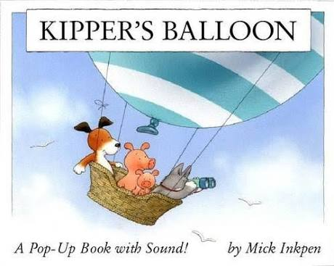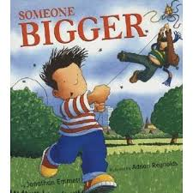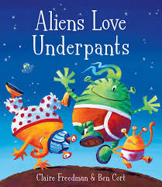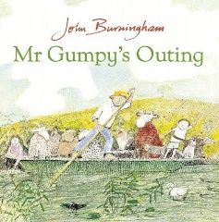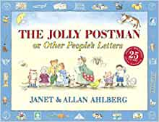

This half term in our Literacy each week our learning will take on a different transport theme. We will be learning about the emergency services and the transport they use. Aliens Love Underpants by Claire Freedman will be our focus for our space week theme. Kipper’s Balloon by Mick Inkpen and Someone Bigger by Jonathan Emmett is our stimulus for our week on air transport. Our wheels week is inspired by The Jolly Postman by Janet and Allan Ahlberg and The Train Ride by June Crebbin. Mr Gumpy’s Outing by John Burningham inspires our week of water and water transport. We will continue to develop the children’s understanding about letter names and sounds. During daily phonic activities children will read simple phrases and sentences made up of words with known letter sound correspondences.

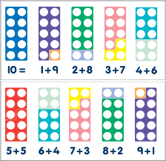
This half term in our Mathematics we will be using the theme of Here, There and Everywhere as a stimulus for many mathematical activities. We will be collecting information about forms of transport around the village and recording it in a bar chart. We will be developing the children’s ability to recognise numbers in a variety of ways, such as looking at number plates. In addition to number we will be finding out about capacity through our water play. We will learn the names of 3D shapes and find out about their properties e.g. a cube has 6 square faces, 8 corners and 12 edges. Throughout our learning the children will be encouraged to use a variety of mathematical language and be encouraged to automatically recall number bonds for numbers 0-10
We will continue to have a weekly circle time to encourage the children to talk about their thoughts and feelings as part of our Personal, Social and Emotional Development. This term our focus will be to develop our ability to speak to others about our wants, needs and opinions. We will also work on how to become more confident as speakers and listeners. We will think about the views of others. We will be learning about life skills such as road safety.

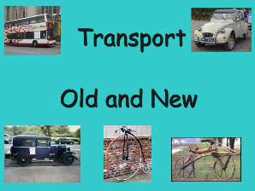
Through our Here, There and Everywhere topic we will use our Understanding of the World to observe our local environment and look at simple maps and globes and Google Earth. The children will be encouraged to understand that some places are special to members of their community. We will investigate forces at work such as ‘pushes and pulls’ when looking at vehicles and using ramps with toy cars. The children will have the opportunity to disassemble and assemble an old bike using tools. We will be learning about old and new transport including cars, bicycles and trains. We will compare and contrast characters from stories, including figures from the past: Emily Earhart and Buzz Aldrin. The children will be finding out why we celebrate Mother’s Day and what Christians celebrate at Easter.

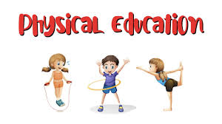
In our Physical Development during our PE lessons, we will be experimenting with different ways of moving to improve control and coordination. We will be using small equipment as obstacles to develop the children’s ability to negotiate space, such as when they are playing chasing games. Within the classroom we will continue to practise fine motor and pencil skills to support the children’s ability to write and form their letters correctly. We will continue to develop the foundation of a handwriting style which is fast, accurate and efficient. We will be using a variety of tools, objects and construction equipment to develop increasing physical control.

In our Expressive Arts and Design, we will continue to listen to songs such as The Wheels on the Bus, The Runaway Train and The Yellow Submarine. and build a repertoire of dances. We will listen to a variety of music and instruments. We will watch and talk about dance and performance art, expressing our feelings and responses. We will continue to combine and manipulate different materials in learning activities such as painting, drawing and creating vehicles out of ‘reclaimed materials’. We will create models collaboratively sharing ideas, resources and skills.

It would be fantastic if you could continue to support your child by reading to them regularly at home and encouraging them to complete reading their school reading books as independently as possible. Please continue to practise recognising the letter sounds and high frequency words that are in your child’s pencil case, as well practising letter formation and spelling words by encouraging your child to write the sounds they can hear.

