Let’s go to the Dough Disco!
Dear Maple Class,
I have really missed going to the dough disco with you on a Wednesday afternoon!
Hopefully you will be able to teach your parents, brothers and sisters all the moves that we learnt together.
If you have playdough at home you can use that. If not follow this simple recipe below to make your own. If you keep it in a bag or box in the fridge it will last a few weeks.
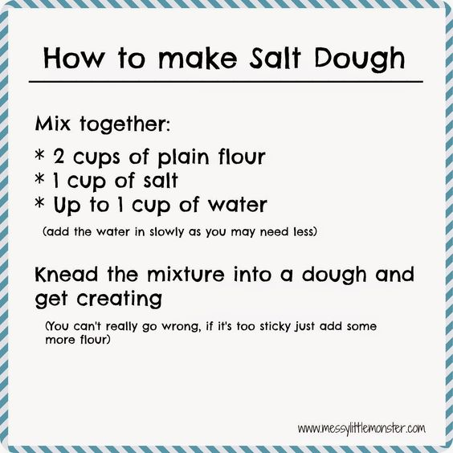
You can watch any of the dough disco videos or make up your own. Remember to do your moves in both hands and keep your fingers moving.
I have included the pictures of the moves we used to do. Can you remember them?
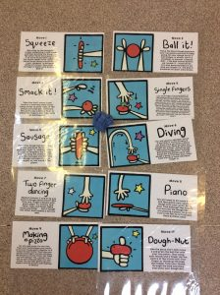
This link takes you to the Dough Disco introduction Watch
This link is a Relaxed dough disco!
Have fun and if you can do dough disco at least once a week for 5 or 10 minutes.
From Mrs McGarr

