Dear Elm Class,

We hope you are all keeping well and learning lots of things.

Please tell your grown-ups to look out for an email after the Easter holidays from us, with lots of work that you can do. The work is based on the next things that we would have been learning in the classroom. As we had some learning left on our current topic of Darwin and Galapagos, I will send out ideas linked to that first and then begin our Kings and Queens topic after that. It can be used as well as the other work on the website. Please remember there is no pressure to complete lots of these activities just do what you can.

We will send an email to your grown-ups on Monday every week, so please make sure that you tell them to check their emails. We will also add the work to the school website.

If you want to let us know what you have been doing, then your grown-ups can send Mrs Edwards an email at louise.edwards@hanslope.milton-keynes.sch.uk

Take care and look out for some fun learning activities.
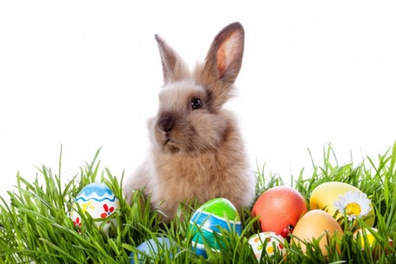
We hope the Easter bunny comes to visit you!

Mrs Edwards, Mrs Thomson and Mrs Smith

