English Home-Learning Summer 2, Week 6
Continuing on with our theme of diversity, this week your task is to write a biography on a Civil Rights activist of your choice.

Remember the meaning of ‘Biography,’ which stems from Greek words:
Bio – meaning ‘life’
Graphy – meaning ‘I write’
So you are writing an account of someone else’s life.
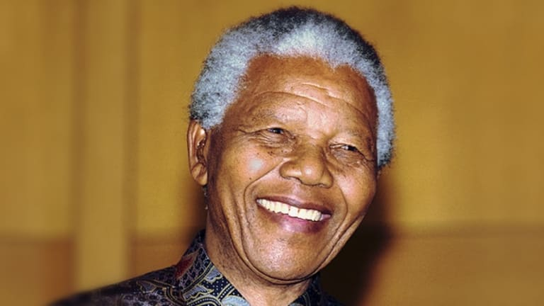
There are hundreds of people you could choose from, but if you’re struggling to find any, here are some ideas to get you started:
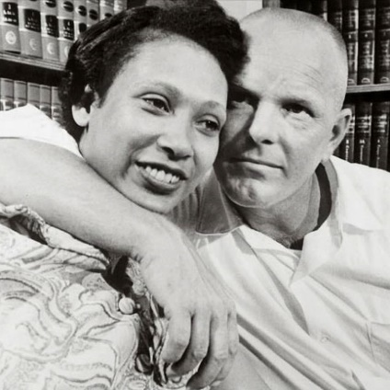
- Nelson Mandela – the first black president of South Africa imprisoned for his anti-apartheid work.
- Richard and Mildred Loving – a couple who fought the Supreme Court and defeated a ban on interracial marriage.
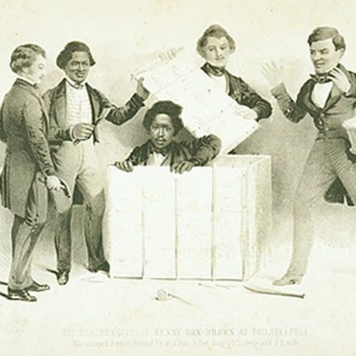
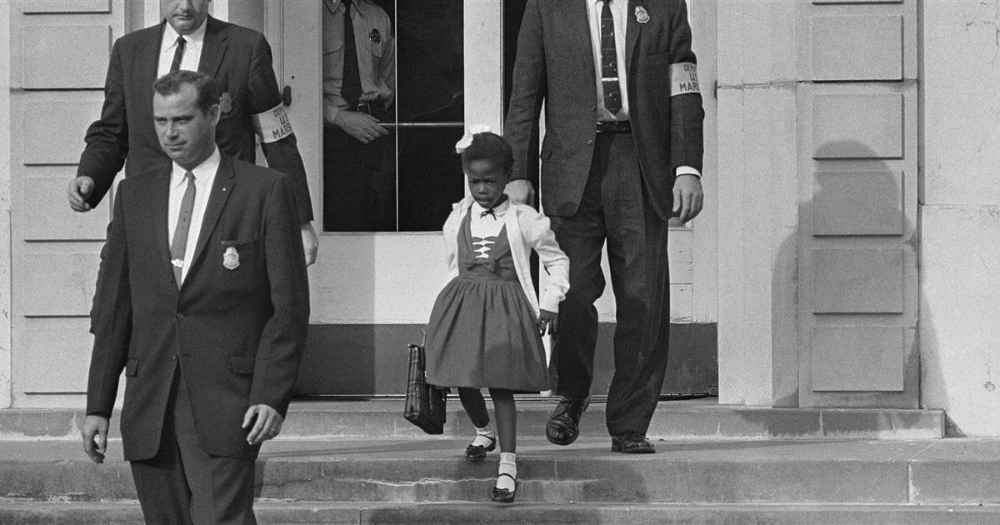
- Ruby Bridges – the first African-American child to integrate an all-white primary school in the south of the USA after a hard battle with protestors.
- Henry ‘Box’ Brown – an enslaved man who managed to ship himself to freedom in a wooden box labelled ‘Dry Goods’ before becoming a magician!
A list of more amazing people can be found here: https://www.biography.com/people/groups/civil-rights-activists but this isn’t exhaustive – there are many more to find. Remember to always add ‘KS2’ or ‘UKS2’ after your search terms to ensure you’re getting age-appropriate results.
It is up to you how you wish to present your work, as long as it is biographical.

