English Home-Learning Summer 2, Week 7
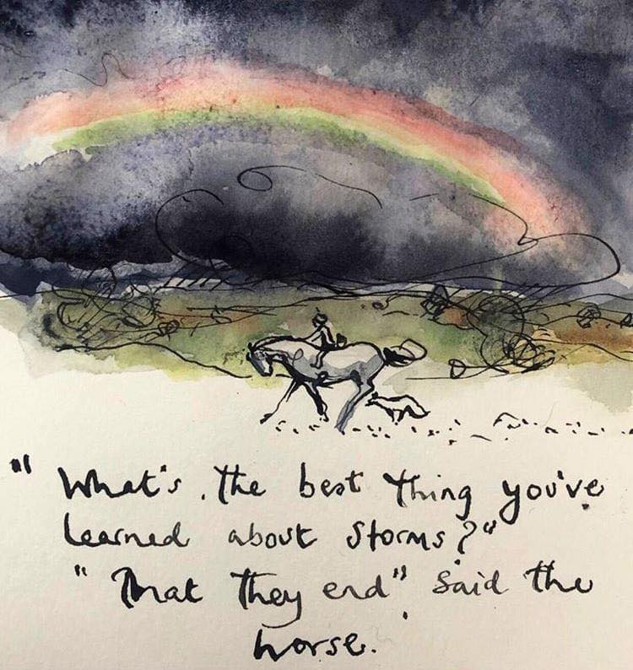
For your final piece of Year 5, Mrs Broughton and I thought it would be a great idea for you to amalgamate* all of the amazing work you have done at home. As you are all no doubt very aware, this has been an incredibly different school year – one nobody was anticipating. We have missed you all very much but we have enjoyed seeing all of the incredible effort you have been putting in to home-learning over the past few months.
It seems only fitting then, for you to create your second and final ‘essay’ of the year. If you can, cast your minds back (to what seems like a lifetime ago!) to the essay you wrote on ‘Frozen Planet.’ You were asked to write as much as you could on all of the different things we had covered, and you were able to supplement your writing with pictures, diagrams, tables, symbols and anything else you could think of to represent your learning over the course of the entire topic.
Your final ‘essay’ is to be based on EVERYTHING you have done over your period of home-learning and of lockdown in general. You can of course include all of the learning you have done over the past few half-terms, including on the ‘Egyptians’ and on ‘Which Country is the Greatest?’ but it would be lovely if you could also include the other aspects of your life during the lockdown-period because your time at home has been more than just about school-work.
Remember: you can include the visual aspects mentioned above, such as pictures, but the main part of your essay must be written. It is up to you to decide on layout – perhaps sub-headings could be helpful – but just like your previous essay, it is entirely in your hands!

