

SUPPORTING PUPILS AT SCHOOL WITH MEDICAL CONDITIONS POLICY and
ADMINISTRATION OF PRESCRIBED MEDICINES FIRST AID

Date policy reviewed | Summer Term 2024
Date for next review | Spring Term 2025
Committee responsible | FGB
Authorisation | Ryan Brown

HANSLOPE PRIMARY SCHOOL
Supporting Pupils at School with Medical Conditions

1. Introduction
The Children and Families Act 2014 places a duty on schools to make arrangements for supporting pupils at the school with medical conditions. Pupils with medical conditions cannot be denied admission or excluded from school on medical grounds alone unless accepting a child in school would be detrimental to the health of that child or others.
Some children with medical conditions may be disabled. Where this is the case governing bodies must comply with their duties under the Equality Act 2010. Some may also have special educational needs (SEN) and may have a statement or Education, Health and Care (EHC) plan. For children with SEN, this guidance should be read in conjunction with the SEN Code of Practice.
The aim of this document is to ensure that all children with medical conditions, in terms of both physical and mental health, are properly supported in school so that they can play a full and active role and achieve their potential.
2. Policy Implementation
The overall responsibility for the successful implementation of this policy is the Headteacher. They are responsible for ensuring that sufficient staff are suitably trained and will ensure cover arrangements in case of staff absence or staff turnover to ensure that someone is always available.
All staff will be expected to show a commitment and awareness of children’s medical conditions. New members of staff will be inducted into the arrangements.
3. Pupils with medical conditions
Pupils with long term and complex medical conditions may require on-going support, medicines or care while at school to help them manage their condition and keep them well. Others may require monitoring and interventions in emergency circumstances. Some medical conditions require the administration of over-the-counter medicines with parental consent.
Children’s health needs may change over time, in ways that cannot always be predicted, sometimes resulting in extended absences. Reintegration back into school will be properly supported so that pupils with medical conditions can quickly re-engage with their learning.

4. Roles and Responsibilities
Supporting a child with a medical condition during school hours is not the sole responsibility of one person. Collaborative working arrangements and working in partnership will ensure that the needs of pupils with medical conditions are met effectively.
- The Governing Body will ensure that the school develops and implements a policy for supporting pupils with medical conditions. It will ensure that sufficient staff have received suitable training and are competent before they take on the responsibility to support children with medical conditions. It will ensure that the appropriate level of insurance is in place to cover staff providing support to pupils with medical conditions. (Appendix A)

- The Headteacher will ensure that the school’s policy is developed and effectively implemented with partners. They will ensure that all staff are aware of the policy and understand their role in its implementation. They will make sure that sufficient numbers of staff are available to implement the policy and deliver against all Individual Healthcare Plans, including in emergency and contingency situations. The Headteacher has the overall responsibility for the implementation of Individual Healthcare Plans. They will make sure that school staff are appropriately insured and are aware that they are insured to support pupils in this way. The school nursing service will be contacted in the case of any child who has a medical condition that may require support at school.

- School staff may be asked to provide support to pupils with medical conditions, including the administering of medicines, although they cannot be required to do so. Although administering medicines is not part of teachers’ professional duties, they should take into account the needs of pupils with medical conditions that they teach. Any member of staff should know what to do and respond accordingly when they become aware that a pupil with a medical condition needs help.

- School nurses are responsible for notifying the school when a child has been identified as having a medical condition which will require support at school. School nurses may support staff on implementing a child’s Individual Healthcare Plan and provide advice and liaison.

- Other healthcare professionals, including GPs and paediatricians notify the school nurse when a child has been identified as having a medical condition that will require support at school. They may provide advice on developing healthcare plans.

- Pupils will be fully involved in discussions about their medical support needs and will contribute as much as possible to the development of their individual healthcare plan since they know best how their condition affects them. Other pupils in the school will be sensitive to the needs of those with medical conditions.

- Parents/carers will provide the school with up-to-date information about their child’s medical needs. They will be involved in the development and review of their child’s individual healthcare plan. They will carry out any action they have agreed to as part of its implementation and ensure they or another nominated adult are always contactable.

- Local authorities should work with schools to support pupils with medical conditions to attend full time.

- Health services can provide valuable support, information, advice and guidance to schools and their staff to support children with medical conditions at school.
5. Procedures to be followed when Notification is received that a pupil has a medical condition
For pupils starting at the school, arrangements will be in place in time for the start of the relevant school term. In other cases, such as a new diagnosis or children moving to a new school mid-term, every effort will be made to ensure that arrangements are put in place within two weeks.

In cases where a pupil’s medical condition is unclear, or where there is a difference of opinion, judgements will be made about what support to provide based on available evidence which would normally involve some form of medical evidence and consultation with parents.

The school will ensure that the focus is on the needs of each individual child and how their medical condition impacts their school life. The school will consider what reasonable adjustments it might make to enable pupils with medical needs to participate in school trips and visits or in sporting activities.

6. Individual Healthcare Plans
Not all children will require an Individual Healthcare Plan. The school, healthcare professional and parent will agree when a healthcare plan would be appropriate, based on evidence. A flow chart for identifying and agreeing the support a child needs and developing an Individual Healthcare Plan can be found at Annex A. Individual Healthcare Plans will often be essential in cases where conditions fluctuate or where there is a high risk that emergency intervention will be needed. They are likely to be helpful in the majority of other cases, especially where medical conditions are long-term and complex.
Individual Healthcare Plans will be accessible to all who need to refer to them, while preserving confidentiality. Where a child has SEN but does not have a statement or EHC plan, their special educational needs should be mentioned in their Individual Healthcare plan (a template can be found at Annex B). Where a child has a special educational need identified in a statement or EHC plan, the Individual Healthcare Plan should be linked to or become part of that statement or EHC plan.
Individual Healthcare Plans and their review may be initiated, in consultation with the parent, by a member of school staff or a healthcare professional involved in providing care to the child. Plans will be drawn up in partnership. Pupils will also be involved, whenever appropriate. Partners will agree who will take the lead in writing the plan however it is the responsibility of the school to ensure it is finalised and implemented. The school will review plans at least annually or earlier if evidence is presented that the child’s needs have changed. Annex B provides a template for an Individual Healthcare Plan and the information that will be recorded on such plans.
7. Children with Health Needs who cannot attend school
If a child is not able to attend school due to health needs, the school will follow the procedures detailed in the statutory guidance and will inform the LA at the first instance of absence.
8. Staff training and support
Any member of school staff providing support to a pupil with medical needs will receive suitable training. Staff must not give prescription medicines or undertake healthcare procedures without appropriate training.
Healthcare professionals, including the school nurse can provide confirmation of the proficiency of staff in a medical procedure, or in providing medication.
The school will make arrangements for whole school awareness training so that all staff, including new staff, are aware of the school’s policy for supporting pupils with medical conditions and their role in implementing that policy. This training will include preventative and emergency measures so that staff can recognise and act quickly when a problem occurs. Parents can also contribute by providing specific advice.
9. The child’s role in managing their own medical needs
Some children are competent to manage their own health needs and medicines. The school, after discussion with parents, will encourage such children to take responsibility for managing their own medicines and procedures. This will also be reflected within Individual Healthcare Plans.

Wherever possible and if appropriate, children will be allowed to carry their own medicines and relevant devices. Children should be able to access their devices for self-medication quickly and easily. Those children who take their medicines themselves or manage their own procedures may require an appropriate level of supervision.

If a child refuses to take medicine or carry out a necessary procedure then they should not be forced by staff. The procedure agreed in the Individual Healthcare Plan should be followed and parents informed so that alternative options can be considered.
10. Managing medicines on the school premises

- A list of all known medical conditions for each class is kept in the class register. A whole school list is kept in the office and is also kept by the staff member in charge of First Aid
- The school will only accept prescribed medicines that are in-date, labelled, provided in the original container as dispensed by a pharmacist and include instructions for administration, dosage and storage. The exception to this is insulin which must still be in date but will generally be available to schools inside an insulin pump, rather than in its original container.
- Medicines will only be administered at school when it would be detrimental to a child’s health or school attendance not to do so. Parents are expected only to ask for assistance if the prescribed dosage cannot be achieved either before or after school.
- Prescribed medicines can only be administered when an agreement form has been completed by a parent/carer.
- All medicines will be stored safely in the medical room fridge or in the medical room cupboard. Children should know where their medicines are at all times and be able to access them immediately
- Devices such as asthma inhalers, blood glucose testing meters and adrenaline pens should always be readily available to children and not locked away. These will be stored in the classroom cupboards where both class teacher and child know how to access them
- During school trips, the member of staff in charge of first aid will carry all medical devices and medicines required
- A child who has been prescribed a controlled drug may legally have it in their possession if they are competent to do so; however passing it on to another child for use is an offence. Monitoring arrangements may be necessary in such cases. The school will otherwise keep controlled drugs that have been prescribed for a pupil securely stored in a non-portable container and only named staff will have access. Controlled drugs should be easily accessible in an emergency.
- Staff administering a controlled drug must do so in accordance with the prescriber’s instructions. The school will keep a record of all medicines administered to individual children, stating what, how and how much was administered, when and by whom. Any side effects should also be noted. These procedures are outlined in Annex C.
- Sharp boxes should always be used for the disposal of needles and other sharps. When no longer required, medicines should be returned to the parent to arrange for safe disposal.
11. Emergency procedures
As part of general risk management processes, the school has arrangements in place for dealing with emergencies. Pupils should know what to do in general terms, such as informing a teacher immediately if they think help is needed. A pupil taken to hospital by ambulance will be accompanied by a member of staff who will stay with the child until the parent arrives.

12. Unacceptable practice
Each child’s case will be judged on its own merit and with reference to the child’s Individual Healthcare Plan; however it is not generally acceptable practice to:
- prevent children from easily accessing their inhalers and medication and administering their medication when and where necessary
- assume that every child with the same condition requires the same treatment
- ignore medical evidence or opinion (although this may be challenged) or ignore the views of the child or their parents
- send children with medical conditions home frequently or prevent them from staying for normal school activities, including lunch, unless this is specified in the Individual Healthcare Plan
- if the child becomes ill send the child to the school office or medical room unaccompanied or with someone unsuitable
- penalise children for their attendance record if their absences are related to their medical condition e.g. hospital appointments
- prevent pupils from drinking, eating or taking toilet or other breaks whenever they need to in order to manage their medical condition effectively
- require parents or make them feel obliged to attend school to administer medication or provide medical support to their child, including with toileting issues. (No parent should have to give up working because the school is failing to support their child’s medical needs)
- prevent children from participating, or create unnecessary barriers to children participating in any aspect of school life, including school trip, e.g. by requiring parents to accompany the child

13. Complaints

Should parents or pupils be dissatisfied with the support provided they should discuss their concerns directly with the school. If the issue is not resolved, a formal complaint via the school’s complaint procedure should be made. After other attempts at resolution have been exhausted, a formal complaint can be made to the Department for Education only if it comes under the scope of section 496/497 of the Education Act 1996.

Administration of Prescribed Medicines
Information for staff and parents
- The school is unable to administer medicine not prescribed by a doctor, unless it is for hay fever where doctors do not prescribe medicine. In this instance the medicine must be provided by the parents/carers and is in its original container, labelled with clear instructions on when and how it should be taken and a ‘Parental Agreement Form for Administration of eye drops/nasal spray for hay fever’ has been signed. Parents also need to confirm that the pupil has previously used the medicine without any negative effect. (Appendix B)

- A list of all known medical conditions for each class is kept in the class register. A whole school copy is kept in the office in the Safeguarding file and is also held by the staff member in charge of First Aid.

- In general, the school will try to help parents by administering prescribed doses of medicine. Parents are expected only to ask for our assistance if the prescribed dosage cannot be achieved either before or after school.

- Prescribed medicines can only be administered when an agreement form has been completed by a parent. * Parents will be issued with pro-formas to complete when necessary. This form must be counter-signed by the Headteacher. Spare forms are kept in the office. *If a child arrives at the school without the necessary form, the school must contact parents and obtain verbal permission over the phone before any medicine can be given. The form must then be signed retrospectively.

- In general, Teaching Assistants, supported by the staff member responsible for First Aid/Medicines, will be responsible for giving medicines to children in that class.

- The school will only accept medicines which are prescribed, are in date, labelled, in their original container as dispensed by a pharmacist and include instructions for administration, dosage and storage. The exception to this is insulin, which must still be in date, but will generally be available to schools inside an insulin pen or pump rather than in its original container.

- In line with revised EYFS welfare requirements the dose administered, as well as the date and time will be recorded on the back of the agreement form and will be signed by the TA/ teacher who administers the medication and by a witness. This practice will apply across the whole school.

- Completed forms are kept in the Medical Room with appropriate security. Copies of completed forms are kept in the Key Stage areas with appropriate security for reference purposes during the school day.

- When medicines are received in school they will be stored in the fridge or the designated cupboard in the Medical Room. Please note that drugs used for treating emergency conditions should be easily available to staff and never locked away.

- Where appropriate children will be encouraged to become self-managing regarding their medications. This is particularly the case with older children using inhalers for controlling asthma. Parents will need to inform school in writing if they agree to this process. The children should always ask before any self administering of any medicines.

- Younger children who are not capable to use their medication independently will be supervised and the procedure managed in the same way as for other medications.

- Where children are on permanent daily medication, a record book will be kept in the child’s classroom. Where a child has an individualised/personal care plan, arrangements will be put in place.

- Whilst the school will send reminders, it is the responsibility of parents to ensure that out of date medication is renewed and sent to school.

For further guidance and information, please refer to the DFE guidance ‘Supporting pupils at school with medical conditions’ December 2015.
Administration of First Aid for pupils
- The school recognises its duty of care to its pupils and ensures that sufficient numbers of staff have undertaken First Aid training and hold First Aid certificates.

- An up-to-date list of First Aiders within the school is located in the main office/ medical room and staffroom.

- The school ensures that there is sufficient First Aid cover for pupils throughout the school day. This includes cover during break and lunchtimes and both day and residential trips.

- All instances of first aid being administered are recorded and a copy sent home to parents for their reference.

- In the event of more serious medical incidents or accidents, parents are contacted and/or the emergency services as required. Official incident reports are completed, a copy of which is sent to the Local Authority Health and Safety Department. The Incident Report book is kept in the school office.

- The school may seek support from the local surgery if deemed necessary.

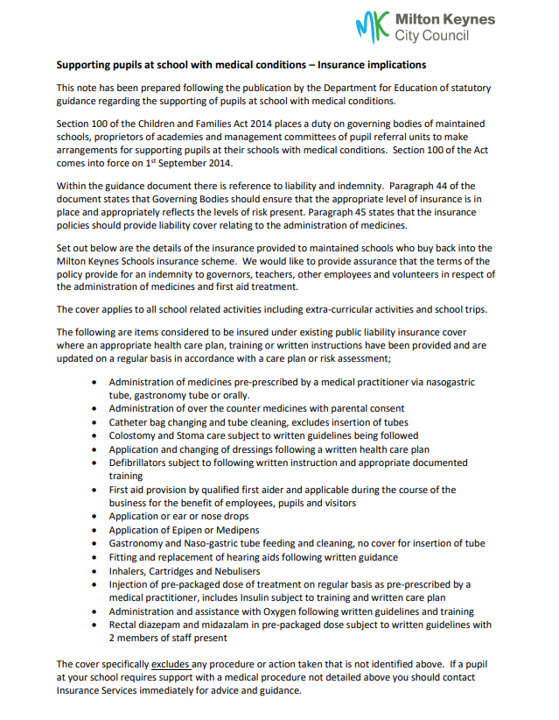
Appendix A
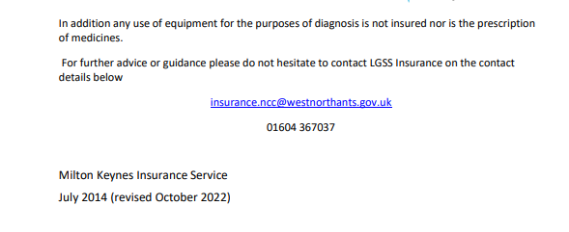

Annex A: Model process for developing Individual Healthcare Plans

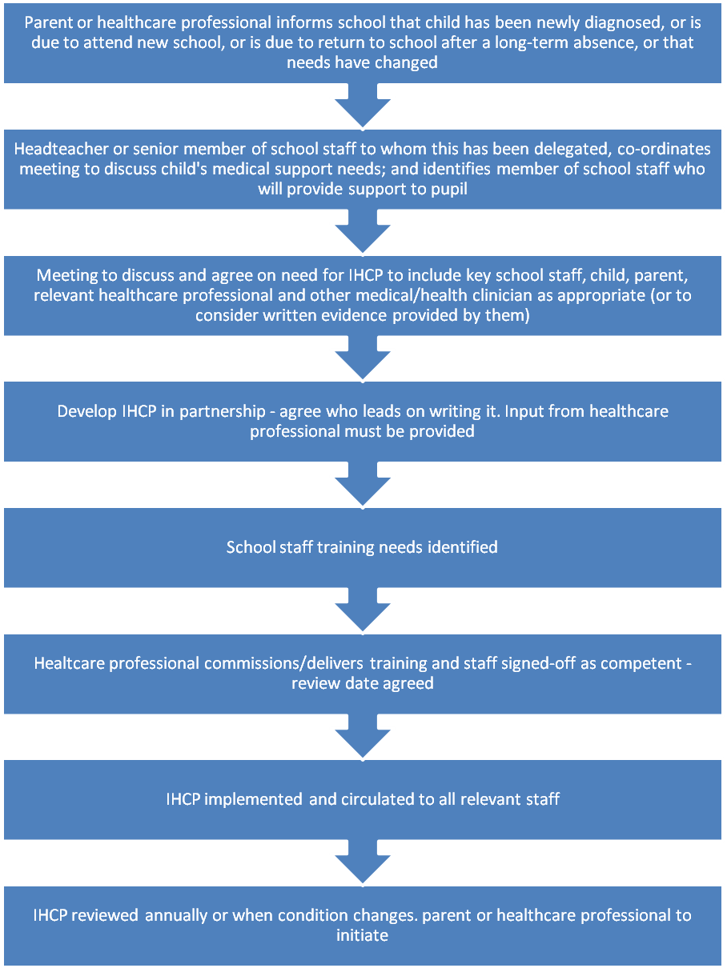

Annex B: Individual Healthcare Plan
Pupil’s Name

Class

Date of Birth

Address

Medical Diagnosis or Condition

Date

Review Date

Name of Parent/Carer 1

Contact Numbers | Work:
Contact Numbers | Home:
Contact Numbers | Mobile:
Relationship to Child

Name of Parent/Carer 2

Contact Numbers | Work:
Contact Numbers | Home:
Contact Numbers | Mobile:
Relationship to Child

Clinic/Hospital Name

Contact Number

GP Name

Contact Number

Please turn over

Individual Healthcare Plan (continued)
Describe the child’s medical needs giving details of symptoms, triggers, signs and treatments

Name of medication, dose, side effects, when to be taken, method of administration, contra-indications, who administered by or self-administered with/without supervision

Daily care requirements

Specific support for the pupil’s educational, social and emotional needs (how absences will be managed, requirements for extra time to complete exams, use of rest periods or additional support in catching up with lessons, counselling sessions etc.)

Who will provide the support needed and the cover arrangements for when they are unavailable

Staff training needed/already undertaken – who, when, what, where

Arrangements for school trips or other school activities outside of normal school timetable

Other information

What to do in an emergency, what action to take and who to contact

Responsibility for an emergency if different for off-site activities

Staff training needed/undertaken (who, what, when, where)

Plan developed with :

Signed:

Signature to include that of the Headteacher
Form copied to:

Annex C: Parental Agreement Form for Administration of Medicines

Hanslope School will not give your child medicine unless you complete and sign this form. All medicines must be in the original container as dispensed.

Child’s Name
Class
Date medicine provided by parent/carer
Name and strength of medicine
Expiry date
Dose to be given
When to be given
Possible side effects
Any other instructions
Daytime phone number of parent
Name of GP

The above information is to the best of my knowledge accurate at the time of writing and I give consent to the staff to administer this medicine in accordance with the school policy.

Parent’s signature
Print name
Date

If more than one medicine is to be given a separate form should be completed for each one.

Signed:.................................... (Headteacher)
Other information:
Record of Medicine Administered
Date
Time given
Dose given
Staff Administrator of Medicine
Print & signature
Witness to administrator
Print & signature

Date
Time given
Dose given
Staff Administrator of Medicine
Print & signature
Witness to administrator
Print & signature

Date
Time given
Dose given
Staff Administrator of Medicine
Print & signature
Witness to administrator
Print & signature

Appendix B

Hanslope Primary School Parental Agreement Form for Administration of eye drops/nasal spray for hay fever
Hanslope School will not give your child medicine unless you complete and sign this form. All eye drops/nasal spray must be unopened in their original container, labelled with your child’s name and clear instructions on when and how it should be taken.
Child’s Name
Class
Date eye drops opened by school
Name of eyedrops
Expiry date
Dose to be given
When to be given
Date nasal spray opened by school
Name of nasal spray
Expiry date
Dose to be given
When to be given
The above information is to the best of my knowledge accurate at the time of writing and I give consent to the staff to administer this medicine in accordance with the school policy. I confirm that my child has previously used this medicine without any negative effect
Parent’s signature
Print name
Date
Signed: (Headteacher)

Other information:

Record of Medicine Administered

*ALL MEDICINES CAN ONLY BE GIVEN IN THE PRESENCE OF A WITNESS
Date
Time given
Dose of eye drops given
Staff Administrator of Medicine
Print & signature
Witness to administrator
Print & signature

Date
Time given
Dose of nasal spray given
Staff Administrator of Medicine
Print & signature
Witness to administrator
Print & signature
This policy links to the following policies:
- Accessibility plan
- Complaints
- Equality information and objectives
- Health and safety
- Safeguarding
- Special educational needs information report and policy
- Children missing in education for health reasons
- Children with health needs that cannot attend school

