Dear Parents/Carers,
Here is an overview of what your child will be learning this half term across the different areas of learning. Our topic for the first half of the Summer term is called ‘Green Fingers’. The last week before half term we will focus on ‘Minibeasts’.
Each week our learning will take on a different theme and we will use these stories as our stimulus.
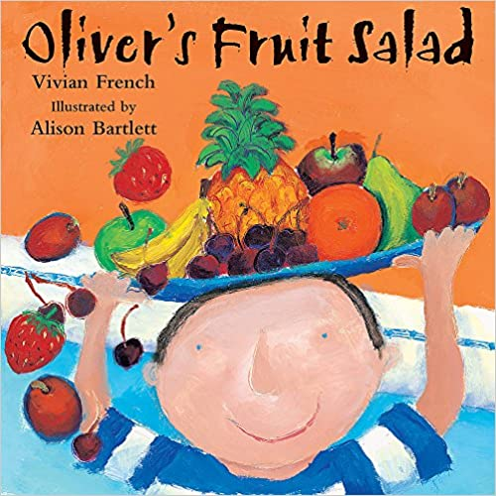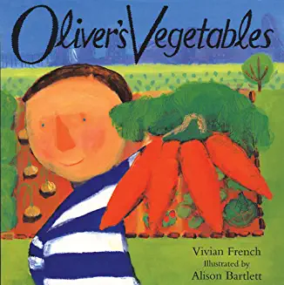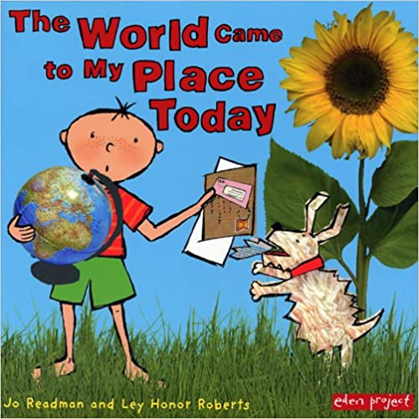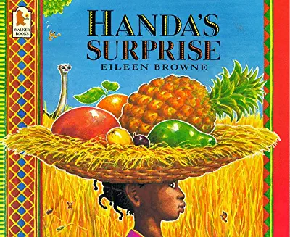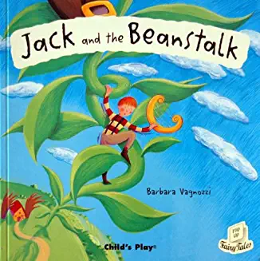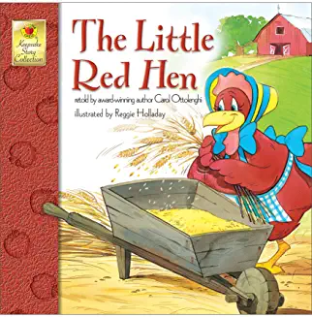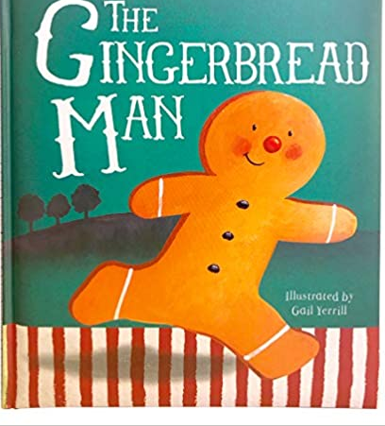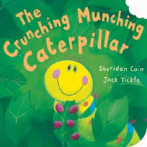

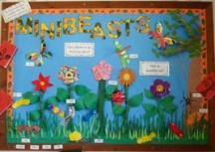
Our Literacy learning will be based on a different theme each week. We will learn all about fruit, vegetables and food from around the world moving onto the Fairy Tales of Jack and the Beanstalk, The Little Red Hen and The Gingerbread Man before finishing the half term focusing on Minibeasts. Our main story focus will be The Very Hungry Caterpillar, The Bad-Tempered Ladybird, The Crunching Munching Caterpillar and Tadpole’s Promise but we shall also be engaging in non-fiction books about minibeasts to develop new knowledge and vocabulary. We will continue practising to read and spell our high frequency and tricky words to use in our reading and writing. We will also continue to learn new phonic sounds as well as consolidating those sounds we have already learnt.

This half term in our Mathematics we will be developing our ability to subitise up to 5 (recognising quantities without counting). Count beyond 20, recognising the pattern of the counting system. Develop our ability to recall number bonds for numbers 0-10. Understand the ‘one more than/one less than’ relationship between consecutive numbers.
Gr
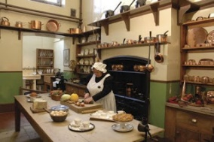
Through our Green Fingers topic, we will develop our Understanding of the World learning about the past and now, for example what kitchens looked like in the past compared to today; what shops were like in the past. We will look at the buildings in Hanslope to see what pubs, shops and other amenities used to be in the village and what the buildings are used for now. We will also continue to develop our ability to explain about some similarities and differences between life in other countries and our own. We will continue to explore the natural world and the effects of the changing seasons. We will also be learning about Saint Georges Day and finding out about Earth Day.
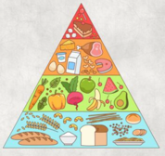
As part of our Personal, Social and Emotional Development we will be learning about ways that we keep healthy such as exercising, eating well, getting enough sleep and good hygiene. We will also be showing an understanding of our own feelings and those of others around us; explaining the reasons for rules, knowing right from wrong and behaving accordingly. We will continue to have circle times to encourage the children to talk about their thoughts and feelings.
In our Physical Development we will continue to have PE lessons twice a week where we will continue to develop our skills to negotiate space and obstacles safely, as well as demonstrating strength, balance and coordination. In the class room, we will continue to develop our fine motor skills by holding a pencil effectively and using a range of tools, including scissors and paintbrushes.
our Physical Development during our PE lessons, we will be experimenting with different ways of moving to l Development during our PE lessons, we will be experimenting with different ways of moving to improve control and coordination. We will be using small equipment as obstacles to develop the children’s ability to negotiate space, such as when they are playing chasing games. Within the classroom we will continue to practise fine motor and pencil skills to support the children’s ability to write and form their letters correctly. We will continue to develop the foundation of a handwriting style which is fast, accurate and efficient. We will be using a variety of tools, objects and construction equipment to develop increasing physical control.ve control and coordination. We will be using small equipment as obstacles to develop the children’s ability to negotiate space, such as when they are playing chasing games. Within the classroom we will continue to practise fine motor and pencil skills to support the children’s ability to write and form their letters correctly. We will continue to develop the foundation of a handwriting style which is fast, accurate and efficient. We will be using a variety of tools, objects and construction equipment to develop increasing physical control.

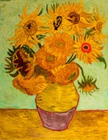

In our Expressive Arts and Design we will safely use and explore a variety of materials, tools and techniques to help us create a fruit kebab and make some bread, jam and butter. We will create some fruit and vegetable prints as well as use different materials to make some sunflowers as we learn about Vincent Van Gough and his famous painting of Sunflowers. We will use a variety of techniques to create a minibeast display.

Please continue to support your child with their learning at home. Continue to hear your child read the school reading books that are sent home on a Monday. Lots of the reading books have examples of how to share the books with your child, as well as the key words and sounds the books are focusing on. The first day that you have the reading book, cover up the words and predict what might be happening in the story by using the pictures. Play I Spy with the book e.g. how many times can you find the tricky word e.g. the, my, said?
Continue to practise recognising the letter sounds and high frequency words in your child’s pencil case, as well as practising letter formation and spelling words. Encourage your child to write by using their phonic knowledge to write the sounds they can hear in words.
Keep the activities short, five minutes a day is better than nothing at all, to secure your child’s knowledge.

