Dear Parents/Carers,
Here is an overview of what your child will be learning this half term across the different areas of learning. Our topic for the second half of the Summer term is called ‘Once Upon a Time’. The last few weeks before the Summer holidays our topic is called ‘Under the Sea’.
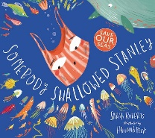
Each week our learning will take on a different theme and we will use some of these stories as our stimulus.
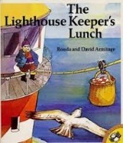
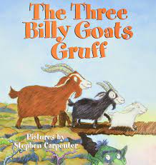
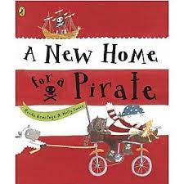
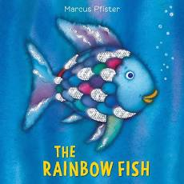
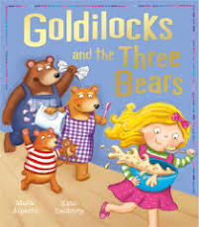
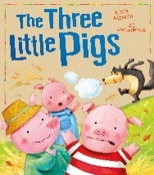

Our Literacy learning will be based on a different theme each week. We will be using the fairy tale texts to develop our story language. During our ‘Under the Sea’ theme, we will also be using non-fiction texts to develop our understanding of animals that live under the sea. In our writing we will continue to develop our letter formation and spelling words by identifying sounds in them and representing the sounds with letters. We will also continue to develop our sentence writing in order to achieve the end of year expectations. We will continue to learn new phonic sounds as well as consolidating those sounds we have already learnt. In order to reach the end of year expectations, please continue to support your child with the words and sounds in their pencil cases.

This half term in our Mathematics we will be consolidating our learning to achieve the end of year expectations by: gaining a deep understanding of the composition of each number up to 10; subitising quantities up to 5 and then 10; recalling number bonds up to 5 and 10; learning double facts; and recognising odd and even numbers.
Gr
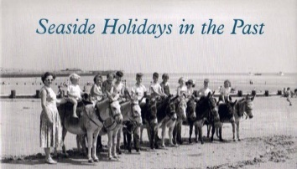
Through our ‘Under the Sea’ topic, we will develop our Understanding of the World learning about the past and now, for example seaside holidays in the past compared to today and where we have been or go on holiday. We will also talk about features of our own environment and how these environments vary compared to other environments, for example a Desert Island compared to Hanslope. We will continue to explore the natural world and the effects of the changing seasons.

our Physical Development during our PE lessons, we will be experimenting with different ways of moving to l Development during our PE lessons, we will be experimenting with different ways of moving to improve control and coordination. We will be using small equipment as obstacles to develop the children’s ability to negotiate space, such as when they are playing chasing games. Within the classroom we will continue to practise fine motor and pencil skills to support the children’s ability to write and form their letters correctly. We will continue to develop the foundation of a handwriting style which is fast, accurate and efficient. We will be using a variety of tools, objects and construction equipment to develop increasing physical control.ve control and coordination. We will be using small equipment as obstacles to develop the children’s ability to negotiate space, such as when they are playing chasing games. Within the classroom we will continue to practise fine motor and pencil skills to support the children’s ability to write and form their letters correctly. We will continue to develop the foundation of a handwriting style which is fast, accurate and efficient. We will be using a variety of tools, objects and construction equipment to develop increasing physical control.

In our Physical Development we will continue to have PE lessons twice a week where we will continue to develop our skills to negotiate space and obstacles safely, as well as demonstrating strength, balance and co-ordination and continuing to practise running, jumping, hopping and skipping. In the class room, we will continue to develop our fine motor skills.

We will continue with our Personal, Social and Emotional Development activities through our circle time discussions where will talk about what Goldilocks did wrong. In our Rainbow fish week, we will discuss sharing, friendships and giving. We will think about the question is it right to take things from others as we discuss pirates. As the weather gets warmer again we will discuss how to stay safe in the sun.
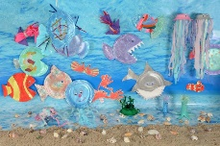
In our Expressive Arts and Design we will continue to invent, adapt and recount stories we have heard. We will safely use and explore a variety of materials, tools and techniques to create an under the sea display.

Please continue to support your child with their learning at home. Continue to hear your child read the school reading books that are sent home on a Monday. Lots of the reading books have examples of how to share the books with your child, as well as the key words and sounds the books are focusing on. The first day that you have the reading book, cover up the words and predict what might be happening in the story by using the pictures. Play I Spy with the book e.g. how many times can you find the tricky word e.g. the, my, said?
Continue to practise recognising the letter sounds and high frequency words in your child’s pencil case, as well as practising letter formation and spelling words. Encourage your child to write by using their phonic knowledge to write the sounds they can hear in words.
Keep the activities short, five minutes a day is better than nothing at all, to secure your child’s knowledge.

